Chapter 8: How to Maximize Your Intermittent Fasting Results

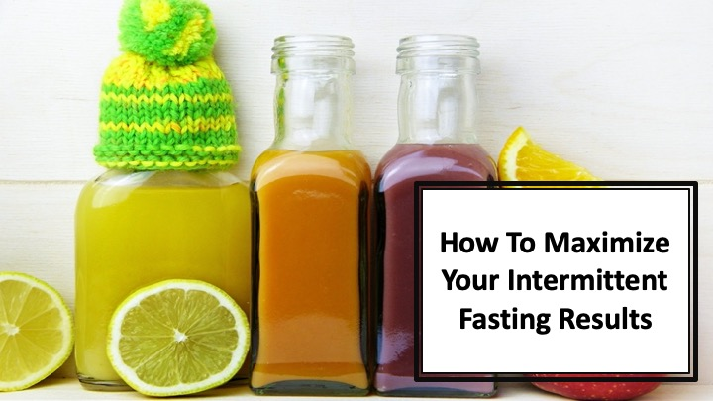
S1 : In this video, we’ll talk about “How to Maximize Your Intermittent Fasting Results”

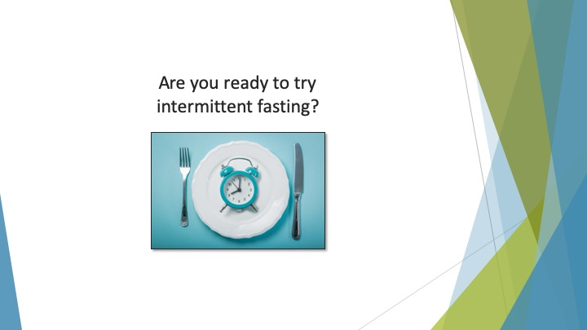
S2 : Are you ready to try intermittent fasting?

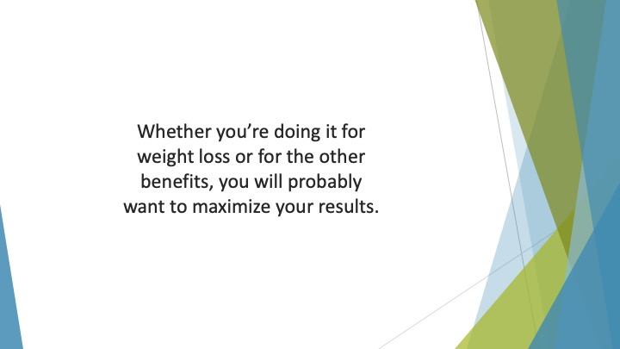
S3 : Whether you’re doing it for weight loss or for the other benefits, you will probably want to maximize your results.

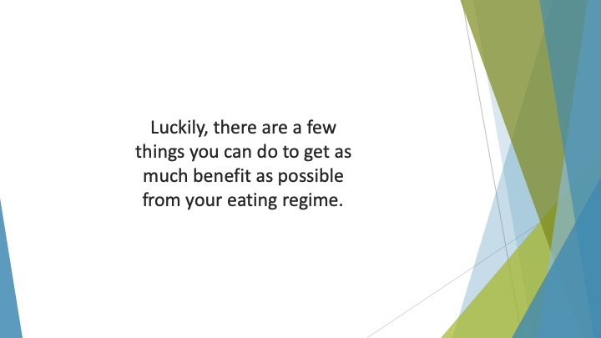
S4 : Luckily, there are a few things you can do to get as much benefit as possible from your eating regime.

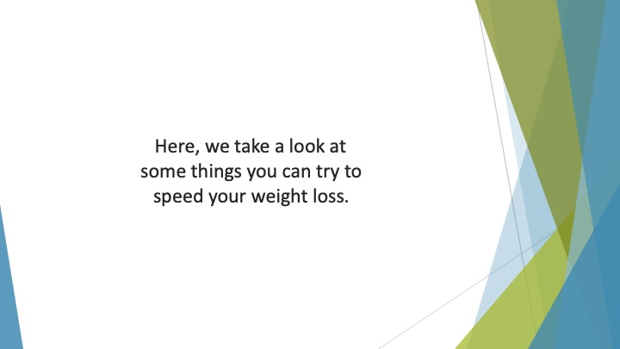
S5 : Here, we take a look at some things you can try to speed your weight loss.

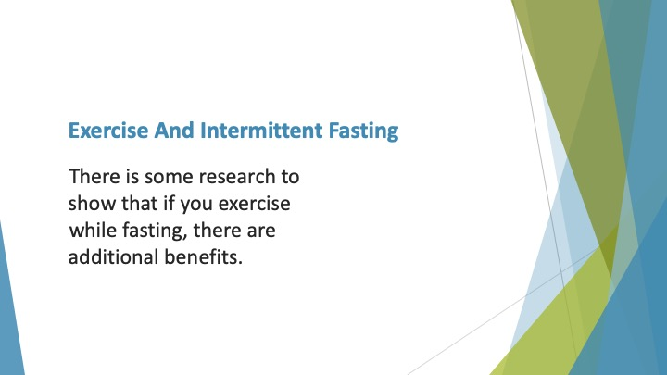
S6 : Exercise and Intermittent Fasting

There is some research to show that if you exercise while fasting, there are additional benefits. There is an impact on your metabolism and muscle biochemistry.

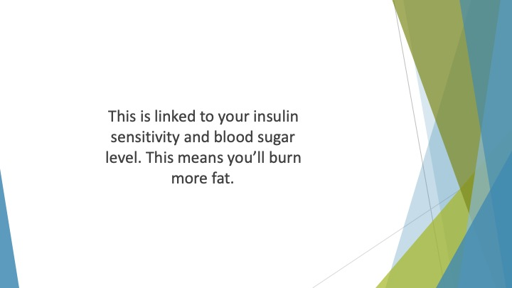
S7 : This is linked to your insulin sensitivity and blood sugar level. If you exercise while fasting, your glycogen (or stored carbs) are depleted. This means you’ll burn more fat.

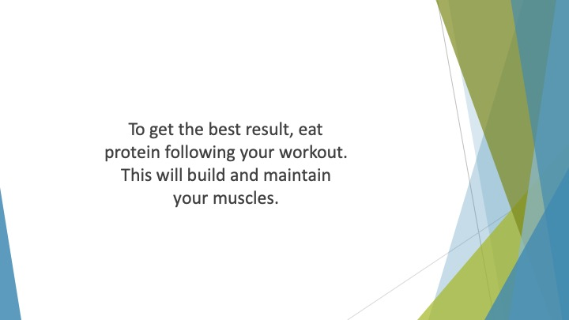
S8 : To get the best result, eat protein following your workout. This will build and maintain your muscles. It will also promote better recovery.

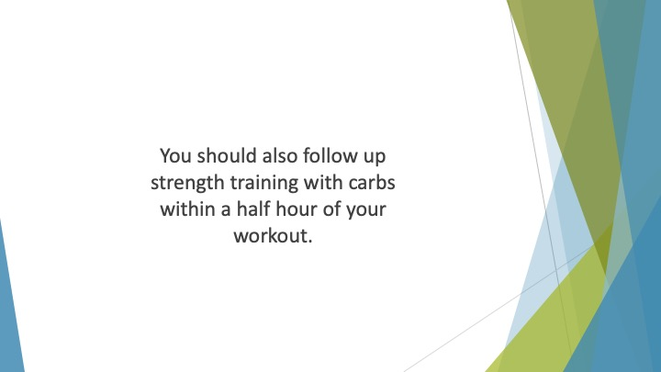
S9 : You should also follow up strength training with carbs within a half hour of your workout.

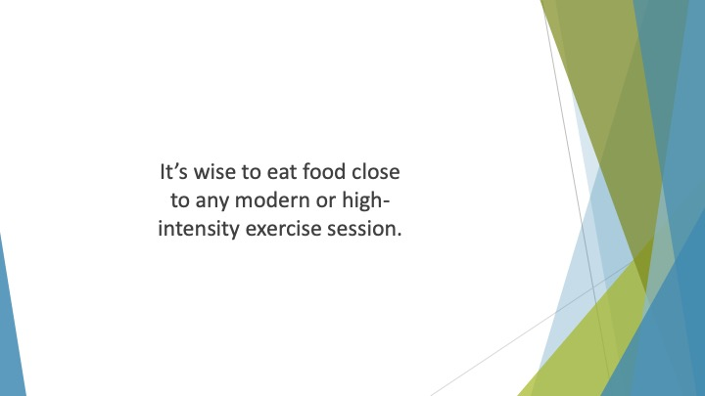
S10 : It’s wise to eat food close to any modern or high-intensity exercise session. You should also drink a lot more water to stay well-hydrated.

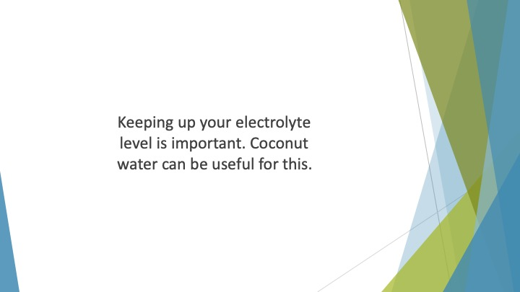
S11 : Keeping up your electrolyte level is important. Coconut water can be useful for this.

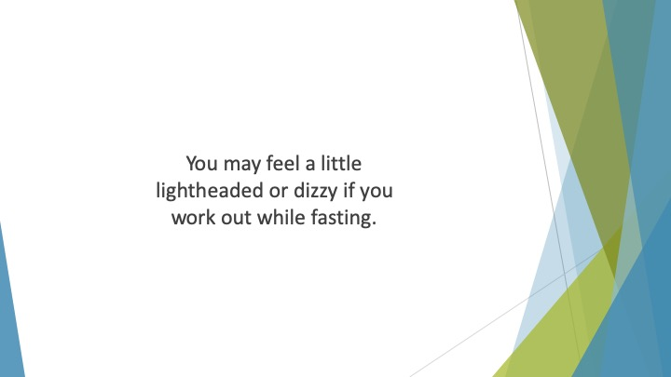
S12 : You may feel a little lightheaded or dizzy if you work out while fasting. If you experience this, take a break. It’s important to listen to your body.

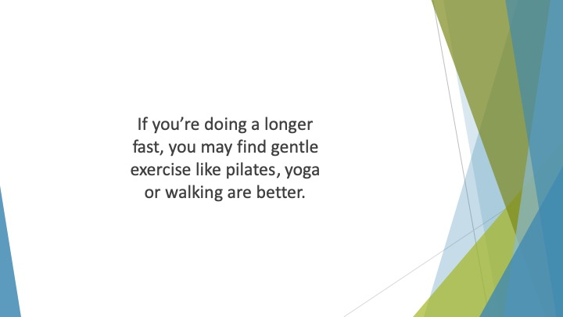
S13 : If you’re doing a longer fast, you may find gentle exercise like pilates, yoga or walking are better. They will help to burn fat without making you feel unwell.

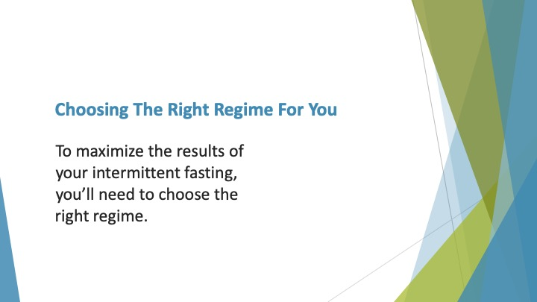
S14 : Choosing the Right Regime for You

To maximize the results of your intermittent fasting, you’ll need to choose the right regime. As you’ve seen there are several different types of intermittent fasting diet.

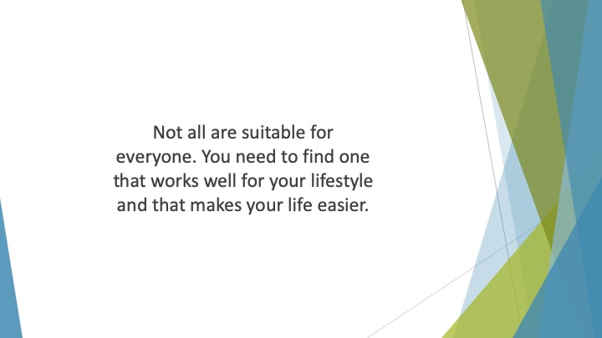
S15 : Not all are suitable for everyone. You need to find one that works well for your lifestyle and that makes your life easier.

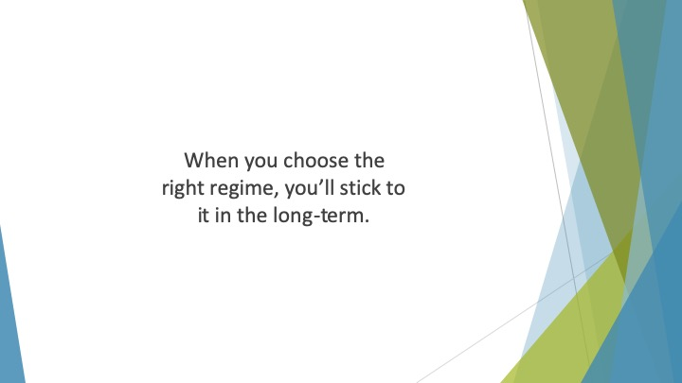
S16 : When you choose the right regime, you’ll stick to it in the long-term.

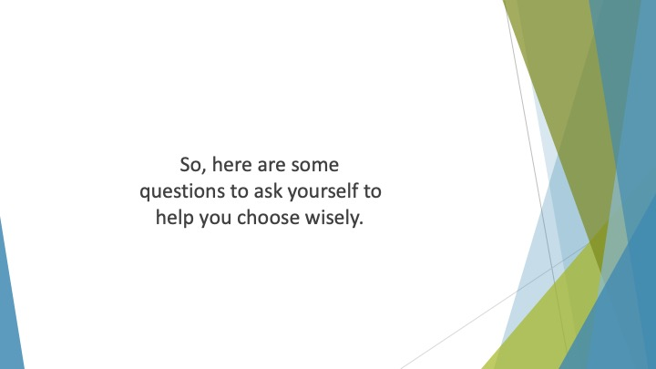
S17 : So, here are some questions to ask yourself to help you choose wisely.

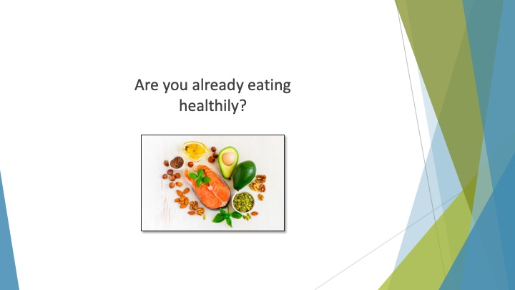
S18 : Are you already eating healthily?

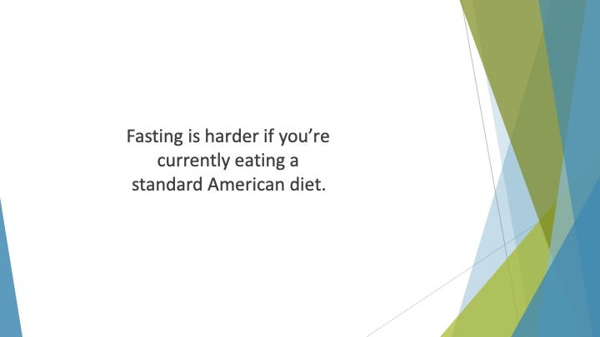
S19 : Fasting is harder if you’re currently eating a standard American diet. This is because it is high carb, full of sugars and very addictive.

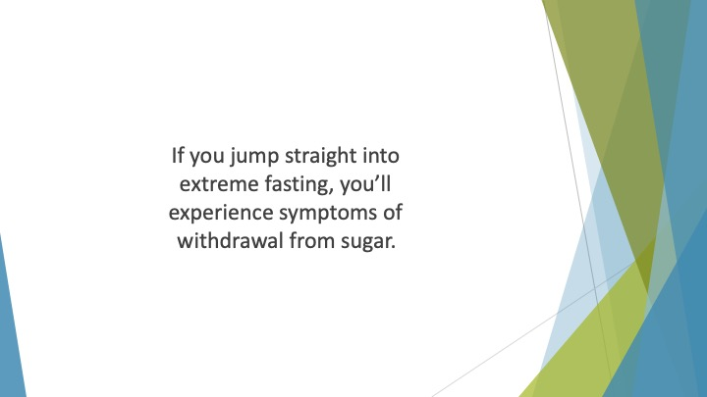
S20 : If you jump straight into extreme fasting, you’ll experience symptoms of withdrawal from sugar. This makes it hard to stick to your new diet.

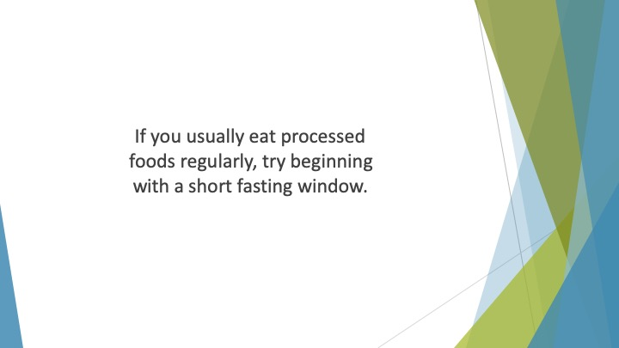
S21 : If you usually eat processed foods regularly, try beginning with a short fasting window. Meanwhile, detox from sugar and begin to eat more cleanly.

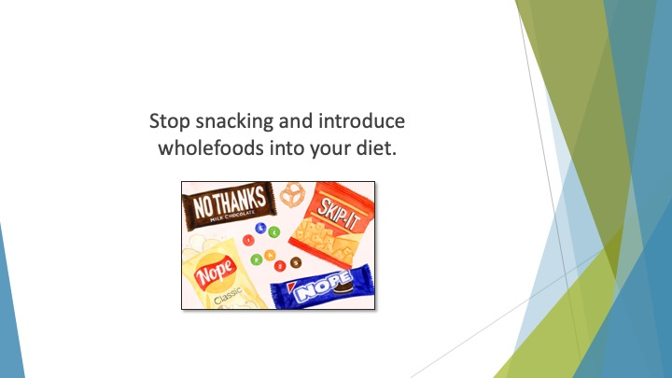
S22 : Stop snacking and introduce wholefoods into your diet. You can then increase the fasting window if necessary.

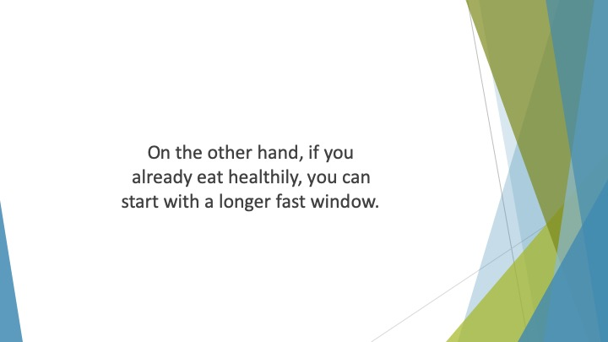
S23 : On the other hand, if you already eat healthily, you can start with a longer fast window.

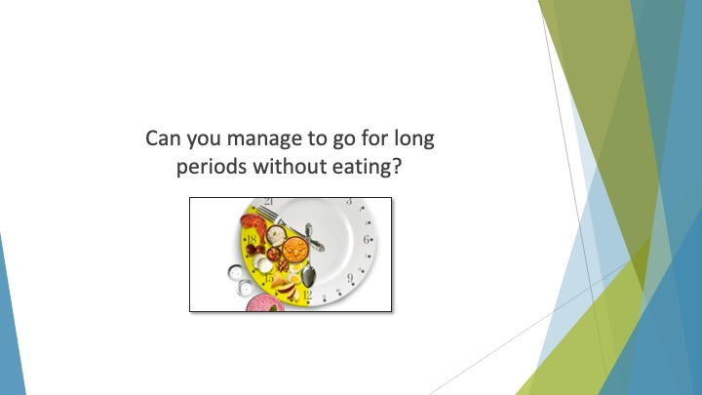
S24 : Can you manage to go for long periods without eating?

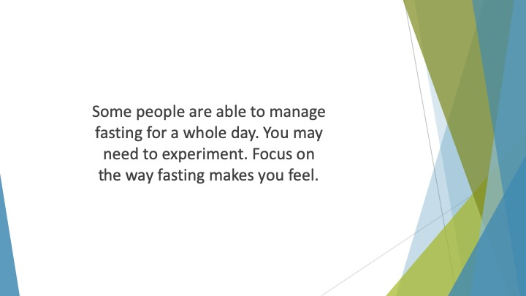
S25 : Some people are able to manage fasting for a whole day. Others can only manage a few hours. You may need to experiment. Focus on the way fasting makes you feel. If you struggle to fast for long periods, choose a method like the 5:2 or 16:8.

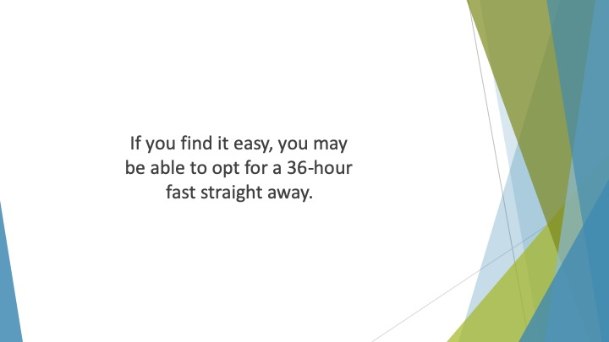
S26 : If you find it easy, you may be able to opt for a 36-hour fast straight away.

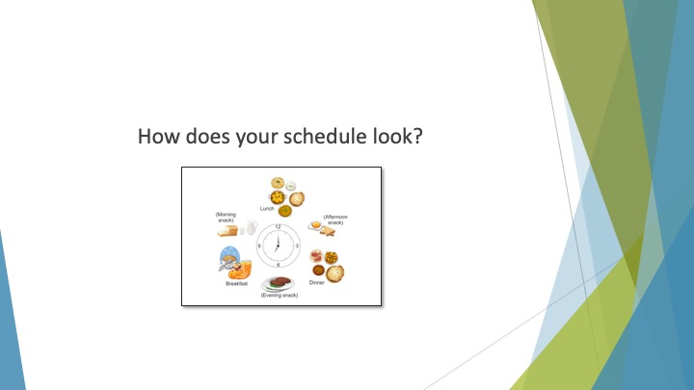
S27 : How does your schedule look?

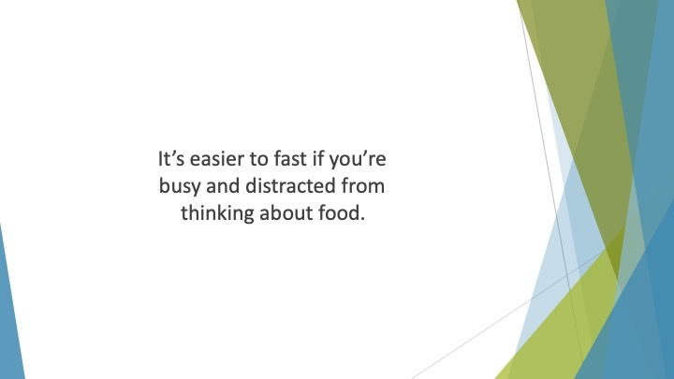
S28 : It’s easier to fast if you’re busy and distracted from thinking about food. If you fast at work or while you’re working on something, you’ll probably feel less hungry.

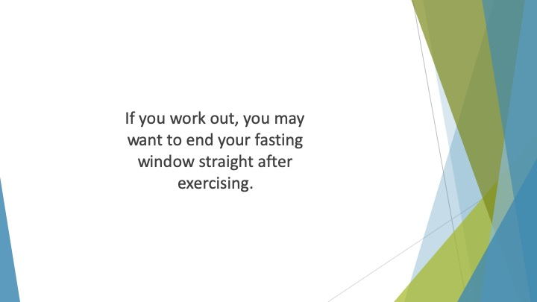
S29 : If you work out, you may want to end your fasting window straight after exercising.

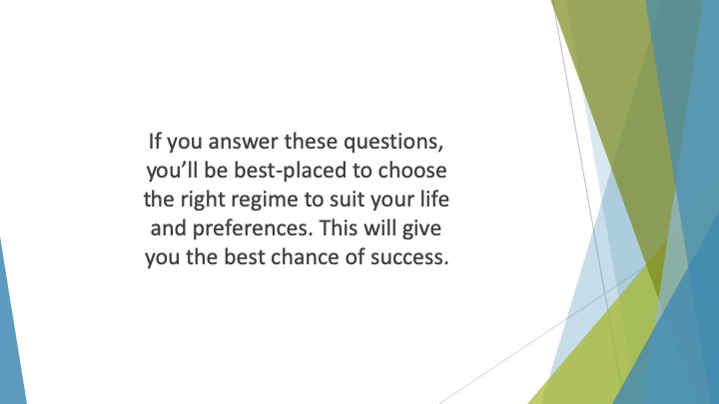
S30 : If you answer these questions, you’ll be best-placed to choose the right regime to suit your life and preferences. This will give you the best chance of success.

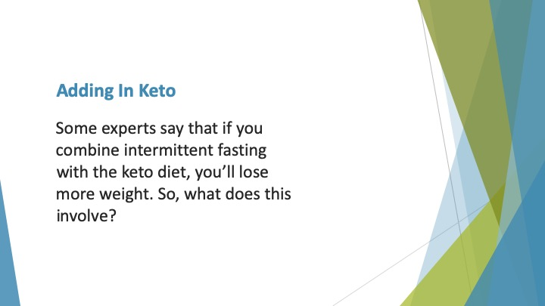
S31 : Adding in Keto

Some experts say that if you combine intermittent fasting with the keto diet, you’ll lose more weight. So, what does this involve?

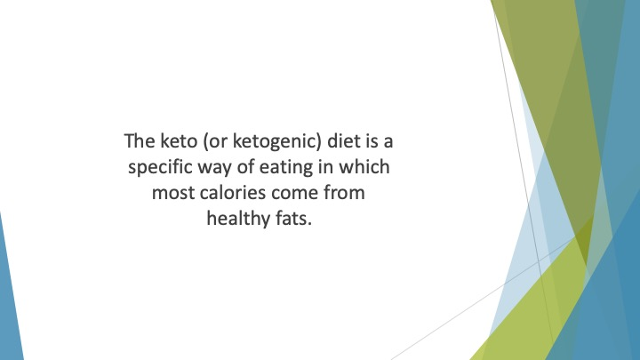
S32 : The keto (or ketogenic) diet is a specific way of eating in which most calories come from healthy fats. The remaining calories are derived from protein.

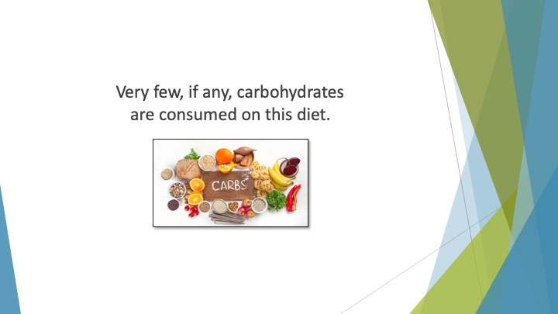
S33 : Very few, if any, carbohydrates are consumed on this diet.

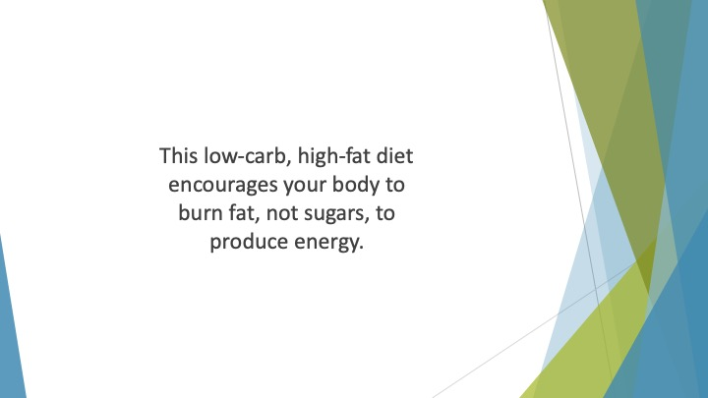
S34 : This low-carb, high-fat diet encourages your body to burn fat, not sugars, to produce energy. If your body lacks sufficient carbs to carry out everyday activities, fat is broken down by the liver.

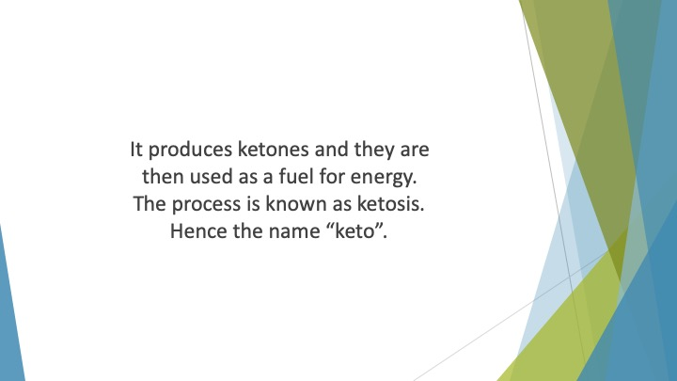
S35 : It produces ketones and they are then used as a fuel for energy. The process is known as ketosis. Hence the name “keto”.

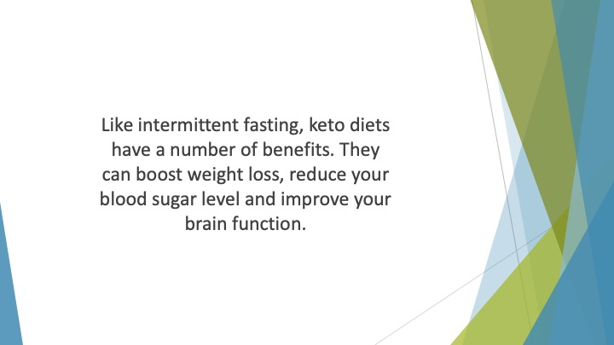
S36 : Like intermittent fasting, keto diets have a number of benefits. They can boost weight loss, reduce your blood sugar level and improve your brain function. Many people say it helps to reduce problems like diabetes and obesity.

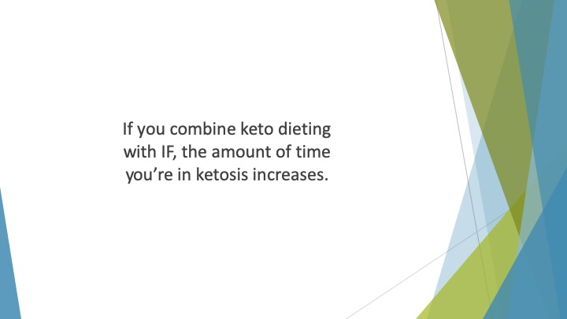
S37 : If you combine keto dieting with IF, the amount of time you’re in ketosis increases.

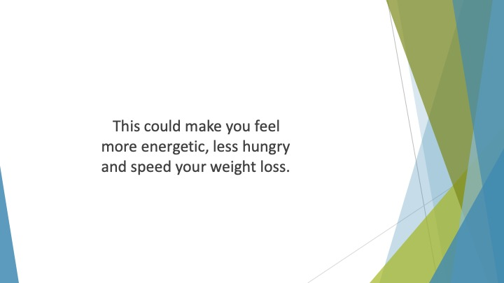
S38 : This could make you feel more energetic, less hungry and speed your weight loss.

