Chapter 7: Other Types of Intermittent Fasting

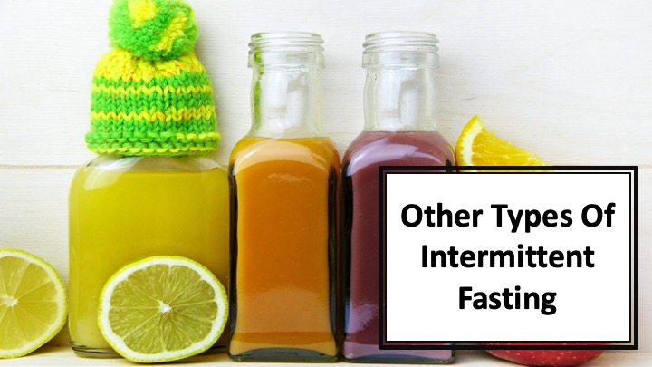
S1 : In this video, we’ll discover about “Other Types of Intermittent Fasting”

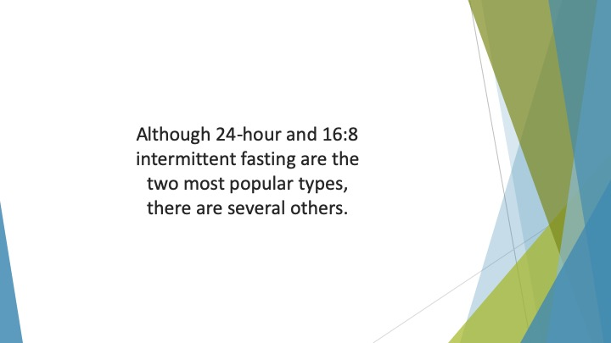
S2 : Although 24-hour and 16:8 intermittent fasting are the two most popular types, there are several others.

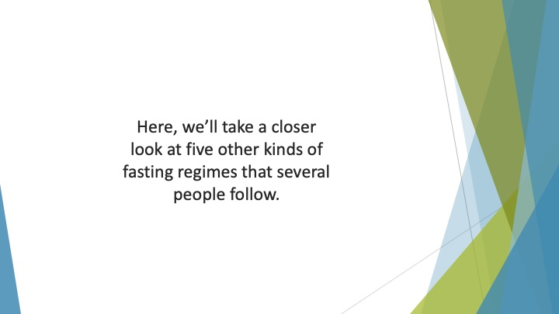
S3 : Here, we’ll take a closer look at five other kinds of fasting regimes that several people follow.

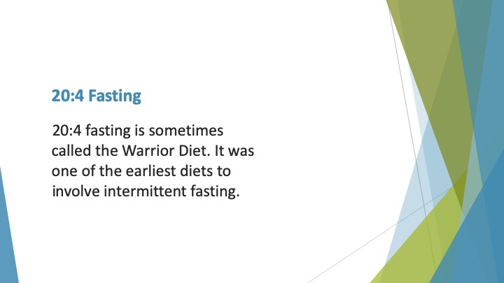
S4 : 20:4 Fasting

20:4 fasting is sometimes called the Warrior Diet. It was one of the earliest diets to involve intermittent fasting. Made popular by Ori Hofmekler, a fitness expert, this diet involves eating one large meal in the evening.

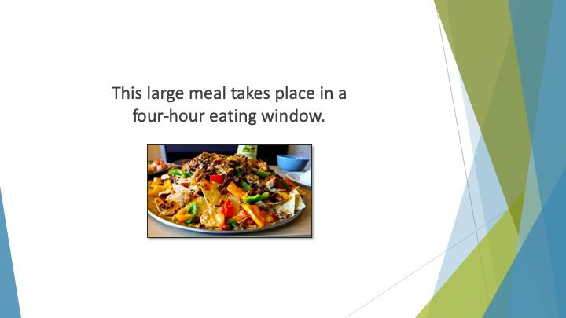
S5 : This large meal takes place in a four-hour eating window.

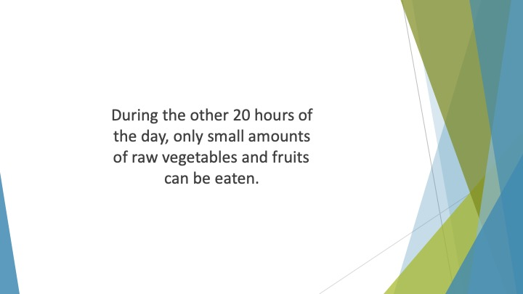
S6 : During the other 20 hours of the day, only small amounts of raw vegetables and fruits can be eaten. The food choices for this diet should be healthy – similar to those on the Paleo diet.

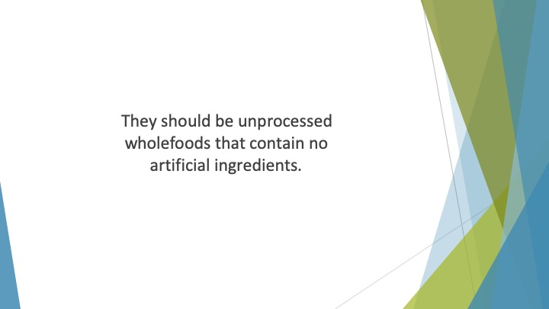
S7 : They should be unprocessed wholefoods that contain no artificial ingredients.

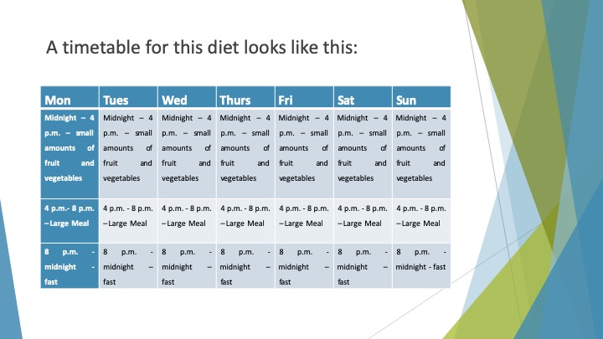
S8 : A timetable for this diet looks like this:
Mon | Tues | Wed | Thurs | Fri | Sat | Sun
Midnight – 4 p.m. – small amounts of fruit and vegetables | Midnight – 4 p.m. – small amounts of fruit and vegetables | Midnight – 4 p.m. – small amounts of fruit and vegetables | Midnight – 4 p.m. – small amounts of fruit and vegetables | Midnight – 4 p.m. – small amounts of fruit and vegetables | Midnight – 4 p.m. – small amounts of fruit and vegetables | Midnight – 4 p.m. – small amounts of fruit and vegetables
4 p.m.- 8 p.m. – Large Meal | 4 p.m. - 8 p.m. – Large Meal | 4 p.m. - 8 p.m. – Large Meal | 4 p.m. - 8 p.m. – Large Meal | 4 p.m. - 8 p.m. – Large Meal | 4 p.m. - 8 p.m. – Large Meal | 4 p.m. - 8 p.m. – Large Meal
8 p.m. -midnight - fast | 8 p.m. -midnight – fast | 8 p.m. -midnight – fast | 8 p.m. -midnight – fast | 8 p.m. -midnight – fast | 8 p.m. -midnight – fast | 8 p.m. -midnight - fast

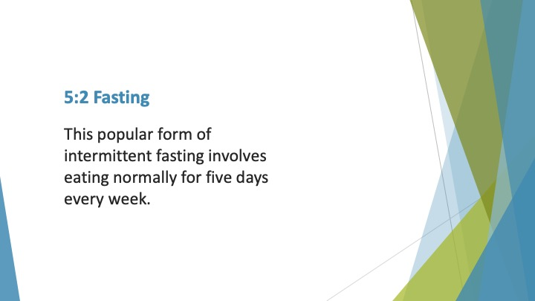
S9 : 5:2 Fasting

This popular form of intermittent fasting involves eating normally for five days every week.

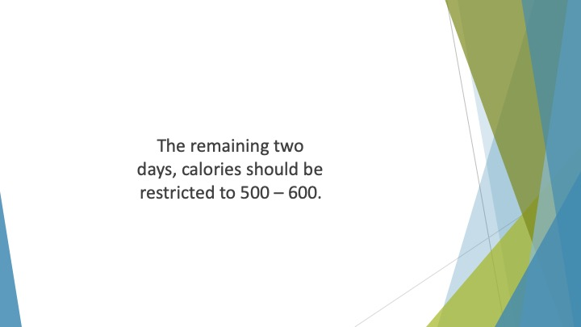
S10 : The remaining two days, calories should be restricted to 500 – 600. Sometimes called the Fast Diet, this way of eating was made popular by Michael Mosley, a journalist.

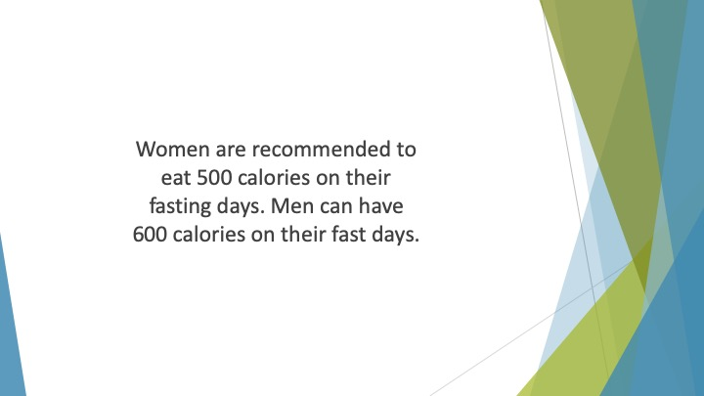
S11 : Women are recommended to eat 500 calories on their fasting days. Men can have 600 calories on their fast days.

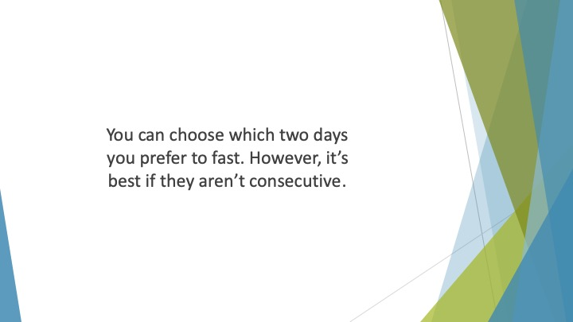
S12 : You can choose which two days you prefer to fast. However, it’s best if they aren’t consecutive. On those days, you can choose to eat one meal or two small meals.

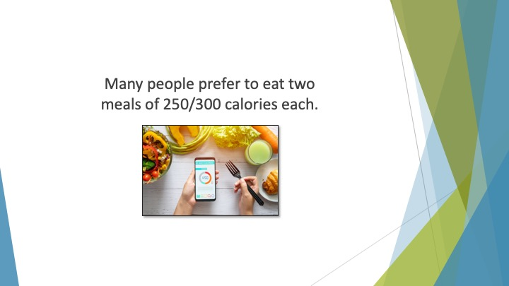
S13 : Many people prefer to eat two meals of 250/300 calories each.

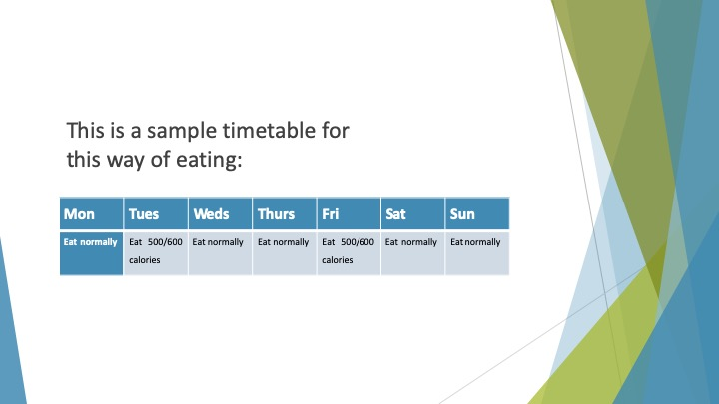
S14 : This is a sample timetable for this way of eating:
Mon | Tues | Weds | Thurs | Fri | Sat | Sun
Eat normally | Eat 500/600 calories | Eat normally | Eat normally | Eat 500/600 calories | Eat normally | Eat normally

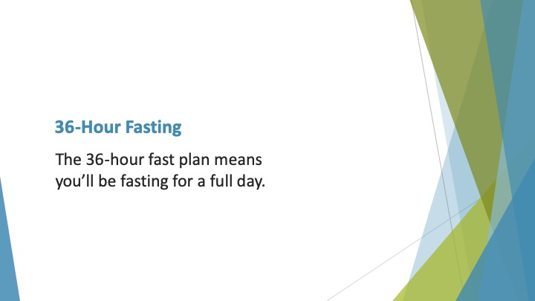
S15 : 36-Hour Fasting

The 36-hour fast plan means you’ll be fasting for a full day.

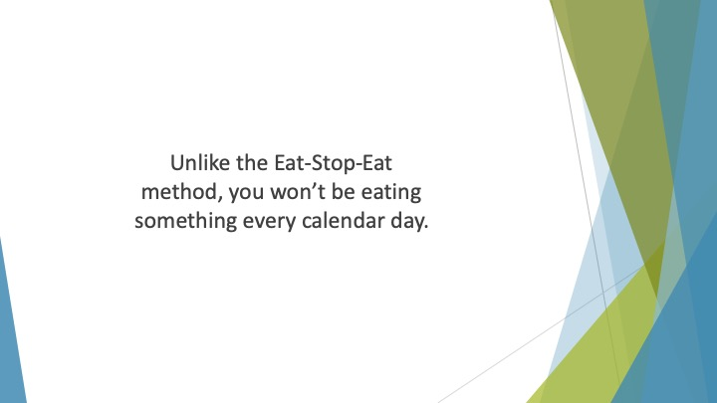
S16 : Unlike the Eat-Stop-Eat method, you won’t be eating something every calendar day.

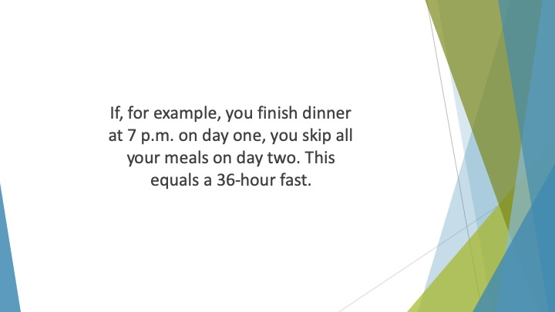
S17 : If, for example, you finish dinner at 7 p.m. on day one, you skip all your meals on day two. You won’t eat your next meal until day 3 at 7 a.m. This equals a 36-hour fast.

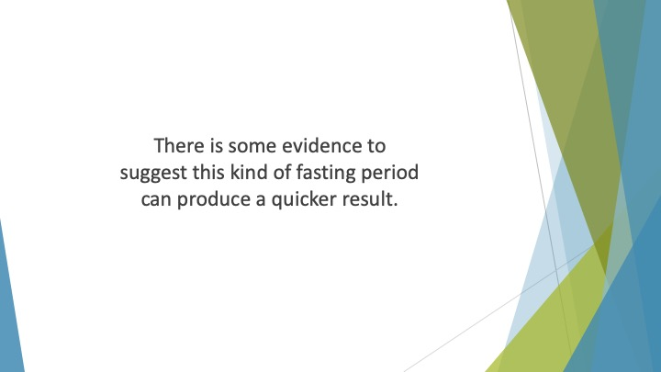
S18 : There is some evidence to suggest this kind of fasting period can produce a quicker result. It may also be beneficial for diabetics.

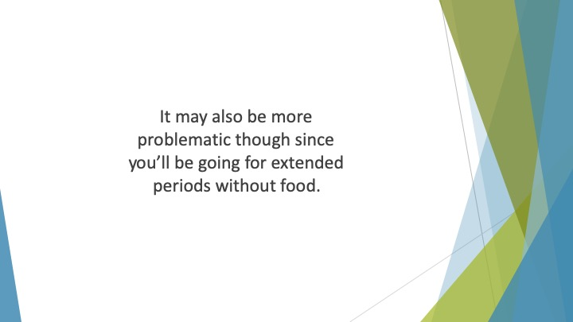
S19 : It may also be more problematic though since you’ll be going for extended periods without food.

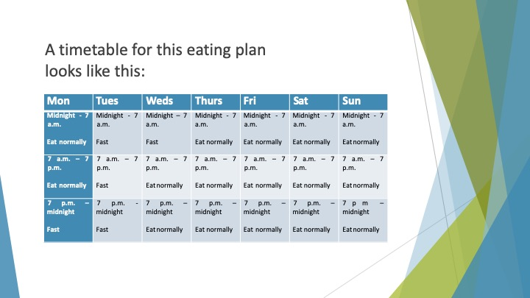
S20 : A timetable for this eating plan looks like this:
Mon | Tues | Weds | Thurs | Fri | Sat | Sun
Midnight - 7 a.m.  Eat normally | Midnight - 7 a.m.  Fast | Midnight – 7 a.m.  Fast | Midnight - 7 a.m.  Eat normally | Midnight - 7 a.m.  Eat normally | Midnight - 7 a.m.  Eat normally | Midnight - 7 a.m.  Eat normally
7 a.m. – 7 p.m.  Eat normally | 7 a.m. – 7 p.m.  Fast | 7 a.m. – 7 p.m.  Eat normally | 7 a.m. – 7 p.m.  Eat normally | 7 a.m. – 7 p.m.  Eat normally | 7 a.m. – 7 p.m.  Eat normally | 7 a.m. – 7 p.m.  Eat normally
7 p.m. – midnight  Fast | 7 p.m. -midnight  Fast | 7 p.m. – midnight  Eat normally | 7 p.m. – midnight  Eat normally | 7 p.m. – midnight  Eat normally | 7 p.m. – midnight  Eat normally | 7 p m – midnight  Eat normally

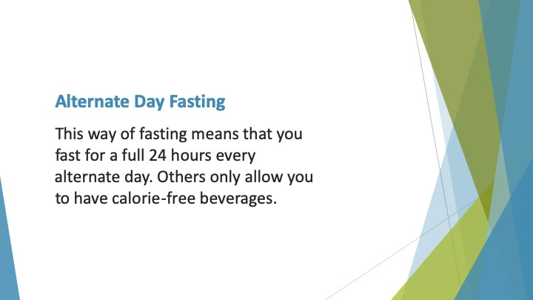
S21 : Alternate Day Fasting

This way of fasting means that you fast for a full 24 hours every alternate day. Some versions of this IF diet allow you to eat up to 500 calories on a fast day. Others only allow you to have calorie-free beverages.

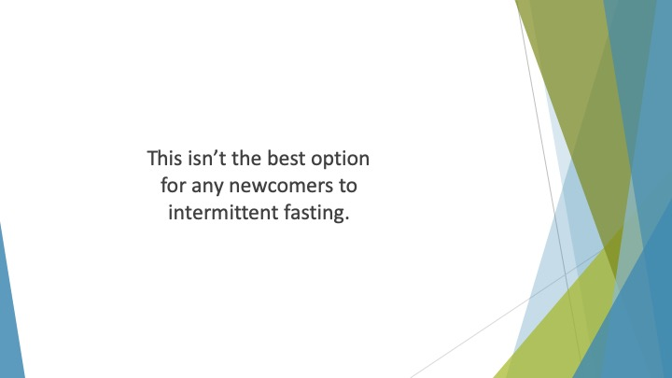
S22 : This isn’t the best option for any newcomers to intermittent fasting. You go to bed feeling hungry several nights each week.

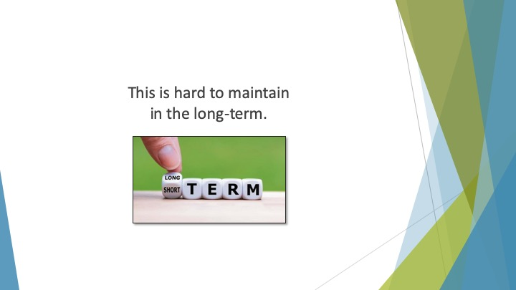
S23 : This is hard to maintain in the long-term.

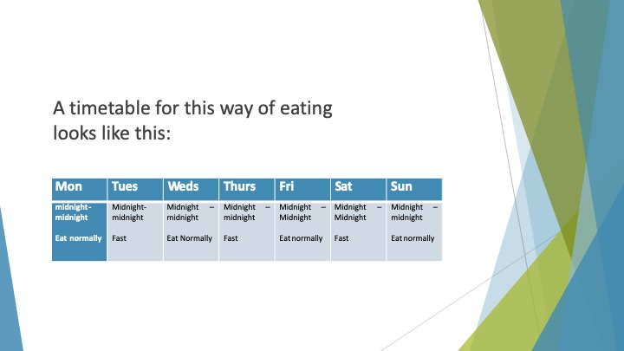
S24 : A timetable for this way of eating looks like this:
Mon | Tues | Weds | Thurs | Fri | Sat | Sun
midnight-midnight  Eat normally | Midnight-midnight  Fast | Midnight – midnight  Eat Normally | Midnight – midnight  Fast | Midnight – Midnight  Eat normally | Midnight – Midnight  Fast | Midnight – midnight  Eat normally

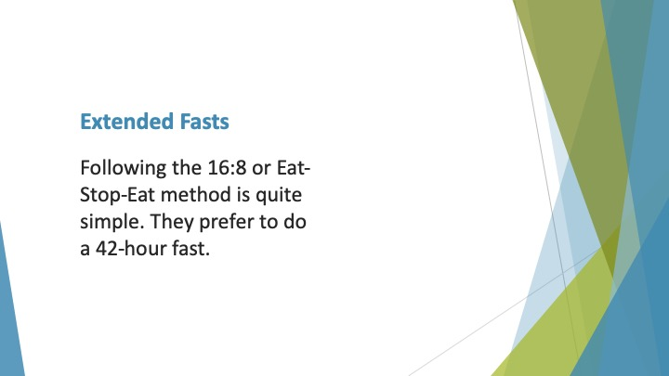
S25 : Extended Fasts

Following the 16:8 or Eat-Stop-Eat method is quite simple. Some people, though, are keen to push the benefits of intermittent fasting to the limit. They prefer to do a 42-hour fast.

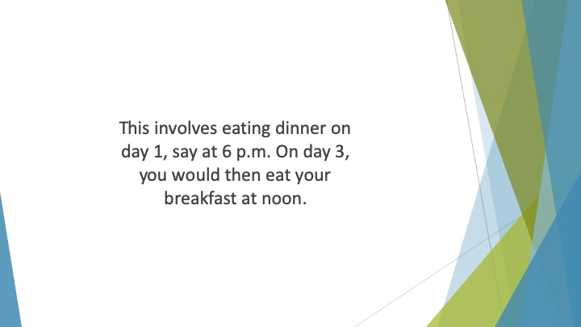
S26 : This involves eating dinner on day 1, say at 6 p.m. All meals would be skipped on the next day. On day 3, you would then eat your breakfast at noon. This would be a total fasting time of 42 hours.

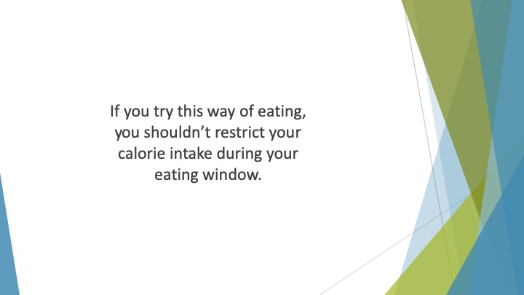
S27 : If you try this way of eating, you shouldn’t restrict your calorie intake during your eating window.

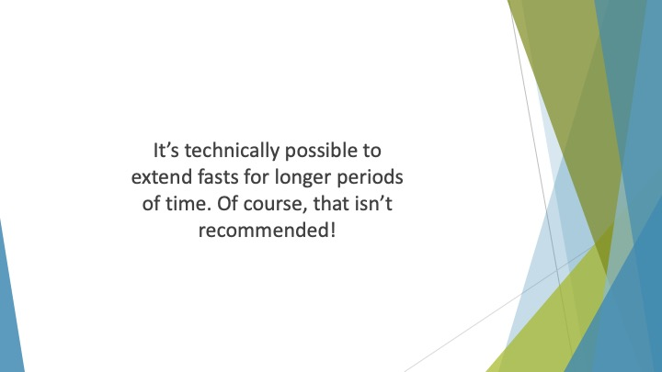
S28 : It’s technically possible to extend fasts for longer periods of time. In fact, the world record stands at 382 days. Of course, that isn’t recommended!

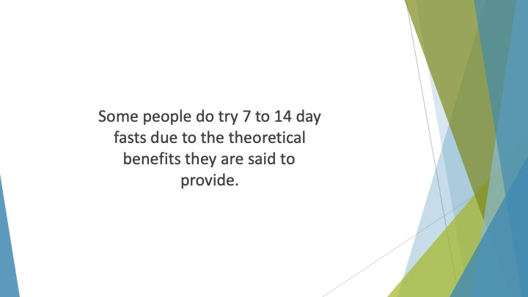
S29 : Some people do try 7 to 14 day fasts due to the theoretical benefits they are said to provide.

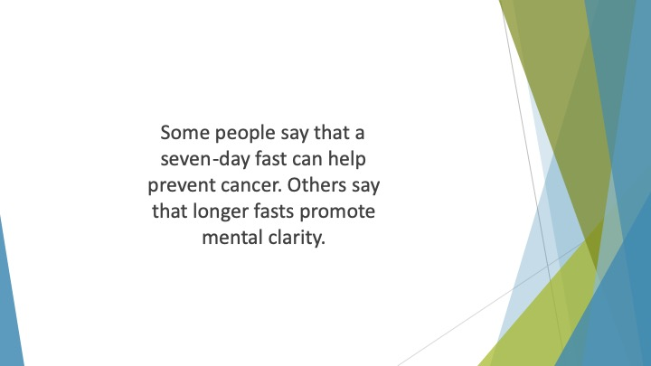
S30 : Some people say that a seven-day fast can help prevent cancer. Others say that longer fasts promote mental clarity.

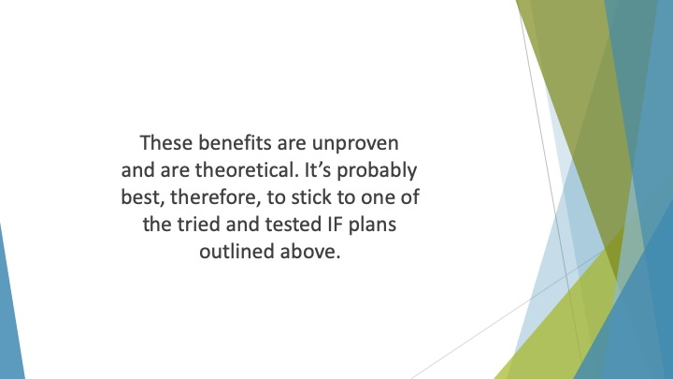
S31 : These benefits are unproven and are theoretical. It’s probably best, therefore, to stick to one of the tried and tested IF plans outlined above.

