Chapter 6: A Protocol for 24-Hour Intermittent Fasting

S1 : In this video, we’ll talk about “A Protocol for 24-Hour Intermittent Fasting”

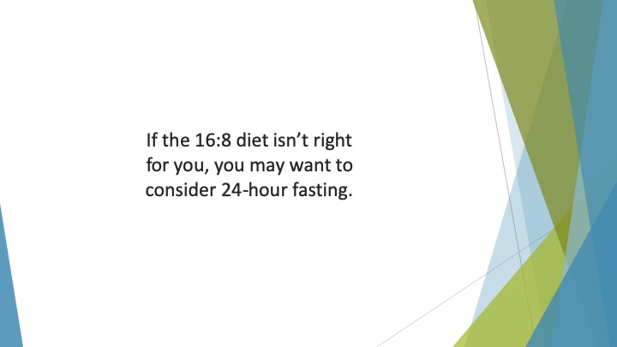
S2 : If the 16:8 diet isn’t right for you, you may want to consider 24-hour fasting. This is known as the Eat-Stop-Eat method.

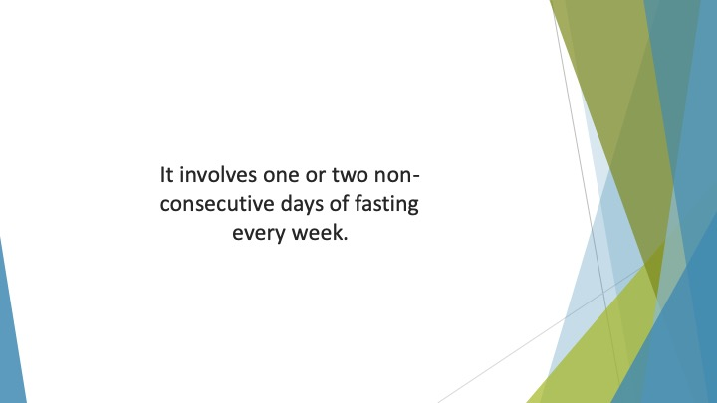
S3 : It involves one or two non-consecutive days of fasting every week.

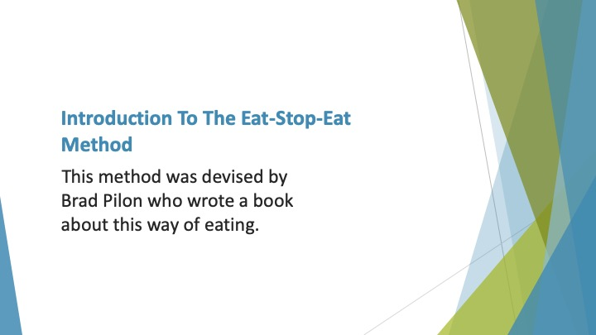
S4 : Introduction to the Eat-Stop-Eat Method

This method was devised by Brad Pilon who wrote a book about this way of eating. His methodology was based on Canadian research into the effect of short-term fasts on metabolic health.

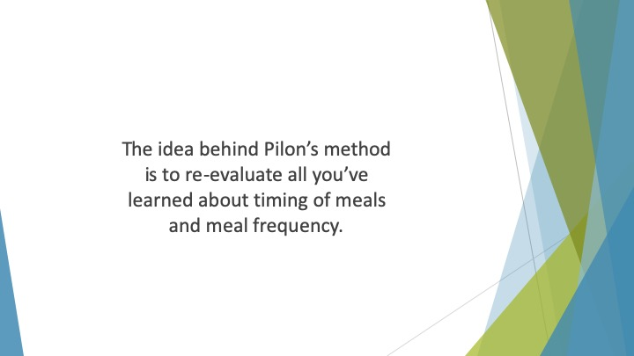
S5 : The idea behind Pilon’s method is to re-evaluate all you’ve learned about timing of meals and meal frequency.

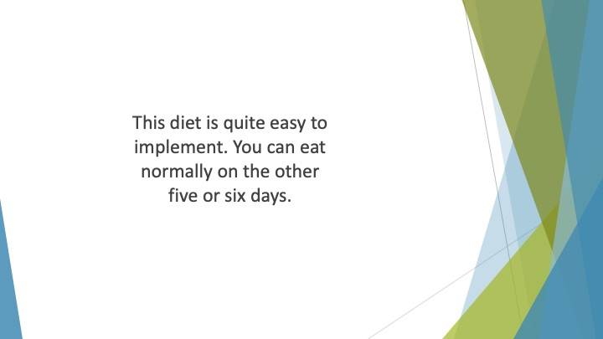
S6 : This diet is quite easy to implement. You simply choose one day or two non-consecutive days of the week in which you won’t eat for 24 hours.

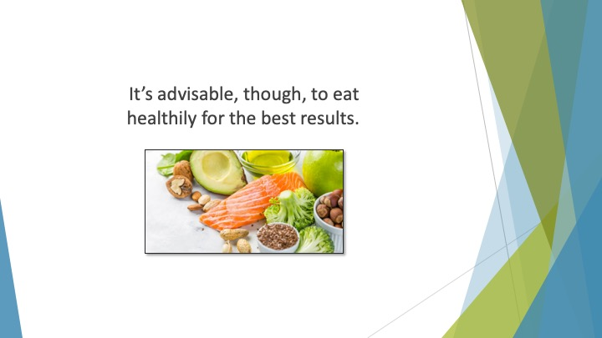
S7 : You can eat normally on the other five or six days. It’s advisable, though, to eat healthily for the best results.

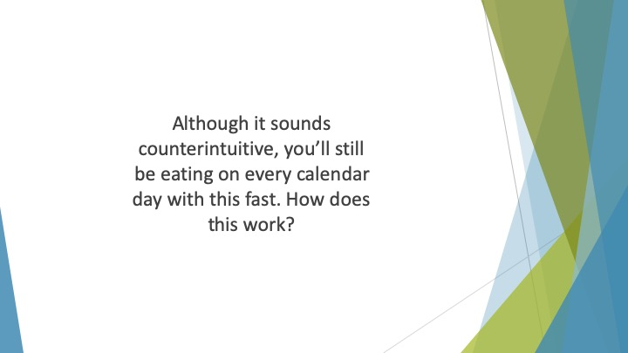
S8 : Although it sounds counterintuitive, you’ll still be eating on every calendar day with this fast. How does this work?

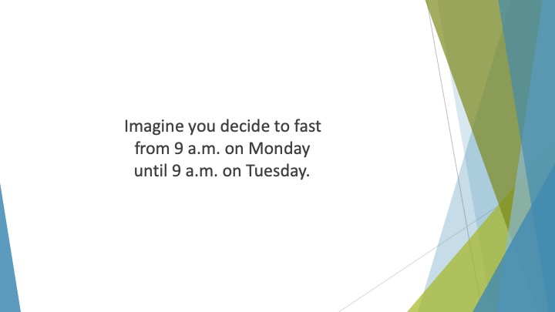
S9 : Imagine you decide to fast from 9 a.m. on Monday until 9 a.m. on Tuesday. You eat your last meal on the Monday morning before 9 a.m.

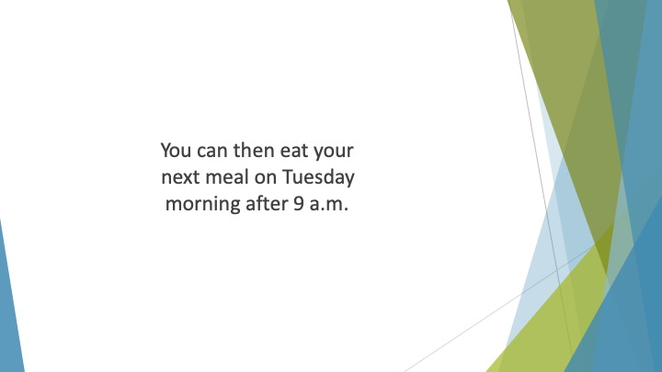
S10 : You can then eat your next meal on Tuesday morning after 9 a.m.

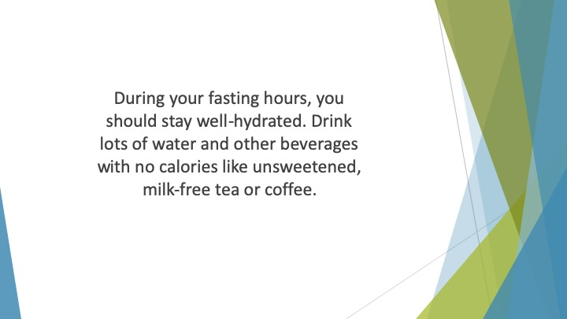
S11 : During your fasting hours, you should stay well-hydrated. Drink lots of water and other beverages with no calories like unsweetened, milk-free tea or coffee.

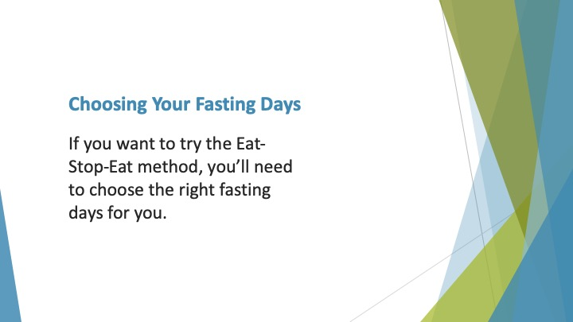
S12 : Choosing Your Fasting Days

If you want to try the Eat-Stop-Eat method, you’ll need to choose the right fasting days for you. This will be down to individual choice.

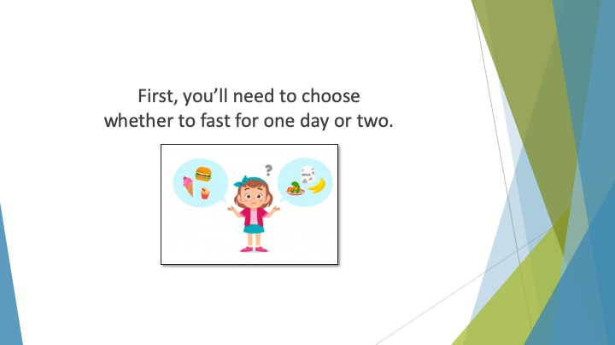
S13 : First, you’ll need to choose whether to fast for one day or two. You’ll probably find it easier to start out with one fasting day per week.

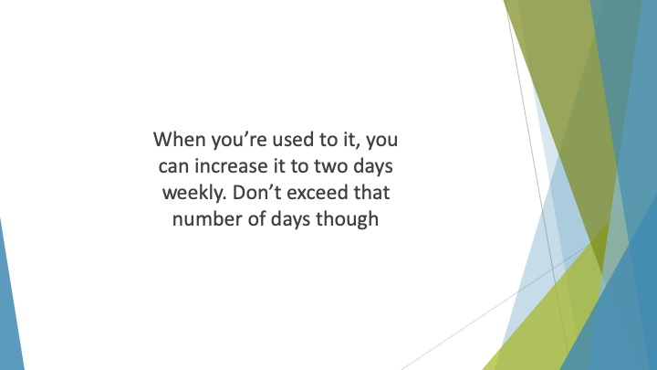
S14 : When you’re used to it, you can increase it to two days weekly. Don’t exceed that number of days though.

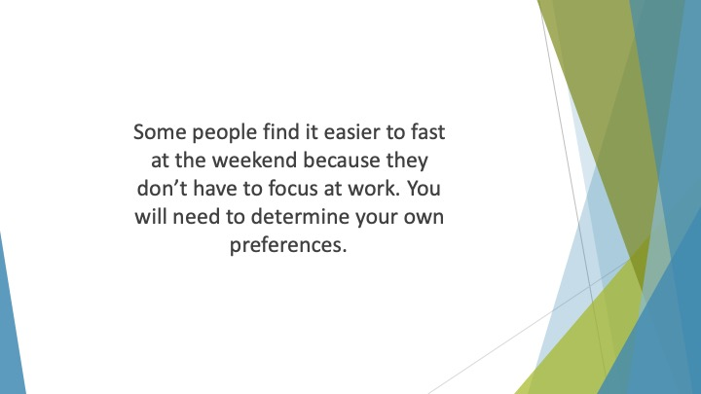
S15 : Some people find it easier to fast at the weekend because they don’t have to focus at work. Others would prefer to fast on workdays so they have distractions to stop them thinking about food. You will need to determine your own preferences.

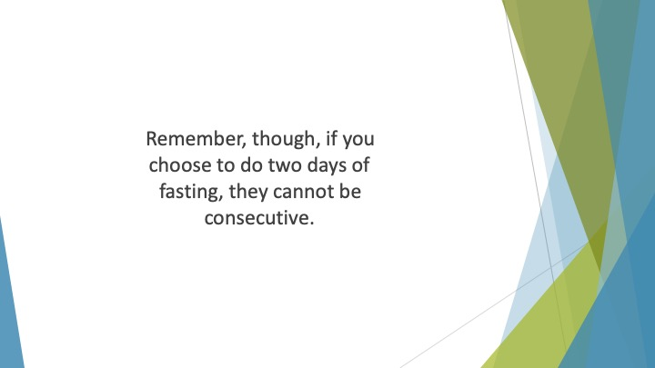
S16 : Remember, though, if you choose to do two days of fasting, they cannot be consecutive. This would be too long an extended period of fasting.

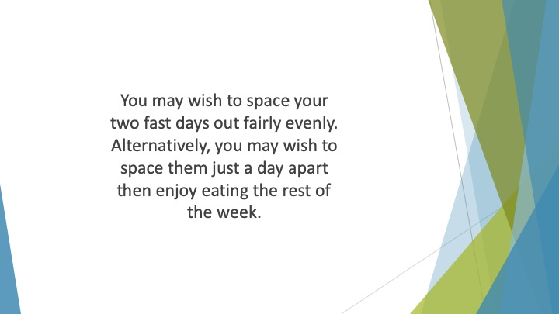
S17 : You may wish to space your two fast days out fairly evenly. Alternatively, you may wish to space them just a day apart then enjoy eating the rest of the week. You may need to experiment to find the right pattern for you.


S18 : A Weekly Timetable

These are some sample timetables to help you plan your 24-hour fasts:

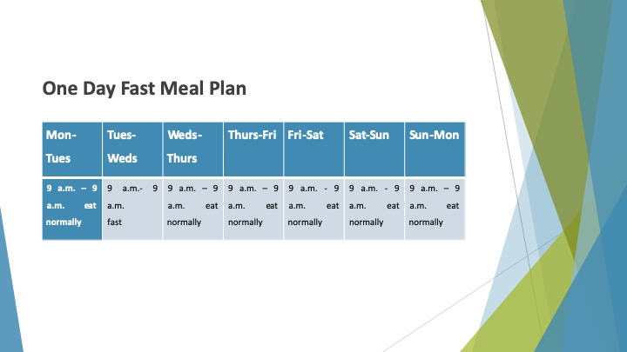
S19 : One Day Fast Meal Plan
Mon-Tues | Tues-Weds | Weds-Thurs | Thurs-Fri | Fri-Sat | Sat-Sun | Sun-Mon
9 a.m. – 9 a.m. eat normally | 9 a.m.- 9 a.m.  fast | 9 a.m. – 9 a.m. eat normally | 9 a.m. – 9 a.m. eat normally | 9 a.m. - 9 a.m. eat normally | 9 a.m. - 9 a.m. eat normally | 9 a.m. – 9 a.m. eat normally

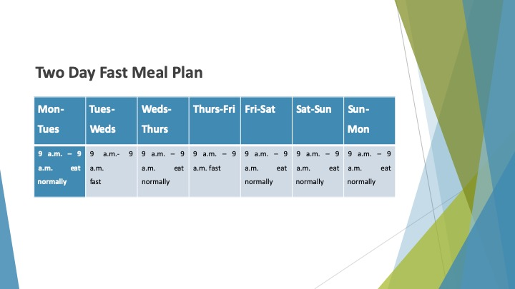
S20 : Two Day Fast Meal Plan
Mon-Tues | Tues-Weds | Weds-Thurs | Thurs-Fri | Fri-Sat | Sat-Sun | Sun-Mon
9 a.m. – 9 a.m. eat normally | 9 a.m.- 9 a.m.  fast | 9 a.m. – 9 a.m. eat normally | 9 a.m. – 9 a.m. fast | 9 a.m. – 9 a.m. eat normally | 9 a.m. – 9 a.m. eat normally | 9 a.m. – 9 a.m. eat normally

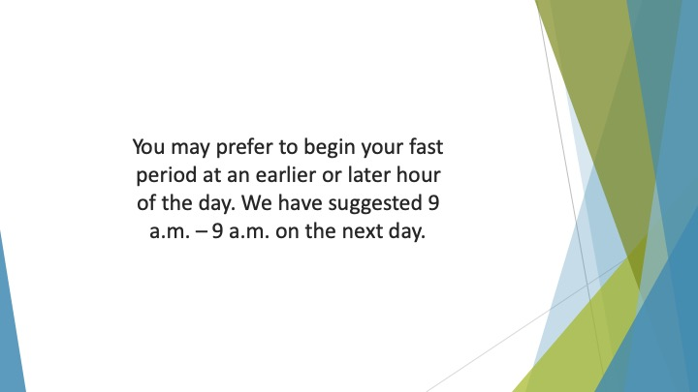
S21 : You may prefer to begin your fast period at an earlier or later hour of the day. We have suggested 9 a.m. – 9 a.m. on the next day.

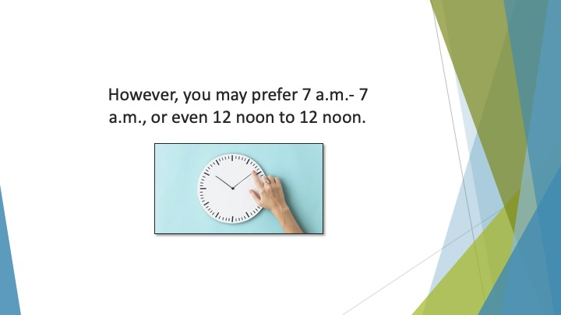
S22 : However, you may prefer 7 a.m.- 7 a.m., or even 12 noon to 12 noon.


S23 : You need to choose the right times for you as well as the right days.

