Chapter 5: A Protocol for 16:8 Intermittent Fasting

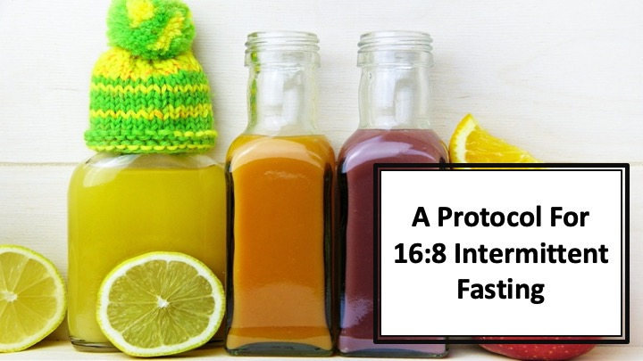
S1 : In this video, we’ll talk about “A Protocol for 16:8 Intermittent Fasting”

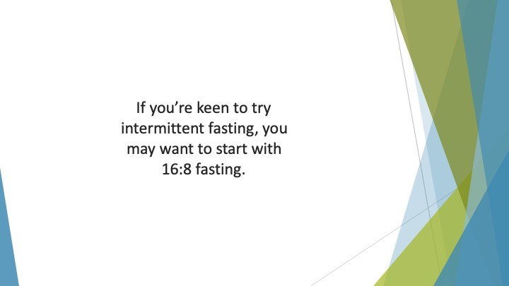
S2 : If you’re keen to try intermittent fasting, you may want to start with 16:8 fasting. This method involves fasting for 16 hours and then having an eating window of 8 hours.

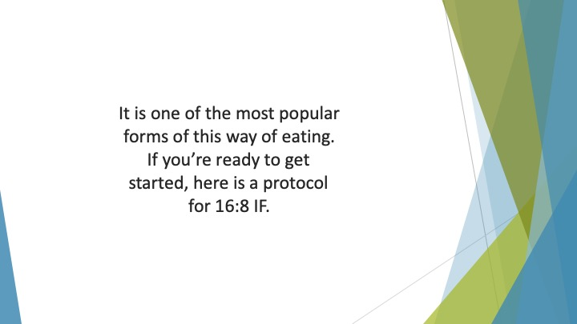
S3 : It is one of the most popular forms of this way of eating. If you’re ready to get started, here is a protocol for 16:8 IF.

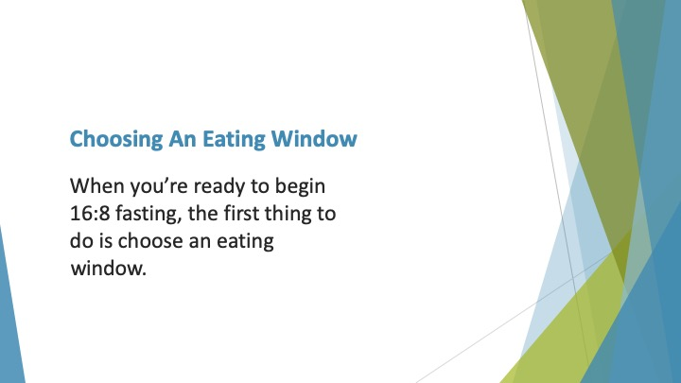
S4 : Choosing an Eating Window

When you’re ready to begin 16:8 fasting, the first thing to do is choose an eating window. This 8-hour period can be at any time of the day.

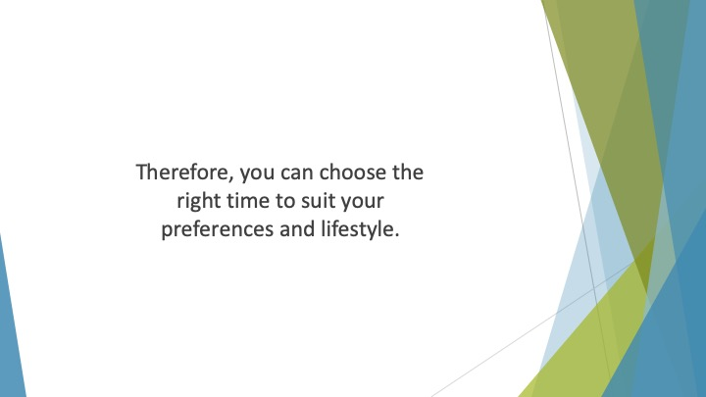
S5 : Therefore, you can choose the right time to suit your preferences and lifestyle. When you have chosen your preferred eight hours, you must limit your consumption of food to those hours.

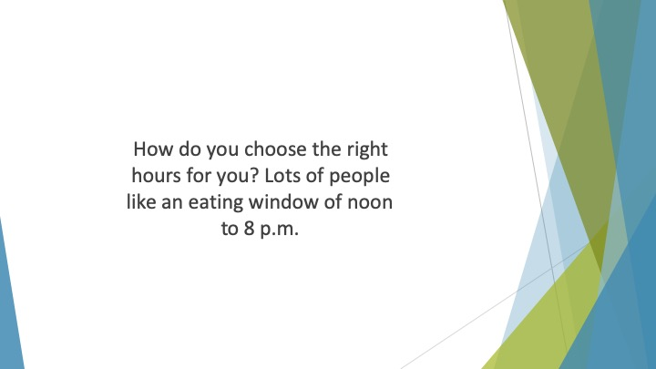
S6 : How do you choose the right hours for you? Lots of people like an eating window of noon to 8 p.m. This is because they can fast overnight, skip breakfast and then enjoy lunch and dinner at the usual times.

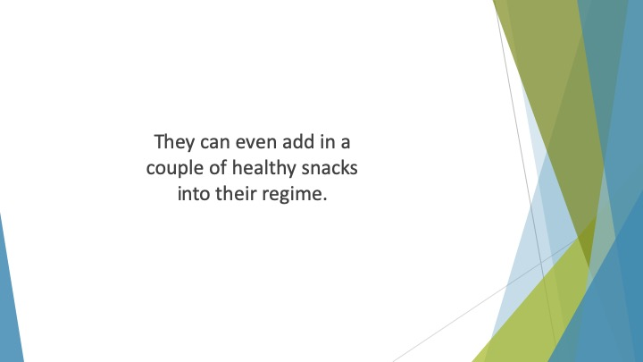
S7 : They can even add in a couple of healthy snacks into their regime.

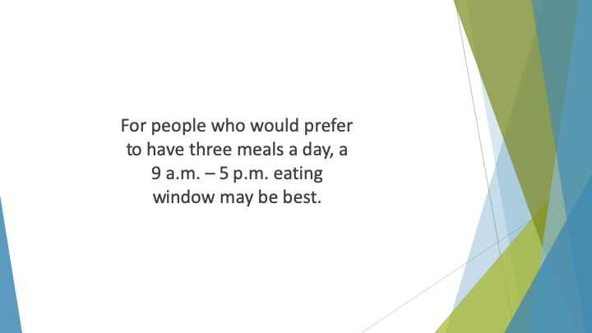
S8 : For people who would prefer to have three meals a day, a 9 a.m. – 5 p.m. eating window may be best. This allows for breakfast at 9 a.m., lunch at noon then an early dinner at 4 p.m.

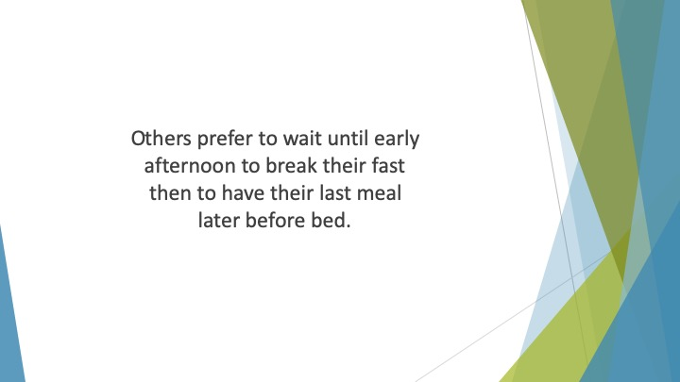
S9 : Others prefer to wait until early afternoon to break their fast then to have their last meal later before bed.

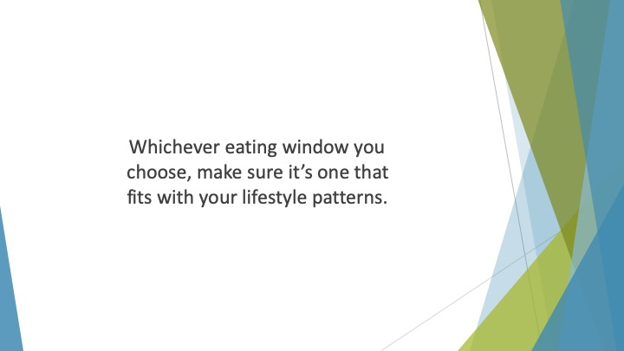
S10 : Whichever eating window you choose, make sure it’s one that fits with your lifestyle patterns.

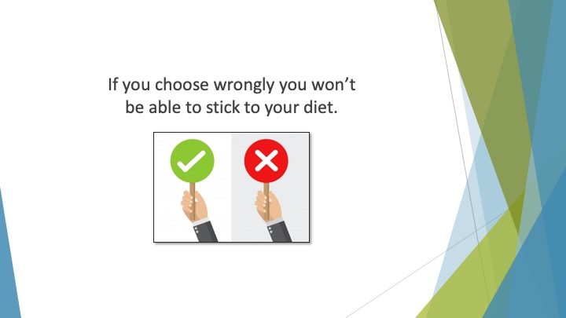
S11 : If you choose wrongly you won’t be able to stick to your diet.

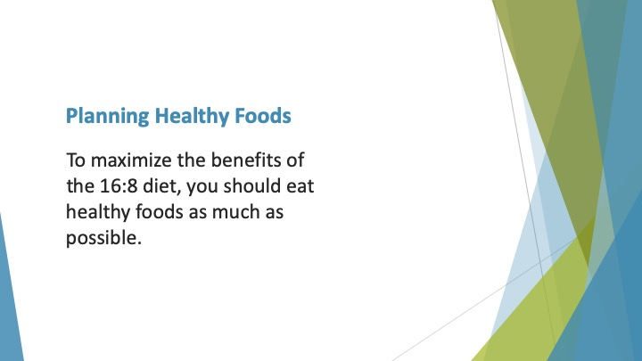
S12 : Planning Healthy Foods

To maximize the benefits of the 16:8 diet, you should eat healthy foods as much as possible. If you fill up on foods that are rich in nutrients, you won’t be hungry or crave unhealthy foods.

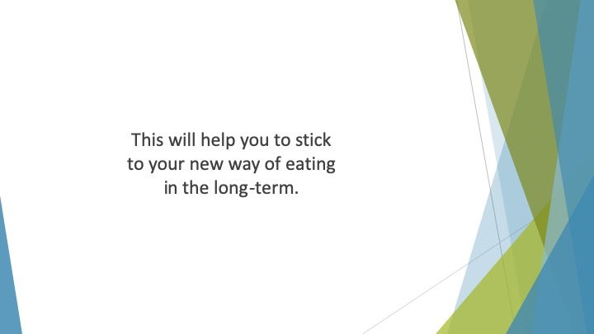
S13 : This will help you to stick to your new way of eating in the long-term.

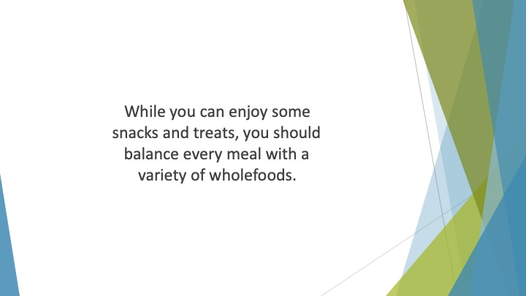
S14 : While you can enjoy some snacks and treats, you should balance every meal with a variety of wholefoods.

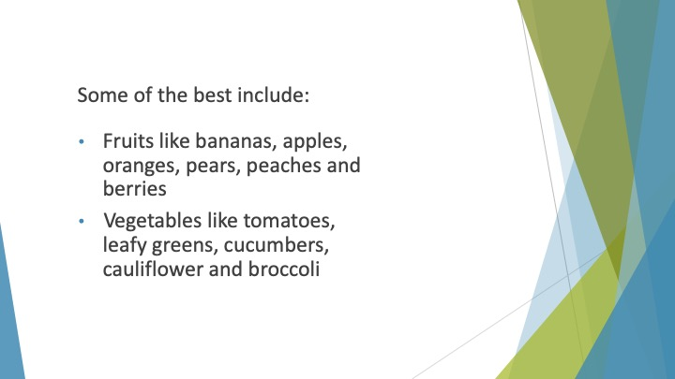
S15 : Some of the best include:

• Fruits like bananas, apples, oranges, pears, peaches and berries
• Vegetables like tomatoes, leafy greens, cucumbers, cauliflower and broccoli

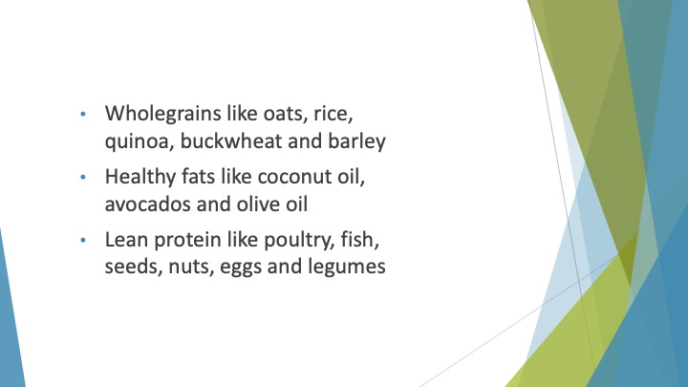
S16 : • Wholegrains like oats, rice, quinoa, buckwheat and barley
• Healthy fats like coconut oil, avocados and olive oil
• Lean protein like poultry, fish, seeds, nuts, eggs and legumes

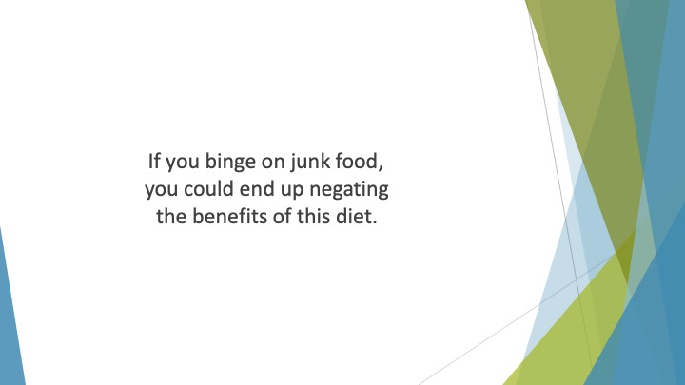
S17 : If you binge on junk food, you could end up negating the benefits of this diet.

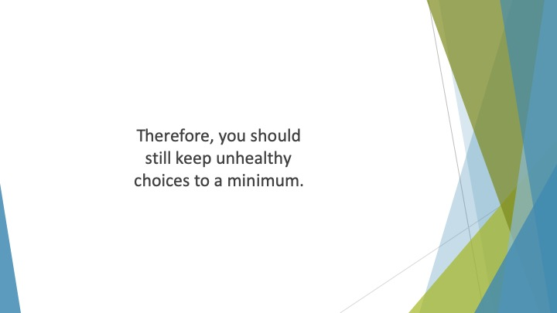
S18 : Therefore, you should still keep unhealthy choices to a minimum.

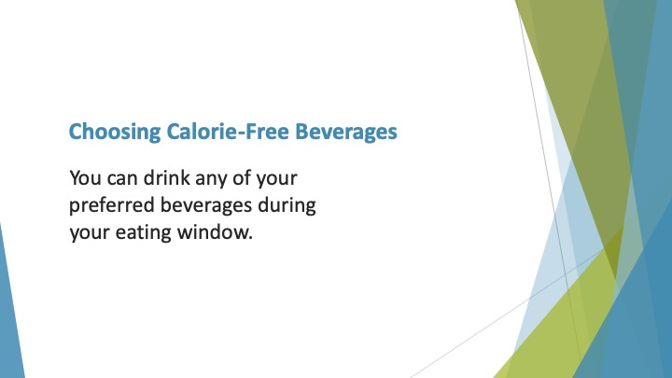
S19 : Choosing Calorie-Free Beverages

You can drink any of your preferred beverages during your eating window. At least within reason!

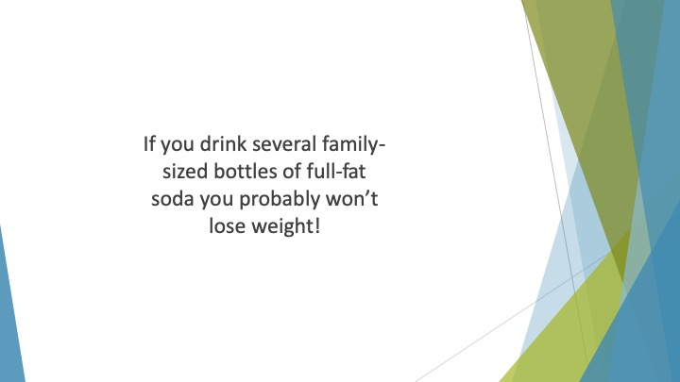
S20 : If you drink several family-sized bottles of full-fat soda you probably won’t lose weight!

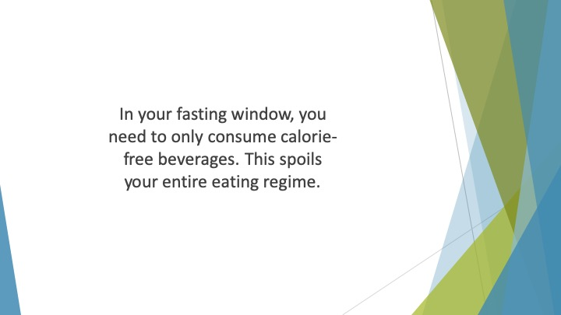
S21 : In your fasting window, you need to only consume calorie-free beverages. If you consume any beverage containing calories you are essentially breaking your fast. This spoils your entire eating regime.

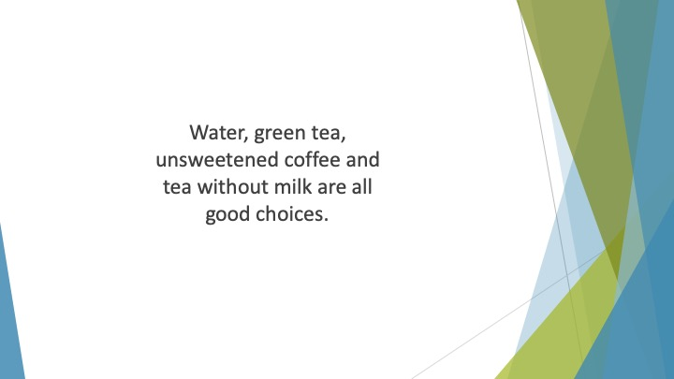
S22 : Water, green tea, unsweetened coffee and tea without milk are all good choices. They will also help you to control your appetite and keep you hydrated until you break your fast.

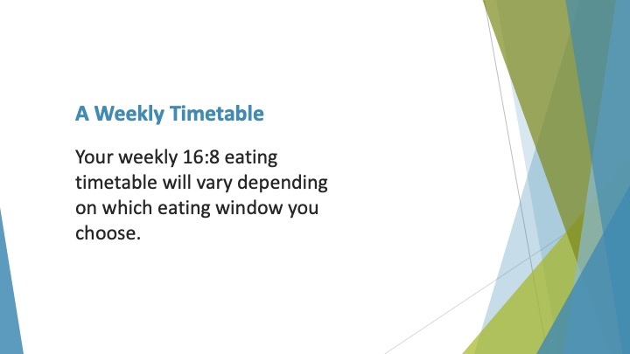
S23 : A Weekly Timetable

Your weekly 16:8 eating timetable will vary depending on which eating window you choose.

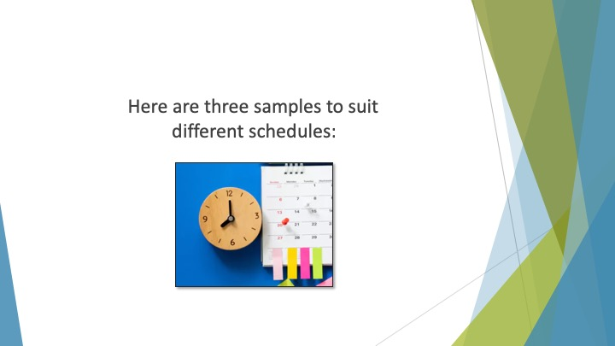
S24 : Here are three samples to suit different schedules:

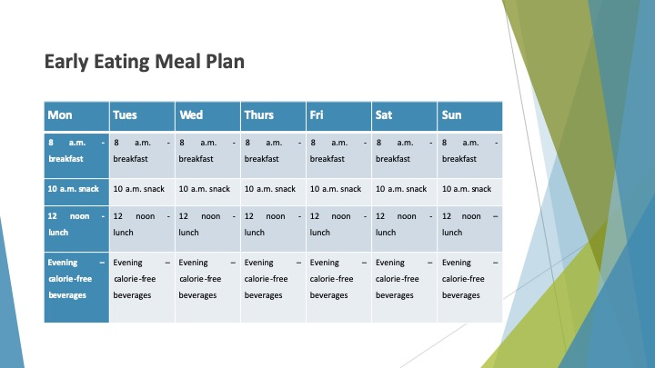
S25 : Early Eating Meal Plan
Mon | Tues | Wed | Thurs | Fri | Sat | Sun
8 a.m. - breakfast | 8 a.m. - breakfast | 8 a.m. - breakfast | 8 a.m. - breakfast | 8 a.m. - breakfast | 8 a.m. - breakfast | 8 a.m. - breakfast
10 a.m. snack | 10 a.m. snack | 10 a.m. snack | 10 a.m. snack | 10 a.m. snack | 10 a.m. snack | 10 a.m. snack
12 noon - lunch | 12 noon - lunch | 12 noon - lunch | 12 noon - lunch | 12 noon - lunch | 12 noon - lunch | 12 noon – lunch
Evening – calorie-free beverages | Evening – calorie-free beverages | Evening – calorie-free beverages | Evening – calorie-free beverages | Evening – calorie-free beverages | Evening – calorie-free beverages | Evening – calorie-free beverages

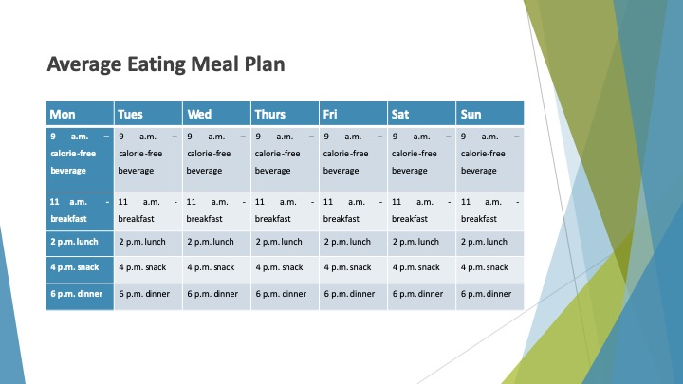
S26 : Average Eating Meal Plan
Mon | Tues | Wed | Thurs | Fri | Sat | Sun
9 a.m. – calorie-free beverage | 9 a.m. – calorie-free beverage | 9 a.m. – calorie-free beverage | 9 a.m. – calorie-free beverage | 9 a.m. – calorie-free beverage | 9 a.m. – calorie-free beverage | 9 a.m. – calorie-free beverage
11 a.m. - breakfast | 11 a.m. - breakfast | 11 a.m. - breakfast | 11 a.m. - breakfast | 11 a.m. - breakfast | 11 a.m. - breakfast | 11 a.m. - breakfast
2 p.m. lunch | 2 p.m. lunch | 2 p.m. lunch | 2 p.m. lunch | 2 p.m. lunch | 2 p.m. lunch | 2 p.m. lunch
4 p.m. snack | 4 p.m. snack | 4 p.m. snack | 4 p.m. snack | 4 p.m. snack | 4 p.m. snack | 4 p.m. snack
6 p.m. dinner | 6 p.m. dinner | 6 p.m. dinner | 6 p.m. dinner | 6 p.m. dinner | 6 p.m. dinner | 6 p.m. dinner

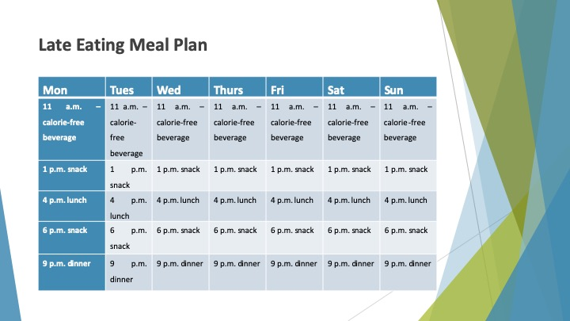
S27 : Late Eating Meal Plan
Mon | Tues | Wed | Thurs | Fri | Sat | Sun
11 a.m. – calorie-free beverage | 11 a.m. – calorie-free beverage | 11 a.m. – calorie-free beverage | 11 a.m. – calorie-free beverage | 11 a.m. – calorie-free beverage | 11 a.m. – calorie-free beverage | 11 a.m. – calorie-free beverage
1 p.m. snack | 1 p.m. snack | 1 p.m. snack | 1 p.m. snack | 1 p.m. snack | 1 p.m. snack | 1 p.m. snack
4 p.m. lunch | 4 p.m. lunch | 4 p.m. lunch | 4 p.m. lunch | 4 p.m. lunch | 4 p.m. lunch | 4 p.m. lunch
6 p.m. snack | 6 p.m. snack | 6 p.m. snack | 6 p.m. snack | 6 p.m. snack | 6 p.m. snack | 6 p.m. snack
9 p.m. dinner | 9 p.m. dinner | 9 p.m. dinner | 9 p.m. dinner | 9 p.m. dinner | 9 p.m. dinner | 9 p.m. dinner

