Chapter 4: Is Intermittent Fasting Safe?

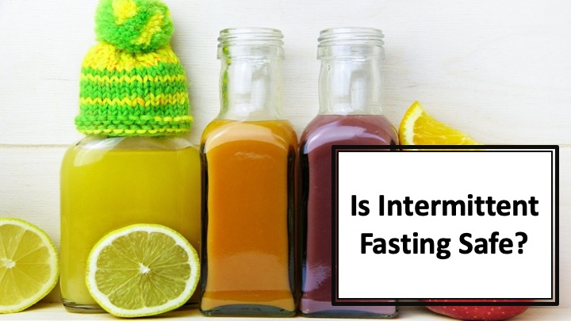
S1 : In this video, we’ll discuss about “Is Intermittent Fasting Safe?”

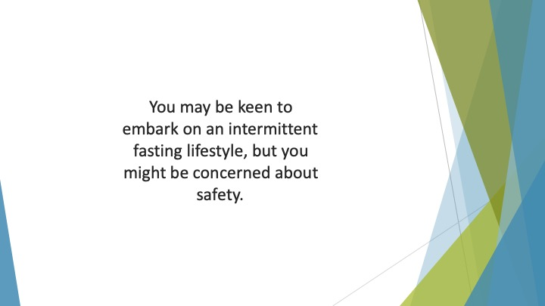
S2 : You may be keen to embark on an intermittent fasting lifestyle, but you might be concerned about safety. After all, not every diet is suitable for everyone.

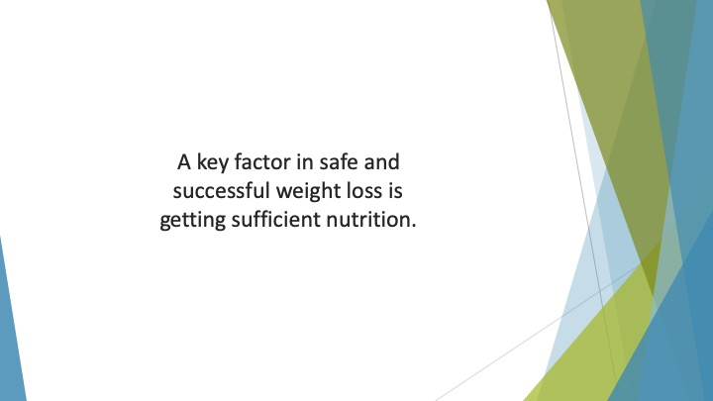
S3 : A key factor in safe and successful weight loss is getting sufficient nutrition. If you don’t get enough minerals, vitamins and protein, you could become ill.

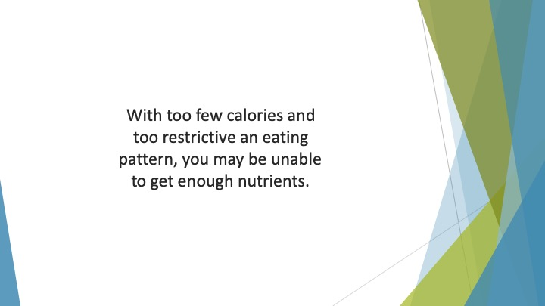
S4 : With too few calories and too restrictive an eating pattern, you may be unable to get enough nutrients. This may cause you to have medical issues.

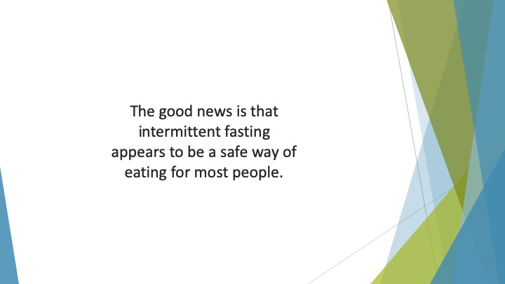
S5 : The good news is that intermittent fasting appears to be a safe way of eating for most people.

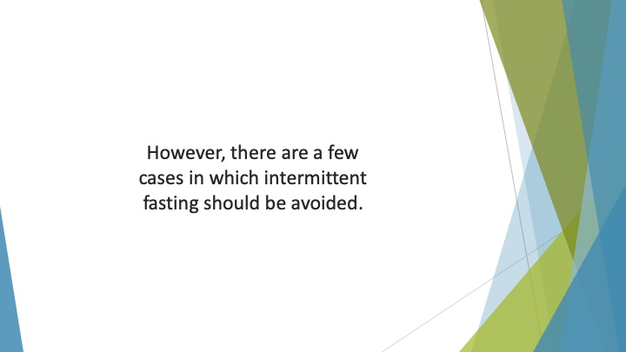
S6 : However, there are a few cases in which intermittent fasting should be avoided.

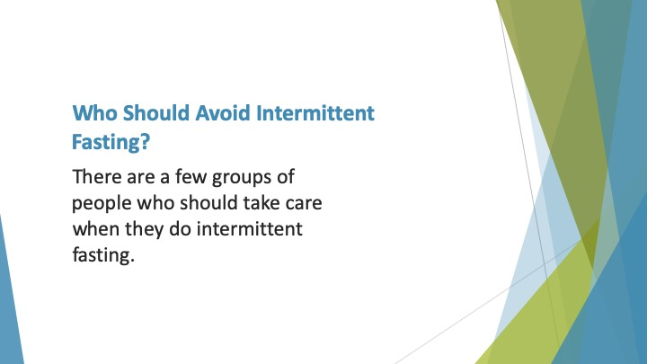
S7 : Who Should Avoid Intermittent Fasting?

There are a few groups of people who should take care when they do intermittent fasting.

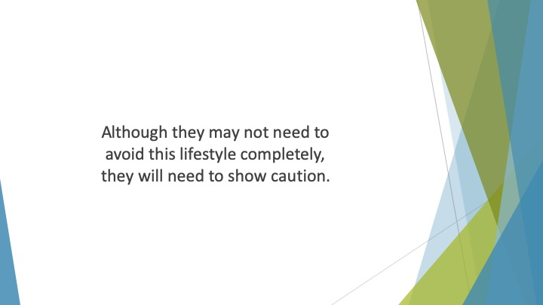
S8 : Although they may not need to avoid this lifestyle completely, they will need to show caution.


S9 : The first is children. Children are growing and developing. They therefore need to eat enough calories every day.

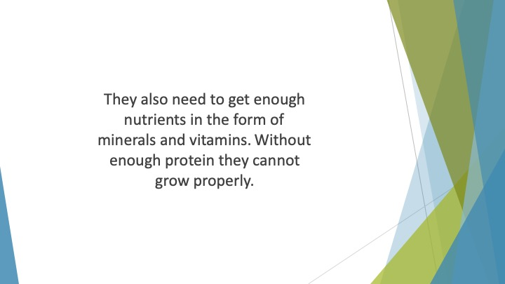
S10 : They also need to get enough nutrients in the form of minerals and vitamins. Without enough protein they cannot grow properly. This could lead to a host of problems.

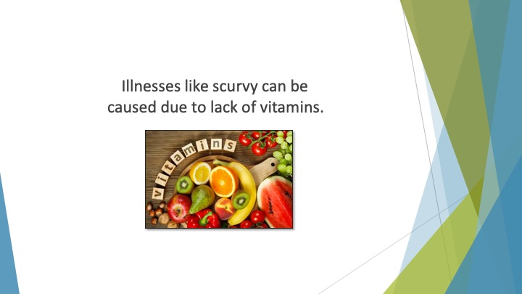
S11 : Illnesses like scurvy can be caused due to lack of vitamins.

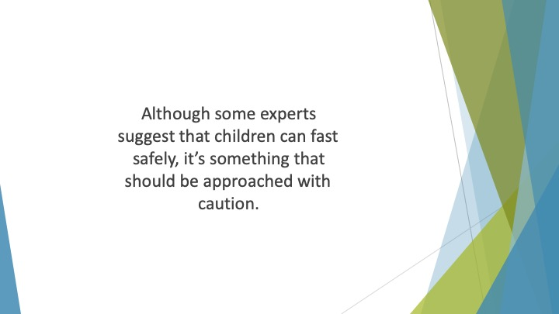
S12 : Although some experts suggest that children can fast safely, it’s something that should be approached with caution.

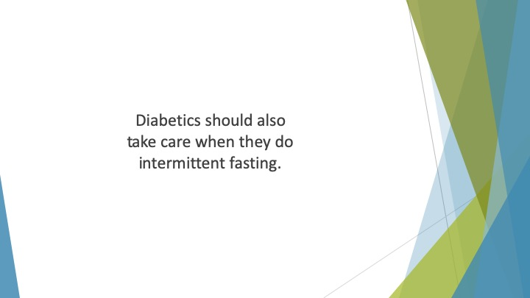
S13 : Diabetics should also take care when they do intermittent fasting. It’s true to say that IF has a number of potential benefits for diabetics.

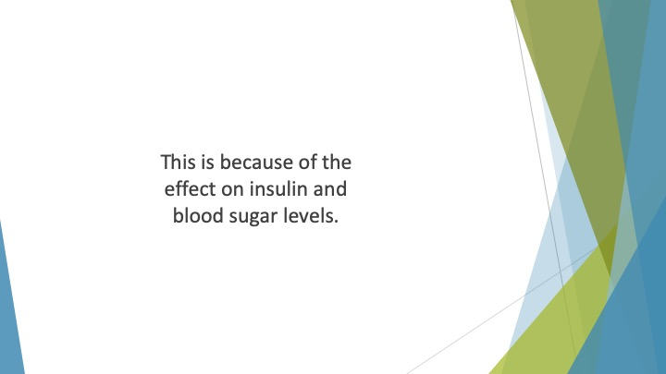
S14 : This is because of the effect on insulin and blood sugar levels.

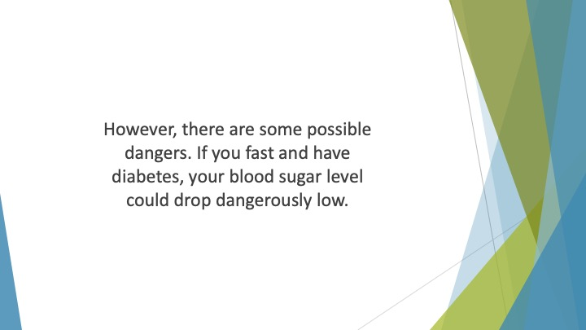
S15 : However, there are some possible dangers. If you fast and have diabetes, your blood sugar level could drop dangerously low. This is especially likely if you’re taking medication to control the condition.

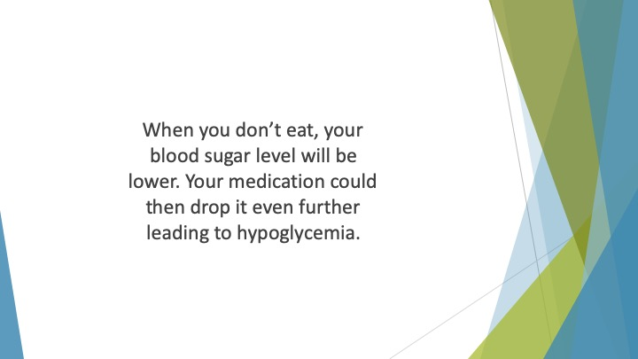
S16 : When you don’t eat, your blood sugar level will be lower. Your medication could then drop it even further leading to hypoglycemia. This can make you pass out, feel shaky or go into a coma.

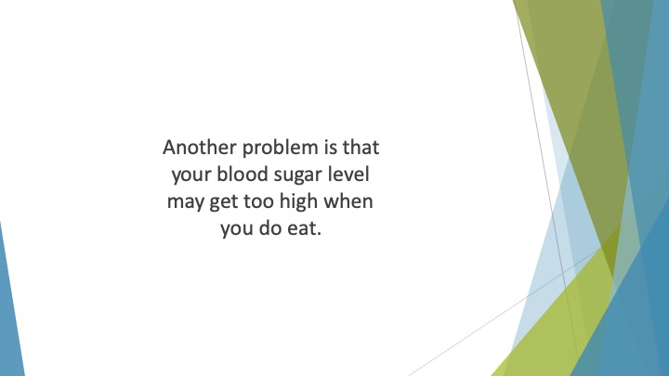
S17 : Another problem is that your blood sugar level may get too high when you do eat.

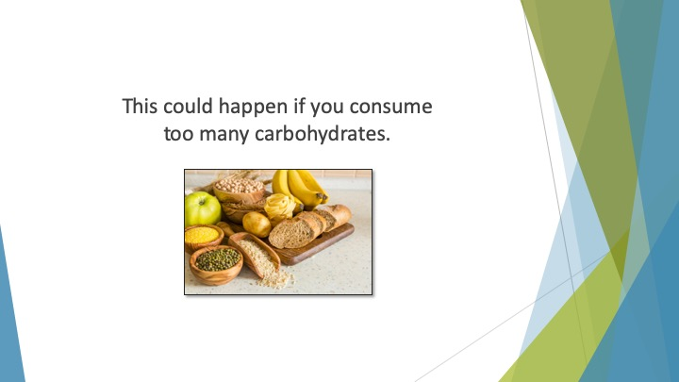
S18 : This could happen if you consume too many carbohydrates.

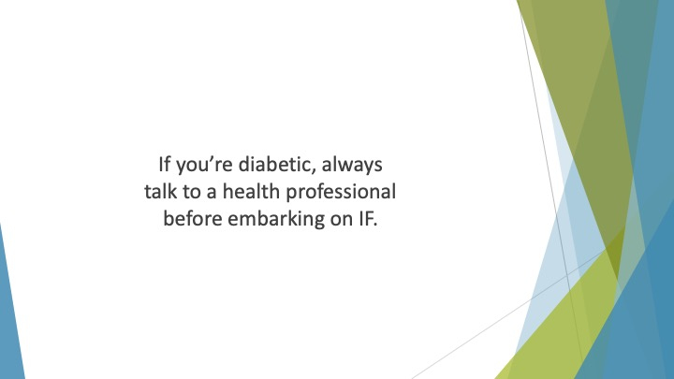
S19 : If you’re diabetic, always talk to a health professional before embarking on IF. You will also need to be more aware of the symptoms of low blood sugar.

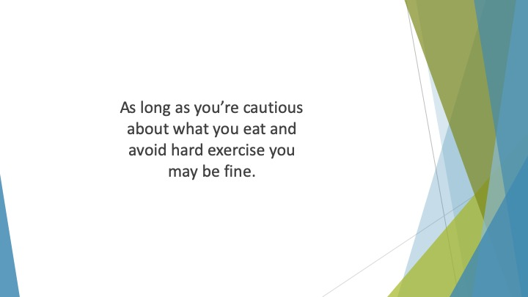
S20 : As long as you’re cautious about what you eat and avoid hard exercise you may be fine.

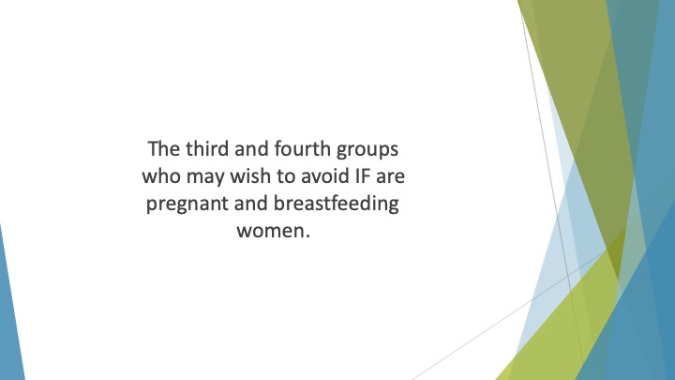
S21 : The third and fourth groups who may wish to avoid IF are pregnant and breastfeeding women. Doctors usually recommend that these groups don’t try intermittent fasting.

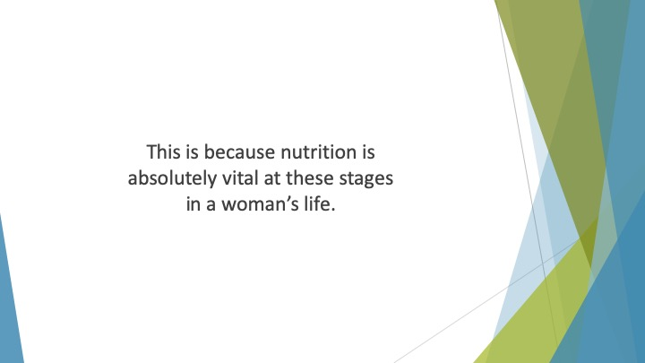
S22 : This is because nutrition is absolutely vital at these stages in a woman’s life. Not only is she feeding herself, she’s feeding her baby.

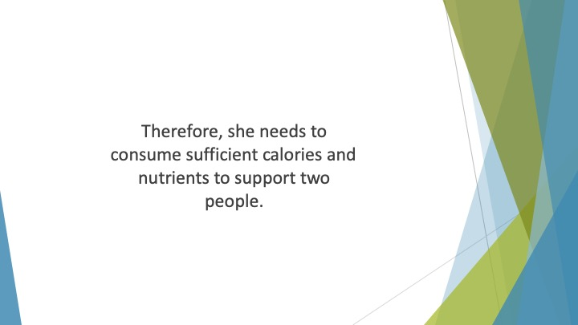
S23 : Therefore, she needs to consume sufficient calories and nutrients to support two people. This can be difficult when fasting intermittently.

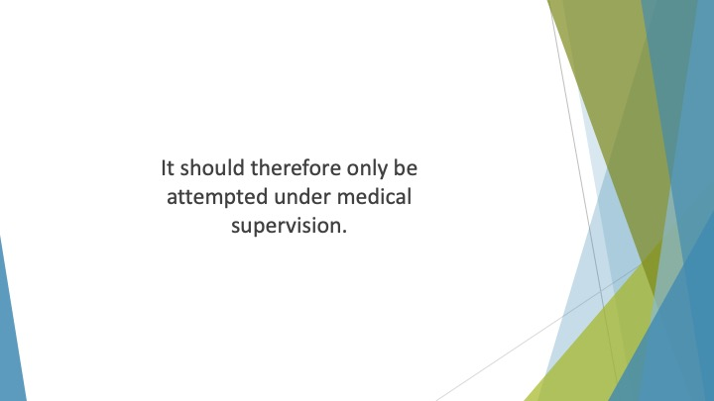
S24 : It should therefore only be attempted under medical supervision.

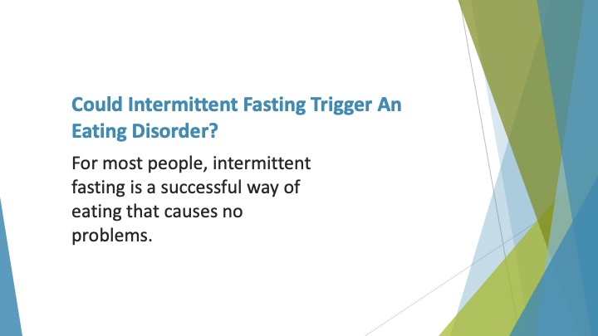
S25 : Could Intermittent Fasting Trigger an Eating Disorder?

For most people, intermittent fasting is a successful way of eating that causes no problems.

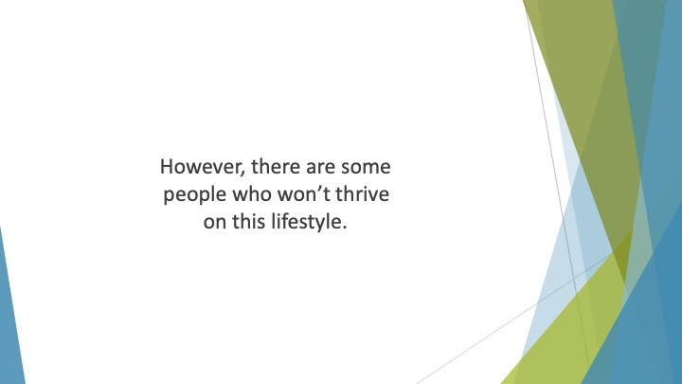
S26 : However, there are some people who won’t thrive on this lifestyle. Some people have a natural tendency to develop disordered eating behaviors.

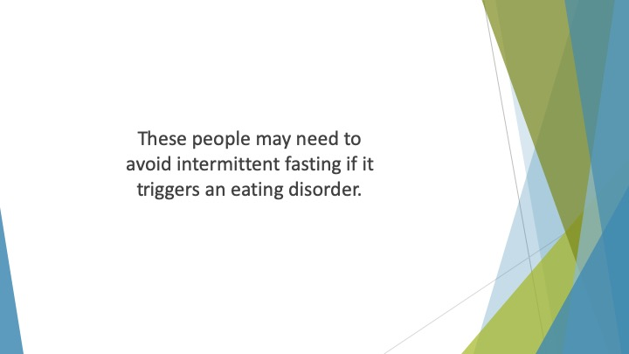
S27 : These people may need to avoid intermittent fasting if it triggers an eating disorder.

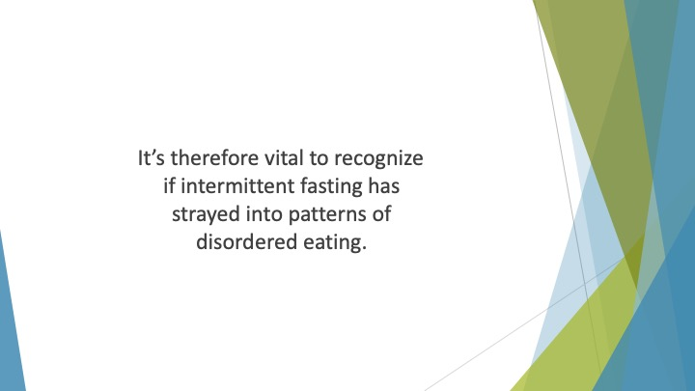
S28 : It’s therefore vital to recognize if intermittent fasting has strayed into patterns of disordered eating.

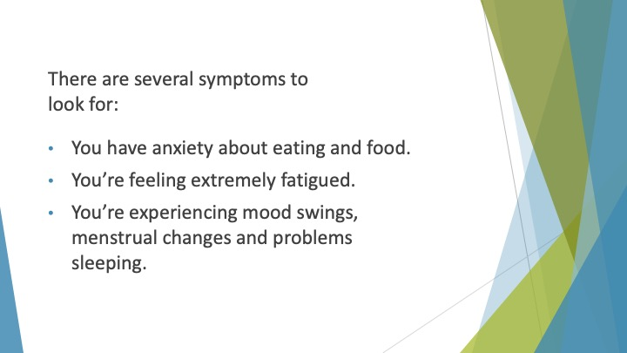
S29 : There are several symptoms to look for:

• You have anxiety about eating and food.
• You’re feeling extremely fatigued.
• You’re experiencing mood swings, menstrual changes and problems sleeping.

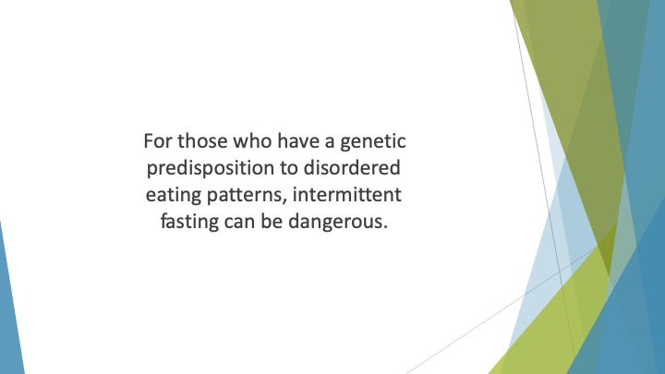
S30 : For those who have a genetic predisposition to disordered eating patterns, intermittent fasting can be dangerous. This is because there is a focus on not eating.

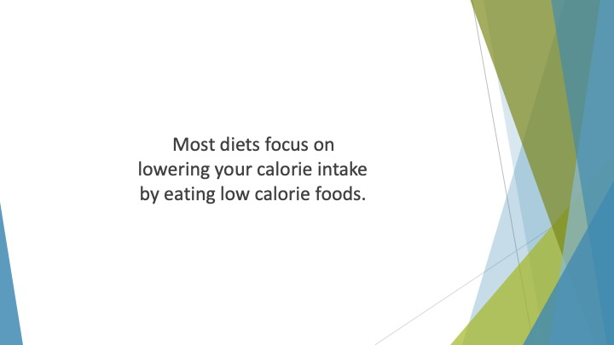
S31 : Most diets focus on lowering your calorie intake by eating low calorie foods. IF minimizes your calorie intake by avoiding eating during certain periods.

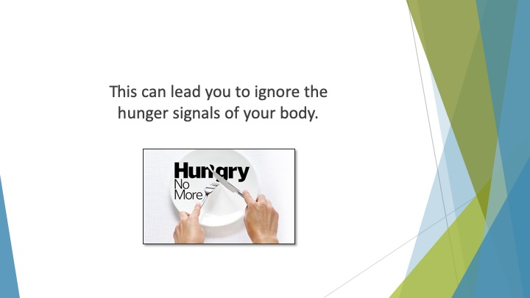
S32 : This can lead you to ignore the hunger signals of your body. Also, for someone with a tendency to develop eating disorders, you may become afraid of food due to IF.

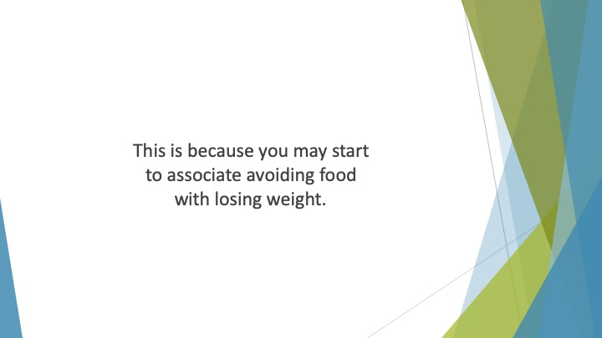
S33 : This is because you may start to associate avoiding food with losing weight.

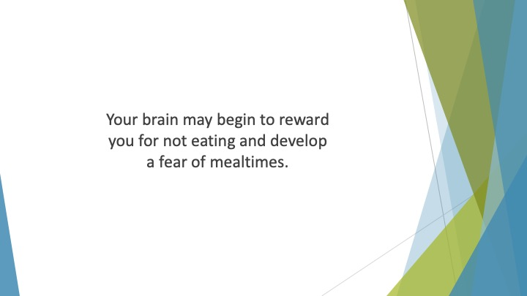
S34 : Your brain may begin to reward you for not eating and develop a fear of mealtimes.

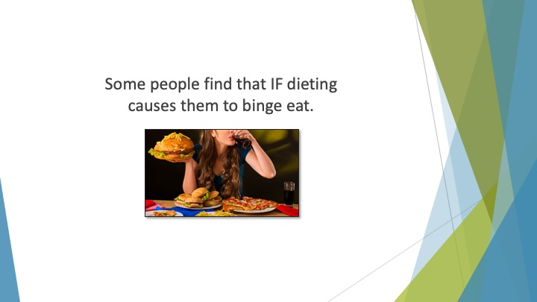
S35 : Some people find that IF dieting causes them to binge eat. When they are in their eating window they end up over-indulging on high calorie foods.

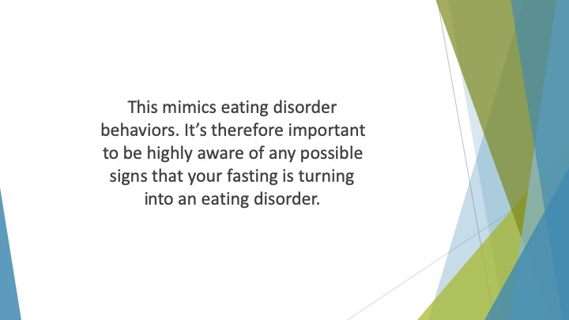
S36 : This mimics eating disorder behaviors. It’s therefore important to be highly aware of any possible signs that your fasting is turning into an eating disorder.

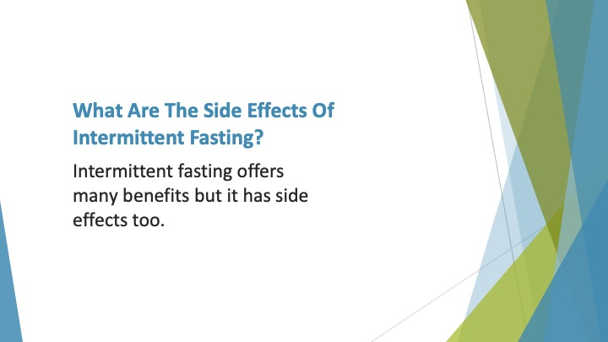
S37 : What are the Side Effects of Intermittent Fasting?

Intermittent fasting offers many benefits but it has side effects too. These may affect each individual differently.

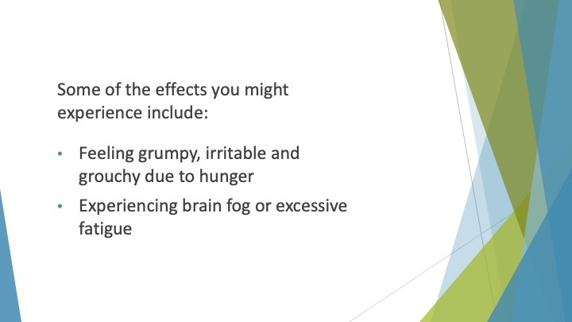
S38 : Some of the effects you might experience include:

• Feeling grumpy, irritable and grouchy due to hunger
• Experiencing brain fog or excessive fatigue

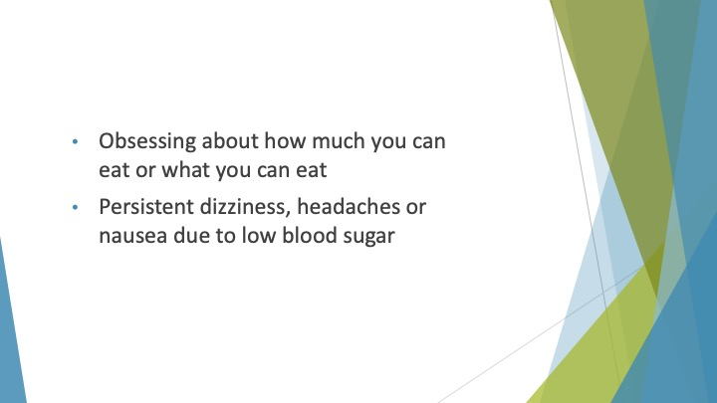
S39 : • Obsessing about how much you can eat or what you can eat
• Persistent dizziness, headaches or nausea due to low blood sugar

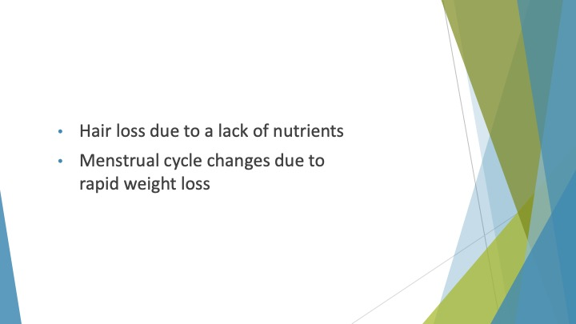
S40 : • Hair loss due to a lack of nutrients
• Menstrual cycle changes due to rapid weight loss

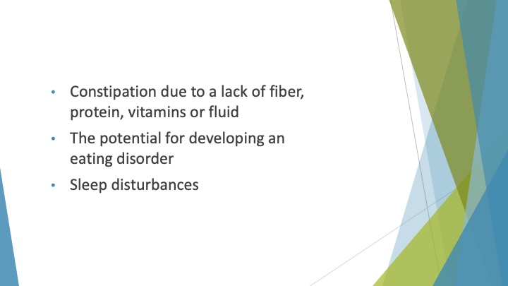
S41 : • Constipation due to a lack of fiber, protein, vitamins or fluid
• The potential for developing an eating disorder
• Sleep disturbances

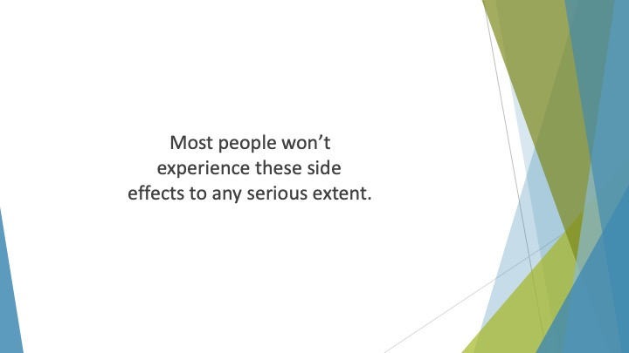
S42 : Most people won’t experience these side effects to any serious extent.

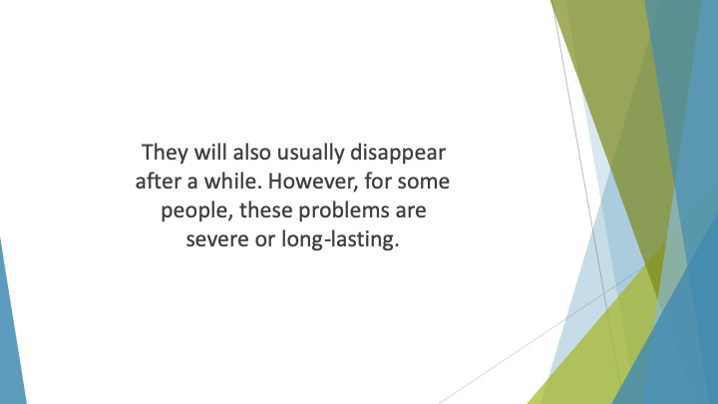
S43 : They will also usually disappear after a while. However, for some people, these problems are severe or long-lasting. If so, you may want to stop intermittent fasting until you seek medical advice.

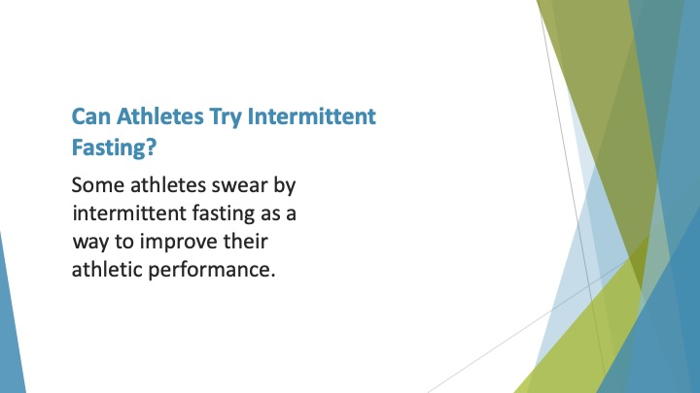
S44 : Can Athletes try Intermittent Fasting?

Some athletes swear by intermittent fasting as a way to improve their athletic performance.

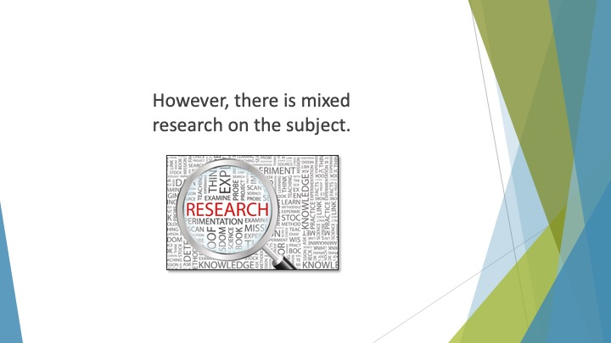
S45 : However, there is mixed research on the subject. Some evidence suggests that if you don’t consume enough carbohydrates, the duration and intensity of your training will suffer.

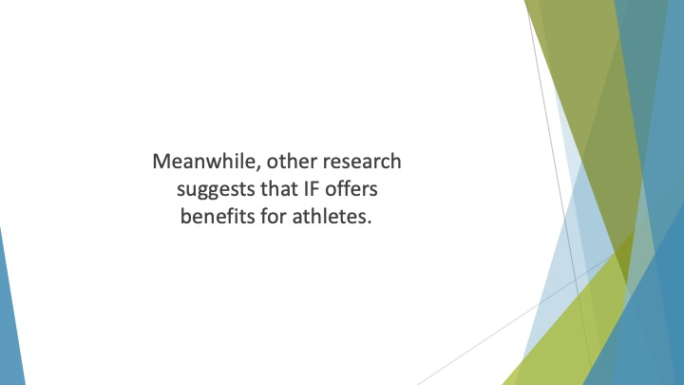
S46 : Meanwhile, other research suggests that IF offers benefits for athletes.

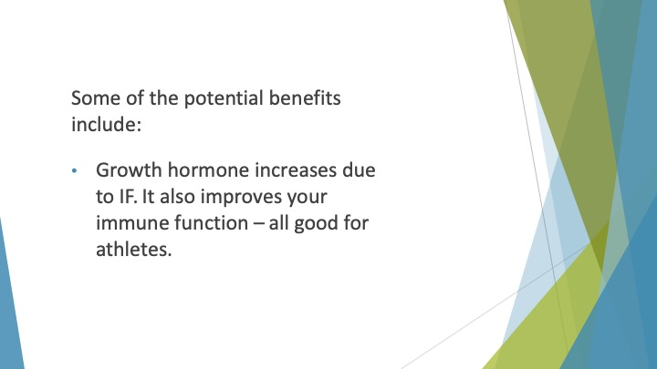
S47 : Some of the potential benefits include:

• Growth hormone increases due to IF. This helps to boost muscle, cartilage and bone growth. It also improves your immune function – all good for athletes.

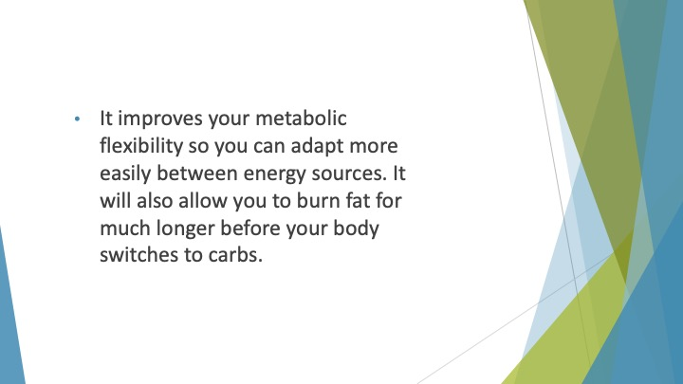
S48 : • It improves your metabolic flexibility so you can adapt more easily between energy sources. Your body will be better able to use carbs or fat as a source of fuel. It will also allow you to burn fat for much longer before your body switches to carbs. As a result, your insulin will stay low and your post-exercise recovery will improve.

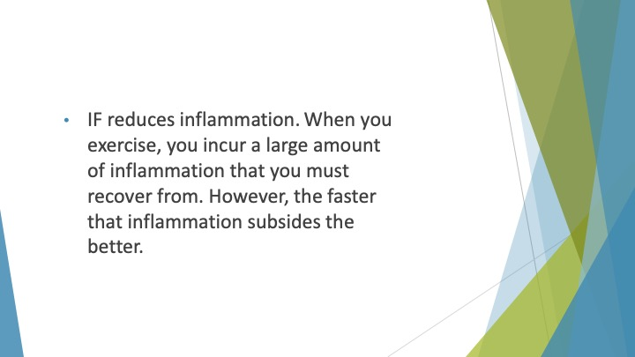
S49 : • IF reduces inflammation. This aids your post-exercise recovery. When you exercise, you incur a large amount of inflammation that you must recover from. However, the faster that inflammation subsides the better. IF can speed the process up.

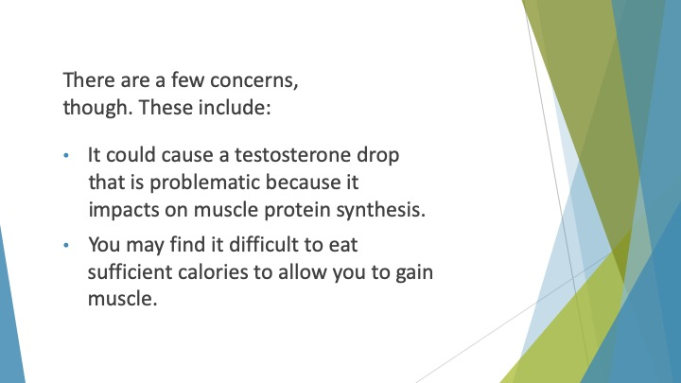
S50 : There are a few concerns, though. These include:

• It could cause a testosterone drop that is problematic because it impacts on muscle protein synthesis.
• You may find it difficult to eat sufficient calories to allow you to gain muscle.

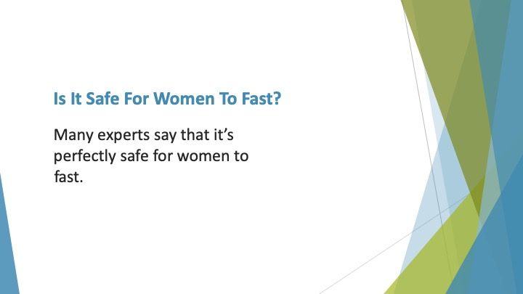
S51 : Is it Safe for Women to Fast?

Many experts say that it’s perfectly safe for women to fast.

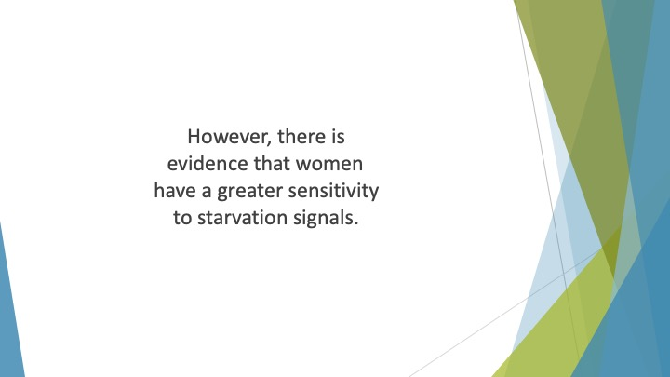
S52 : However, there is evidence that women have a greater sensitivity to starvation signals. When the body senses starvation, it increases production of ghrelin and leptin, the hunger hormones.

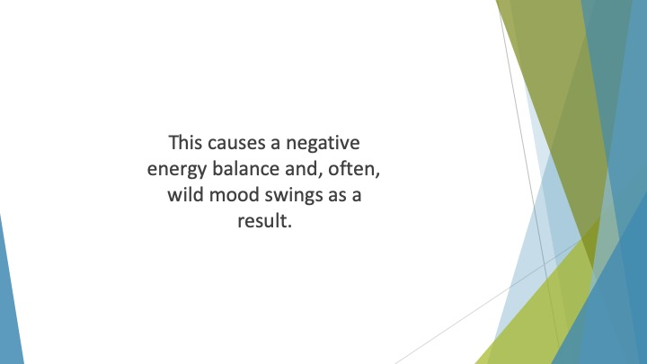
S53 : This causes a negative energy balance and, often, wild mood swings as a result.

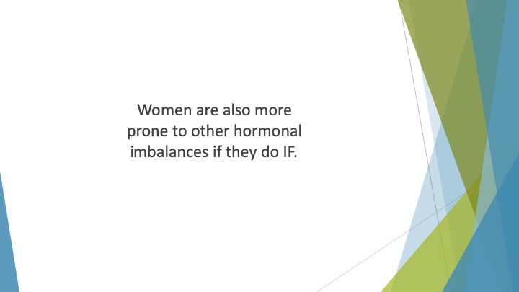
S54 : Women are also more prone to other hormonal imbalances if they do IF. This can cause menstrual cycle difficulties. It may also interfere with the production of the thyroid hormone.

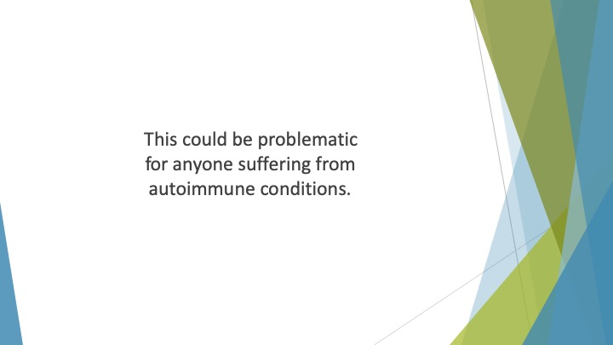
S55 : This could be problematic for anyone suffering from autoimmune conditions.

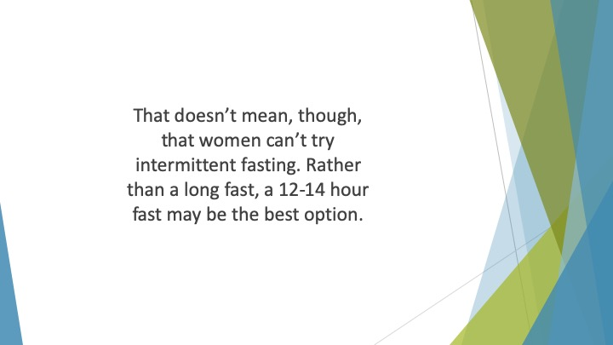
S56 : That doesn’t mean, though, that women can’t try intermittent fasting. It only means that they need to take more care. It may be better for women to begin with a gentler form of IF. Rather than a long fast, a 12-14 hour fast may be the best option.

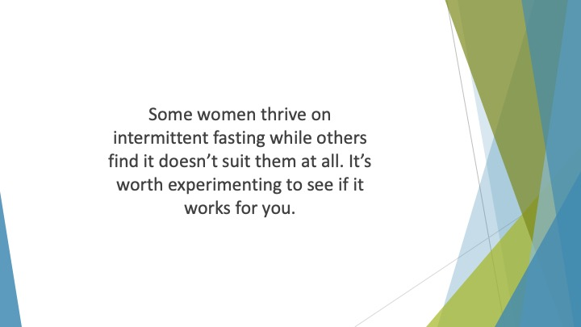
S57 : Some women thrive on intermittent fasting while others find it doesn’t suit them at all. It’s worth experimenting to see if it works for you.

