Chapter 3: Why Does Intermittent Fasting Help to Promote Weight Loss?


S1 : In this video, we’ll learn about “Why Does Intermittent Fasting Help to Promote Weight Loss?”

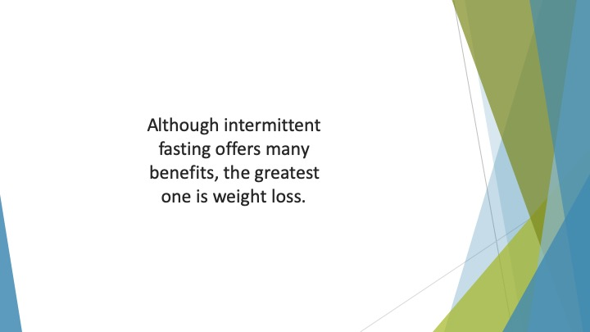
S2 : Although intermittent fasting offers many benefits, the greatest one is weight loss. Most people who embark on this lifestyle are hoping to shed pounds and maintain a healthy bodyweight.

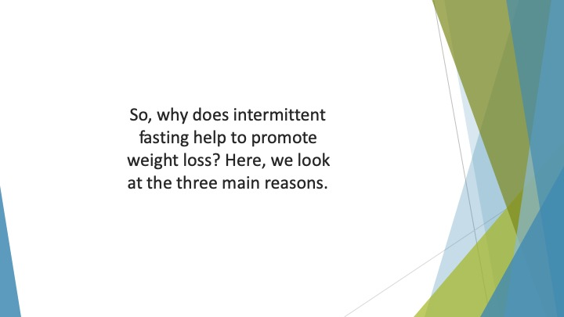
S3 : So, why does intermittent fasting help to promote weight loss? Here, we look at the three main reasons.

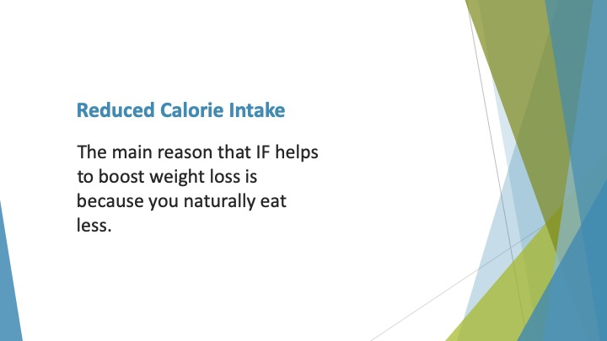
S4 : Reduced Calorie Intake

The main reason that IF helps to boost weight loss is because you naturally eat less. When you only have a short eating window, you have less time to eat.


S5 : Usually, you’ll miss at least one meal per day in order to accommodate this schedule.

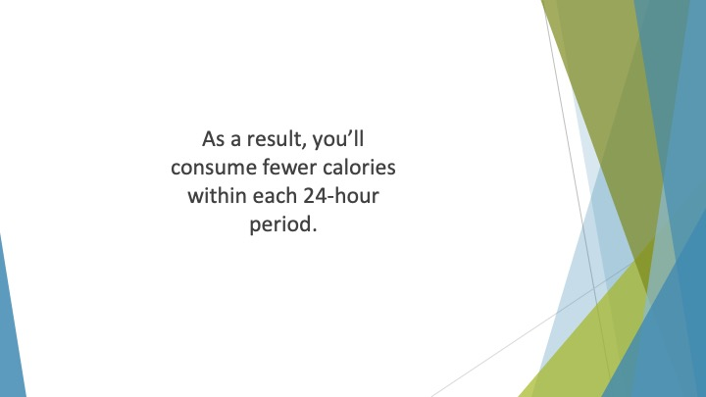
S6 : As a result, you’ll consume fewer calories within each 24-hour period. As you know, you must maintain a calorie deficit to shed weight.

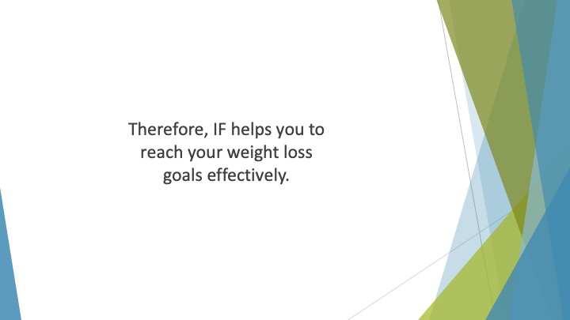
S7 : Therefore, IF helps you to reach your weight loss goals effectively.

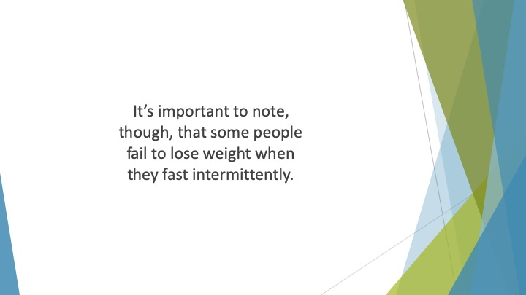
S8 : It’s important to note, though, that some people fail to lose weight when they fast intermittently. This is because they don’t reduce their calorie intake.

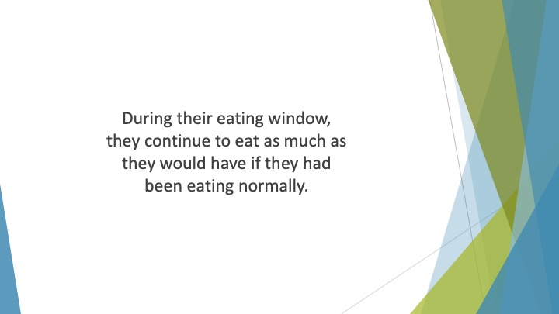
S9 : During their eating window, they continue to eat as much as they would have if they had been eating normally.

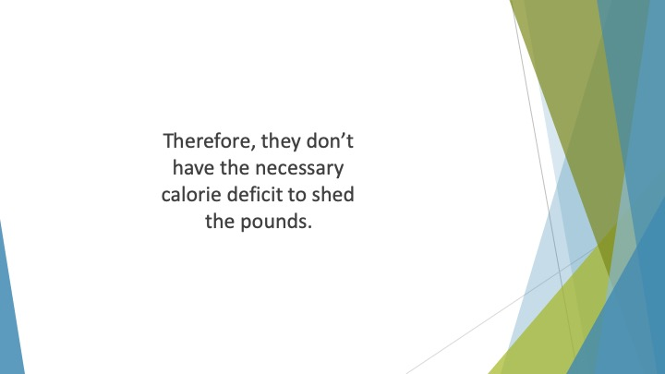
S10 : Therefore, they don’t have the necessary calorie deficit to shed the pounds.

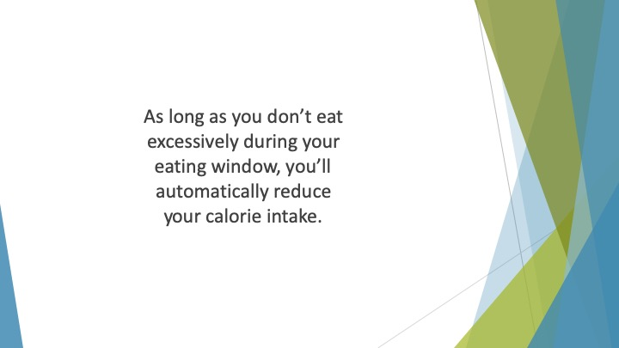
S11 : As long as you don’t eat excessively during your eating window, you’ll automatically reduce your calorie intake.

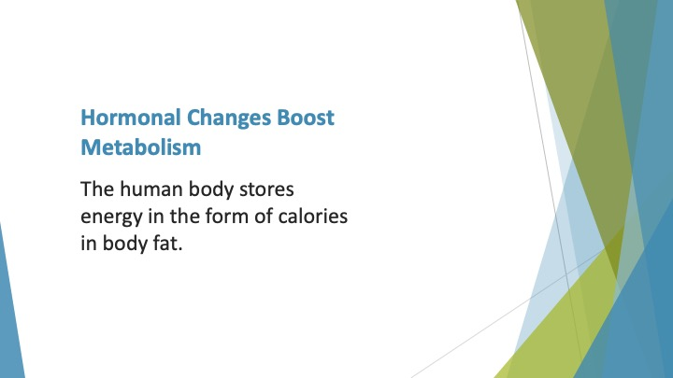
S12 : Hormonal Changes Boost Metabolism

The human body stores energy in the form of calories in body fat. If you don’t eat, your body changes a number of things so that stored energy can be more accessible.

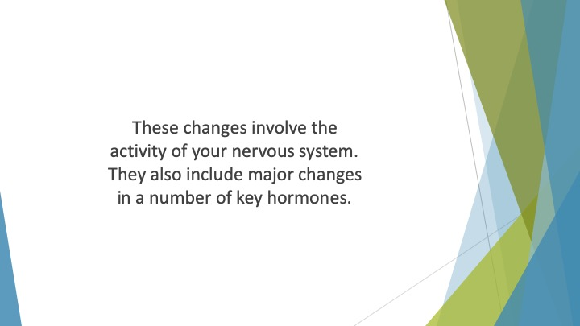
S13 : These changes involve the activity of your nervous system. They also include major changes in a number of key hormones.

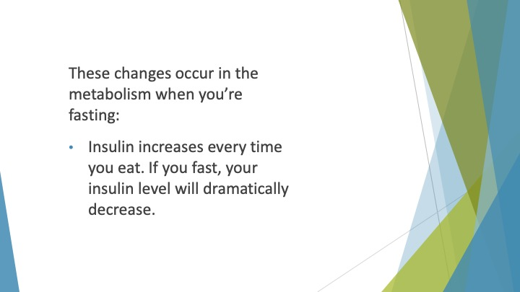
S14 : These changes occur in the metabolism when you’re fasting:

• Insulin increases every time you eat. If you fast, your insulin level will dramatically decrease. A lower insulin level facilitates fat burning.

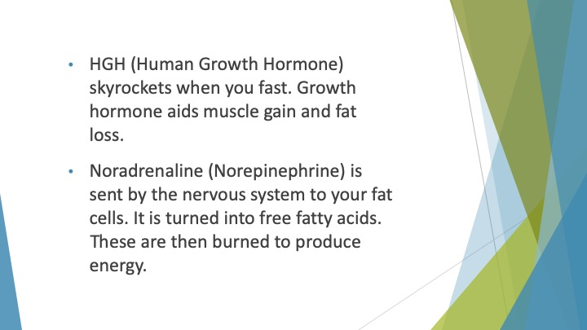
S15 : • HGH (Human Growth Hormone) skyrockets when you fast. It can increase by as much as five times its normal level. Growth hormone aids muscle gain and fat loss.

• Noradrenaline (Norepinephrine) is sent by the nervous system to your fat cells. This causes them to break down your body fat. It is turned into free fatty acids. These are then burned to produce energy.

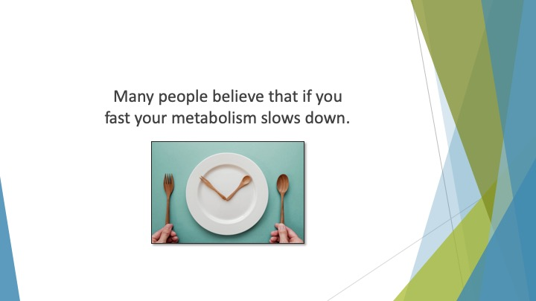
S16 : Many people believe that if you fast your metabolism slows down.

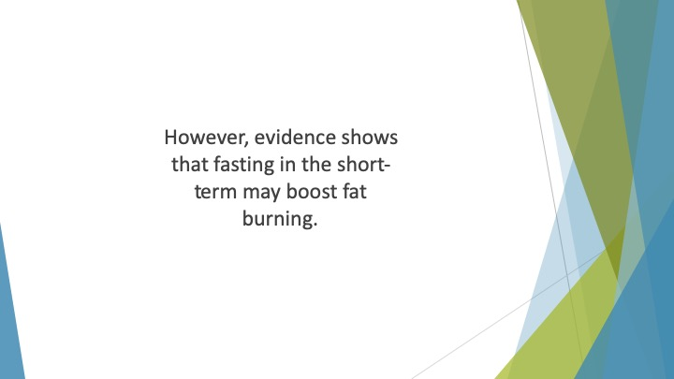
S17 : However, evidence shows that fasting in the short-term may boost fat burning. There have been two studies that have shown fasting for 48 hours increases metabolism up to 14 percent.

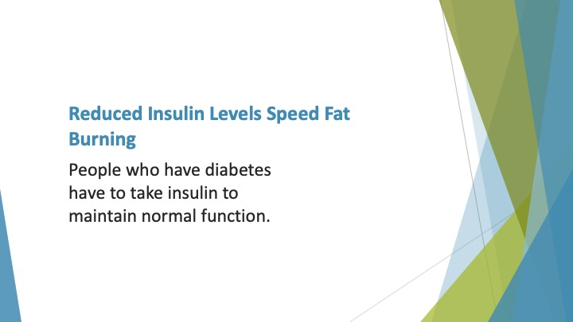
S18 : Reduced Insulin Levels Speed Fat Burning

You probably already know about insulin because of its importance for diabetics. People who have diabetes have to take insulin to maintain normal function.

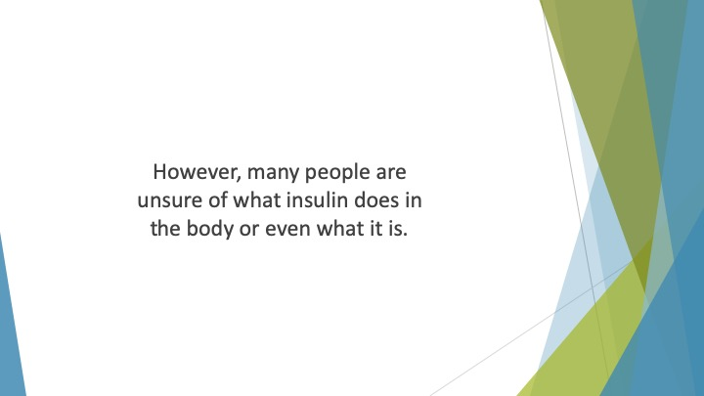
S19 : However, many people are unsure of what insulin does in the body or even what it is.

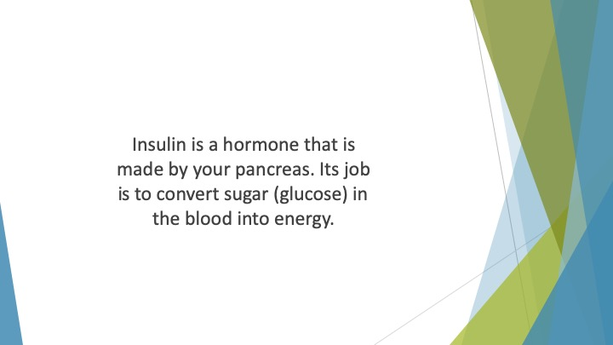
S20 : Insulin is a hormone that is made by your pancreas. Its job is to convert sugar (glucose) in the blood into energy. The cells then use that energy as fuel.

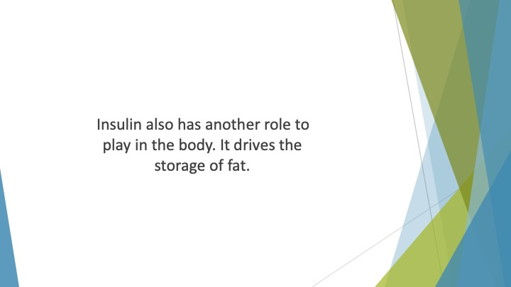
S21 : Insulin also has another role to play in the body. It drives the storage of fat.

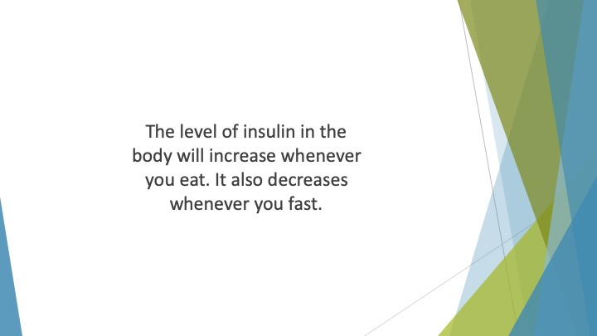
S22 : The level of insulin in the body will increase whenever you eat. It also decreases whenever you fast. The lower level of insulin caused when you fast can help to prevent excess storage of fat.

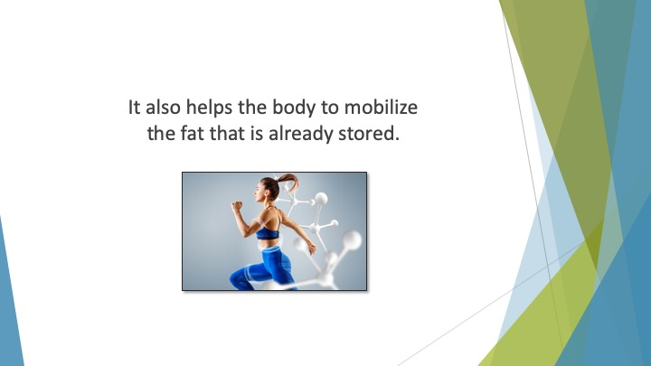
S23 : It also helps the body to mobilize the fat that is already stored.

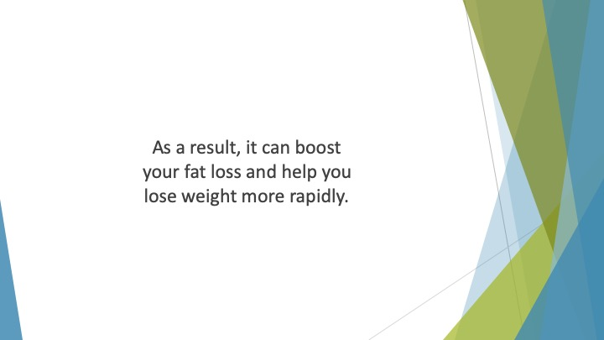
S24 : As a result, it can boost your fat loss and help you lose weight more rapidly.

