Chapter 2: The Benefits of Intermittent Fasting

S1 : In this video, we’ll talk about “The Benefits of Intermittent Fasting”

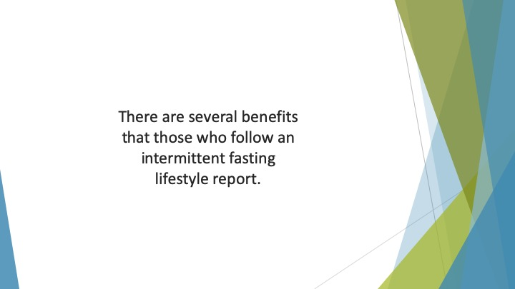
S2 : There are several benefits that those who follow an intermittent fasting lifestyle report.


S3 : Here, we take a closer look at some of the most common.

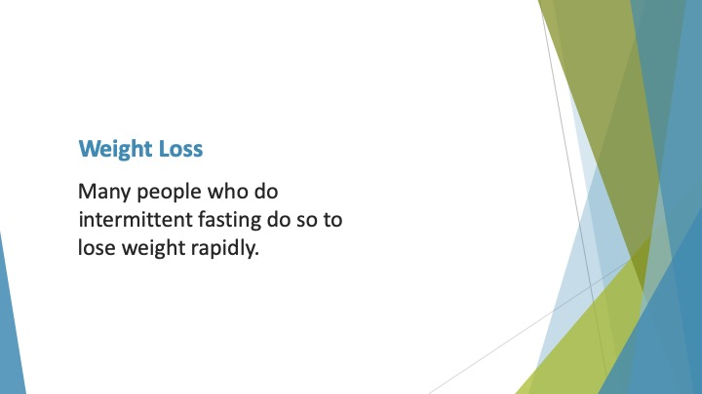
S4 : Weight Loss

Many people who do intermittent fasting do so to lose weight rapidly. There is evidence to show that this way of eating helps you to shed the pounds more quickly.

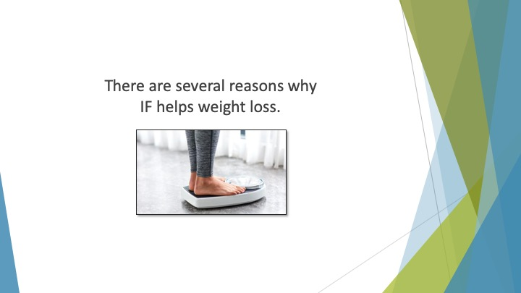
S5 : There are several reasons why IF helps weight loss. It enhances the function of the metabolism for faster fat burning.

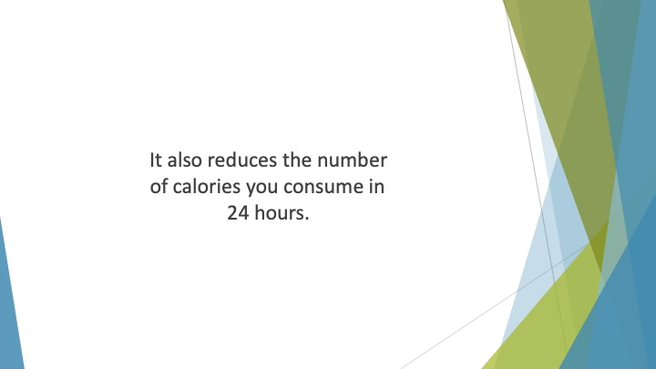
S6 : It also reduces the number of calories you consume in 24 hours.

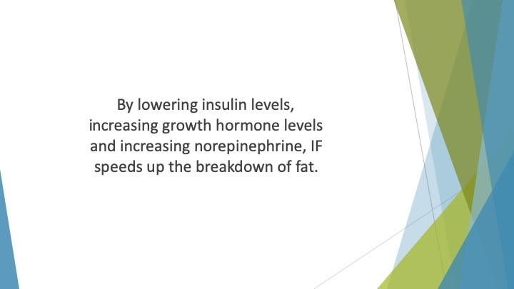
S7 : By lowering insulin levels, increasing growth hormone levels and increasing norepinephrine, IF speeds up the breakdown of fat. It also facilitates the use of fat to produce energy.

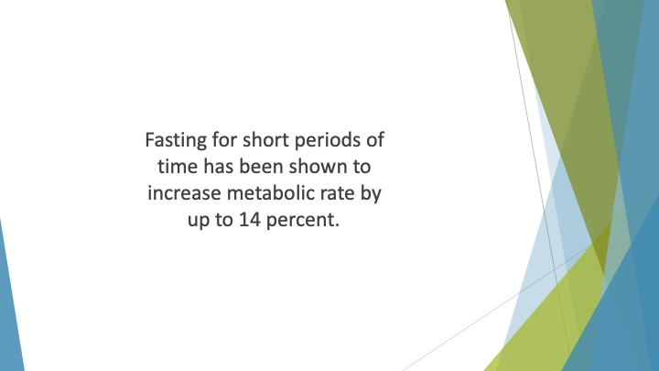
S8 : Fasting for short periods of time has been shown to increase metabolic rate by up to 14 percent. This means you’ll burn more calories.

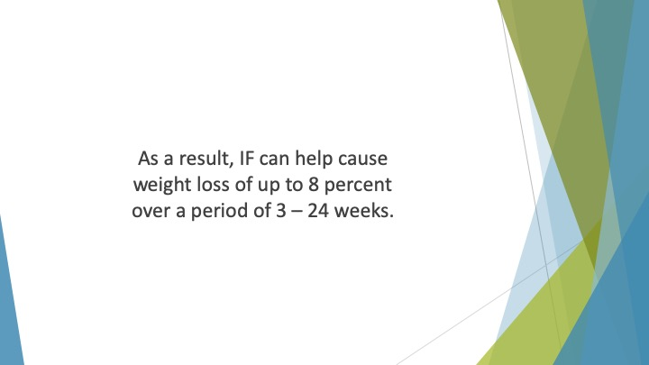
S9 : As a result, IF can help cause weight loss of up to 8 percent over a period of 3 – 24 weeks. That’s an impressive loss!

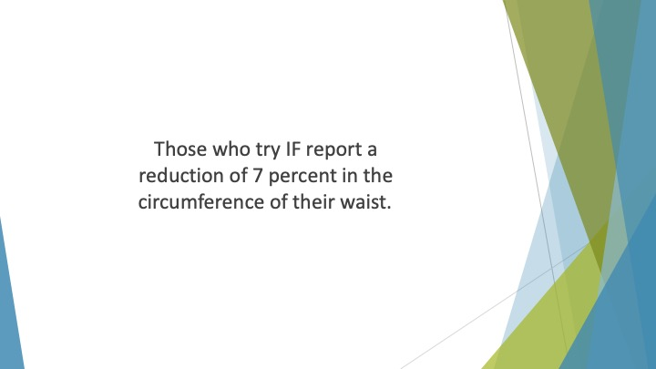
S10 : Those who try IF report a reduction of 7 percent in the circumference of their waist.

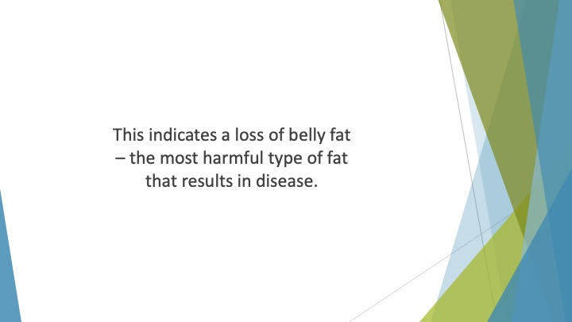
S11 : This indicates a loss of belly fat – the most harmful type of fat that results in disease.

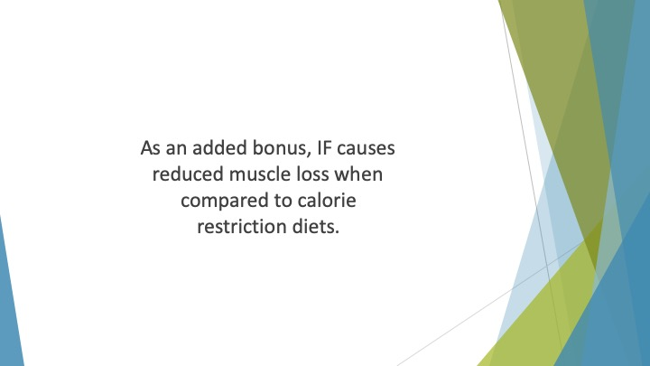
S12 : As an added bonus, IF causes reduced muscle loss when compared to calorie restriction diets.

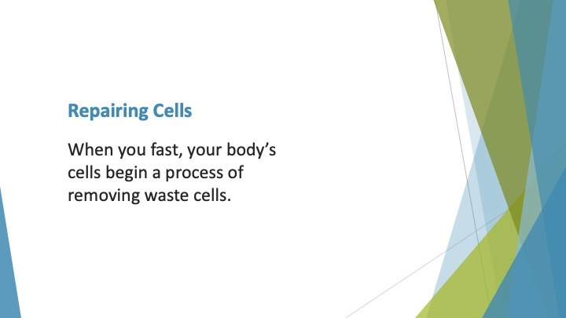
S13 : Repairing Cells

When you fast, your body’s cells begin a process of removing waste cells. This is known as “autophagy”.

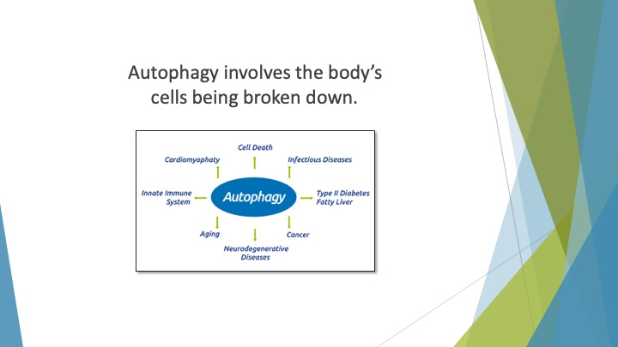
S14 : Autophagy involves the body’s cells being broken down.

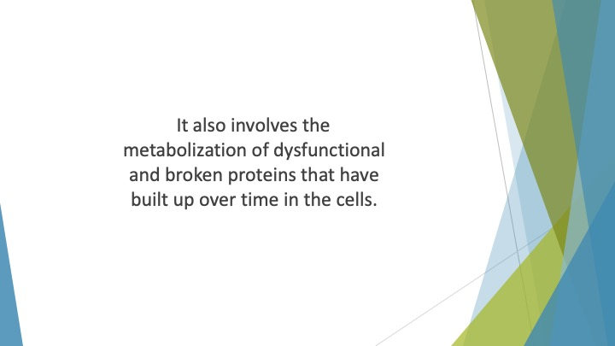
S15 : It also involves the metabolization of dysfunctional and broken proteins that have built up over time in the cells.

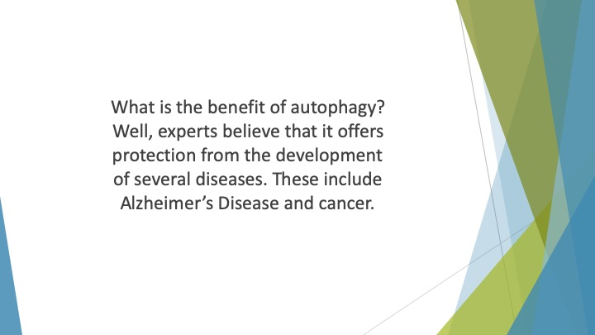
S16 : What is the benefit of autophagy? Well, experts believe that it offers protection from the development of several diseases. These include Alzheimer’s Disease and cancer.

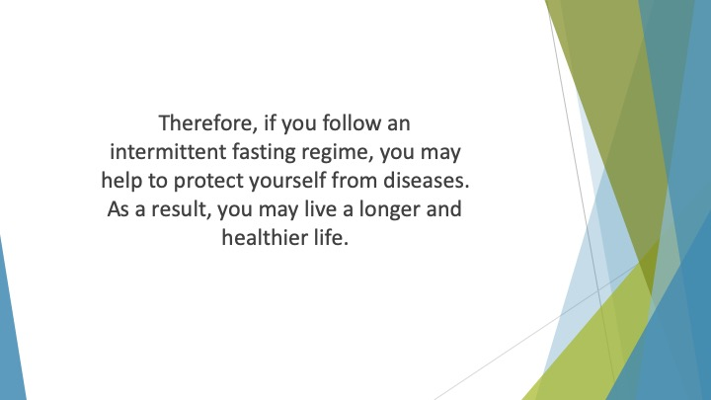
S17 : Therefore, if you follow an intermittent fasting regime, you may help to protect yourself from diseases. As a result, you may live a longer and healthier life. .

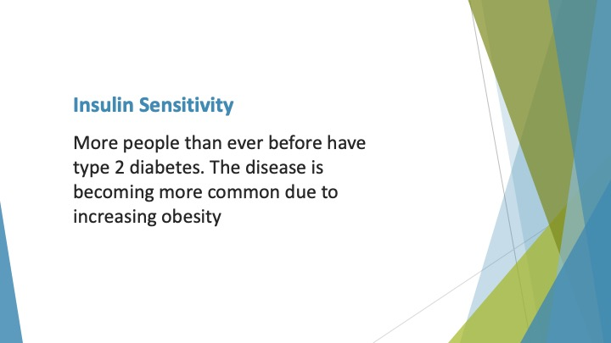
S18 : Insulin Sensitivity

More people than ever before have type 2 diabetes. The disease is becoming more common due to increasing obesity. The primary feature of diabetes is increased levels of sugar in the blood due to insulin resistance.

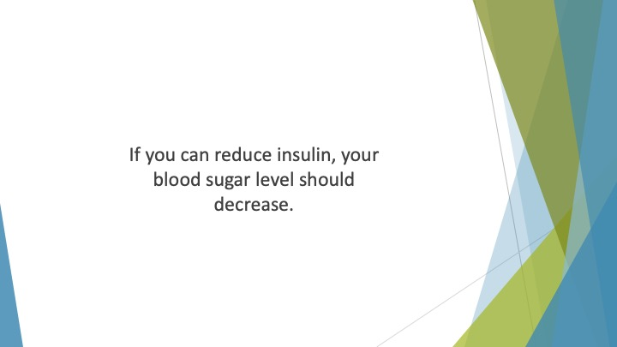
S19 : If you can reduce insulin, your blood sugar level should decrease.

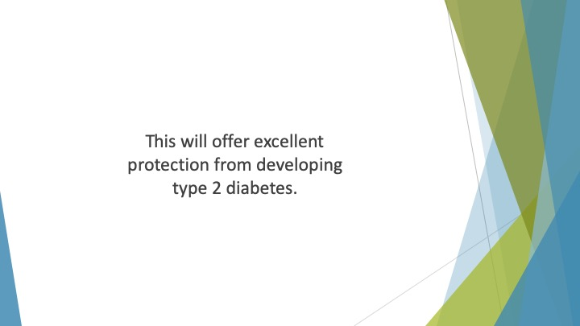
S20 : This will offer excellent protection from developing type 2 diabetes.

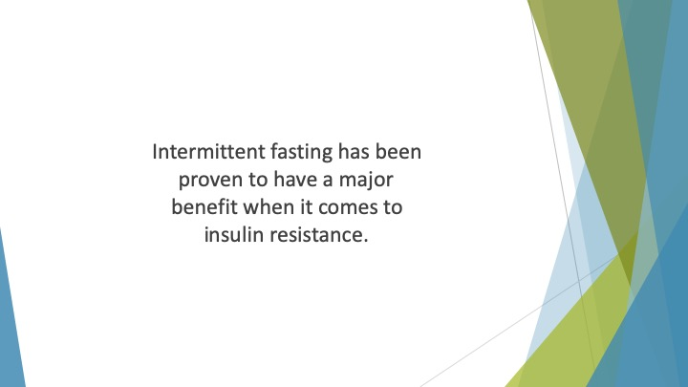
S21 : Intermittent fasting has been proven to have a major benefit when it comes to insulin resistance. It can reduce blood sugar levels by an impressive amount.

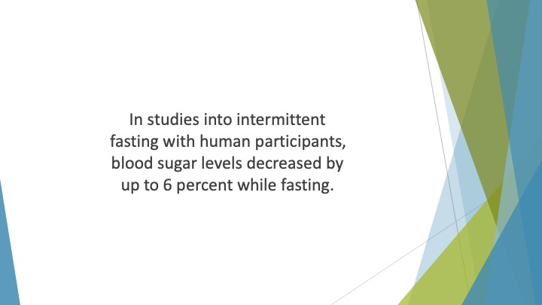
S22 : In studies into intermittent fasting with human participants, blood sugar levels decreased by up to 6 percent while fasting. As a result, fasting insulin levels can reduce by as much as 31 percent.

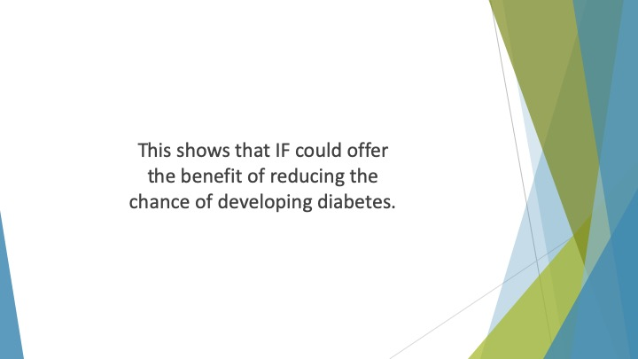
S23 : This shows that IF could offer the benefit of reducing the chance of developing diabetes.

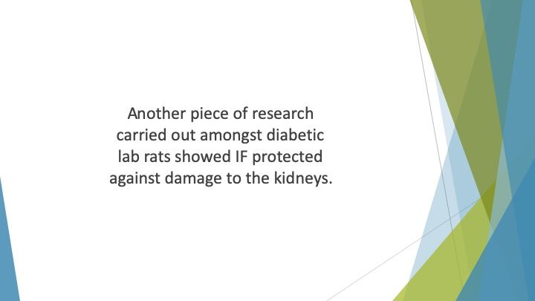
S24 : Another piece of research carried out amongst diabetic lab rats showed IF protected against damage to the kidneys. This is a severe complication associated with diabetes.

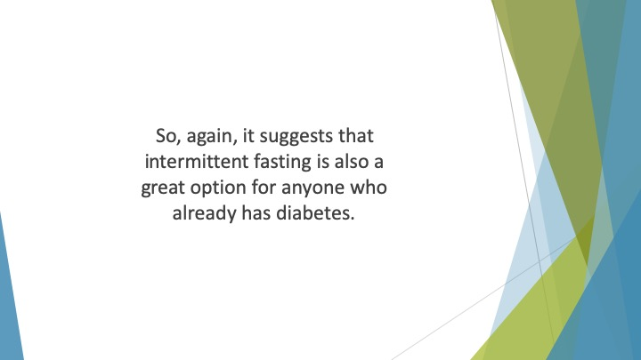
S25 : So, again, it suggests that intermittent fasting is also a great option for anyone who already has diabetes.

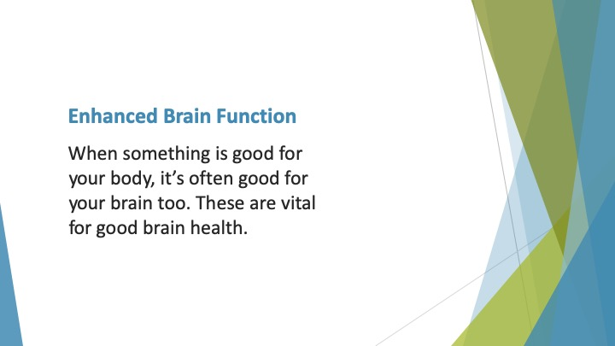
S26 : Enhanced Brain Function

When something is good for your body, it’s often good for your brain too. Intermittent fasting is known to improve several metabolic features. These are vital for good brain health.

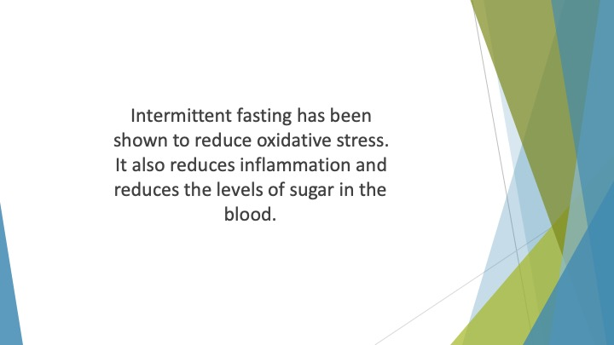
S27 : Intermittent fasting has been shown to reduce oxidative stress. It also reduces inflammation and reduces the levels of sugar in the blood. Not only that, it reduces insulin resistance as we showed above.

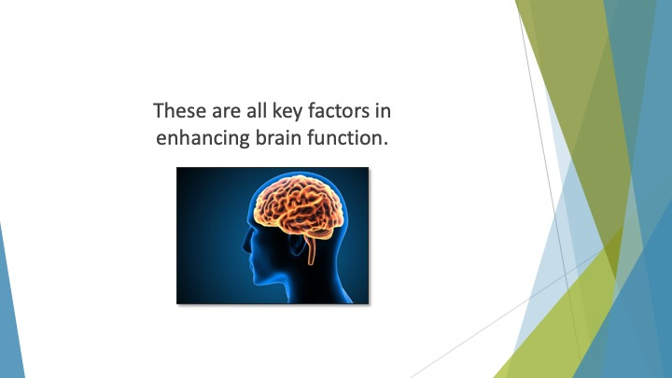
S28 : These are all key factors in enhancing brain function.

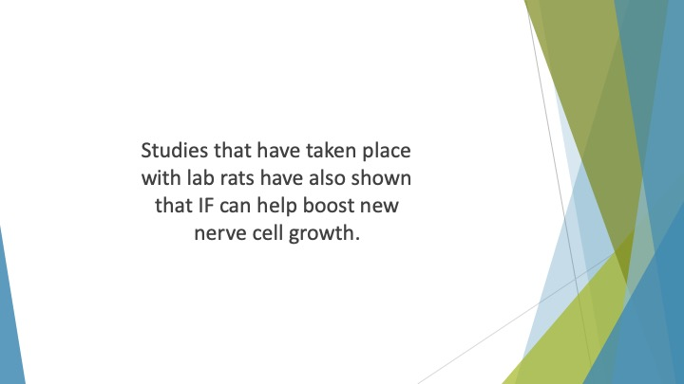
S29 : Studies that have taken place with lab rats have also shown that IF can help boost new nerve cell growth. This too offers benefits when it comes to brain function.

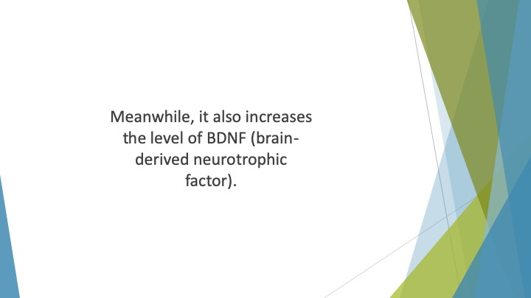
S30 : Meanwhile, it also increases the level of BDNF (brain-derived neurotrophic factor).

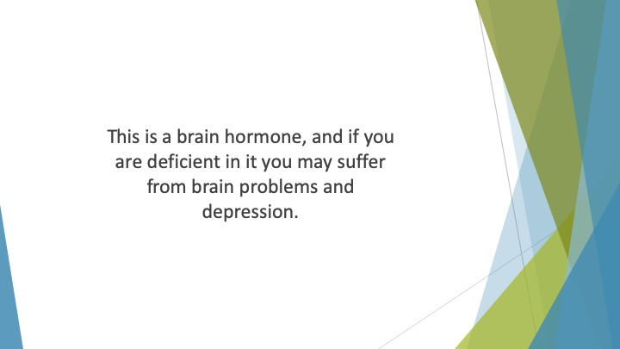
S31 : This is a brain hormone, and if you are deficient in it you may suffer from brain problems and depression. When you try intermittent fasting you will have better protection from these problems.

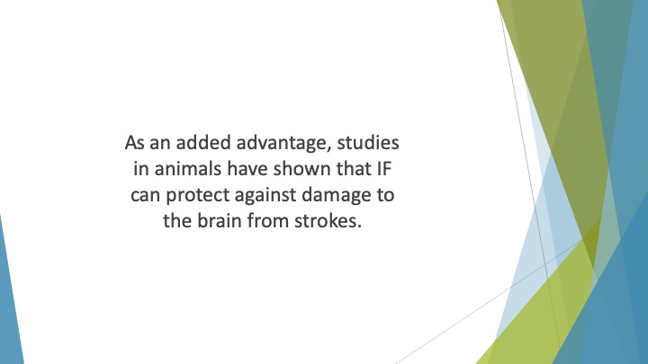
S32 : As an added advantage, studies in animals have shown that IF can protect against damage to the brain from strokes.

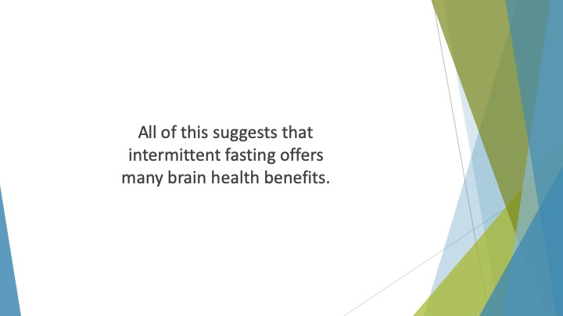
S33 : All of this suggests that intermittent fasting offers many brain health benefits.

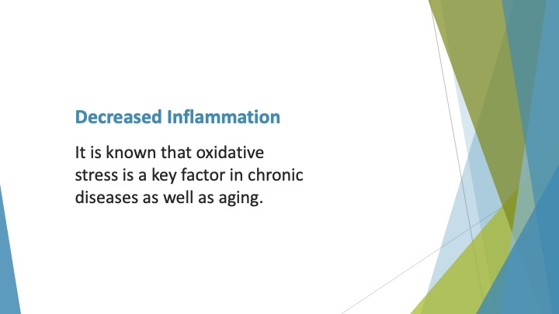
S34 : Decreased Inflammation
It is known that oxidative stress is a key factor in chronic diseases as well as aging. Oxidative stress involves free radicals which are unstable molecules reacting with other key molecules such as DNA and protein.

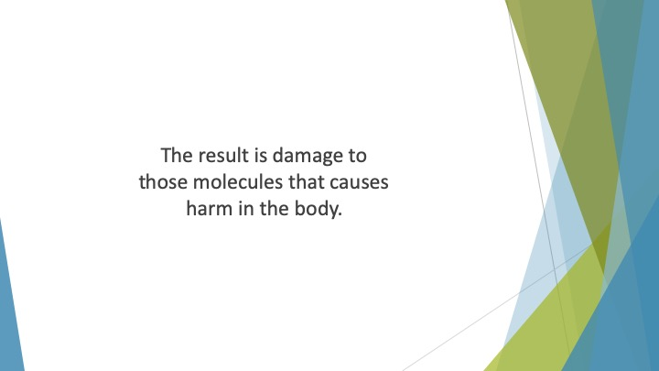
S35 : The result is damage to those molecules that causes harm in the body.

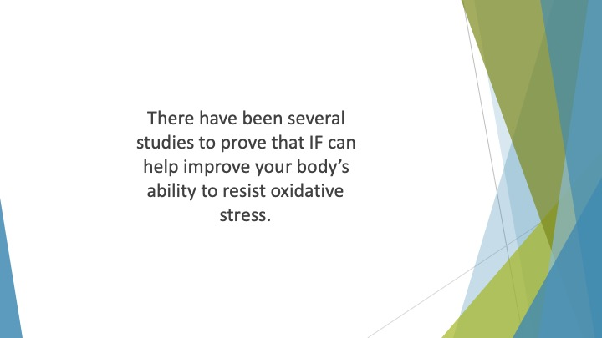
S36 : There have been several studies to prove that IF can help improve your body’s ability to resist oxidative stress.

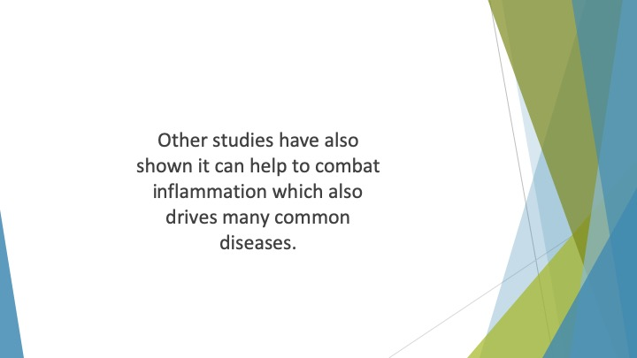
S37 : Other studies have also shown it can help to combat inflammation which also drives many common diseases.

