Chapter 1: What is Intermittent Fasting?
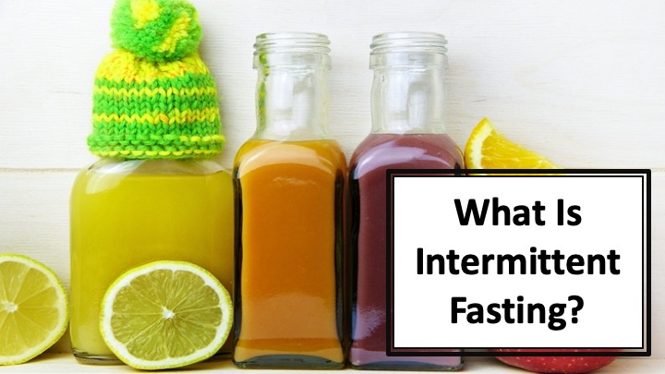
S1 : In this video, we’ll talk about “What is Intermittent Fasting?”

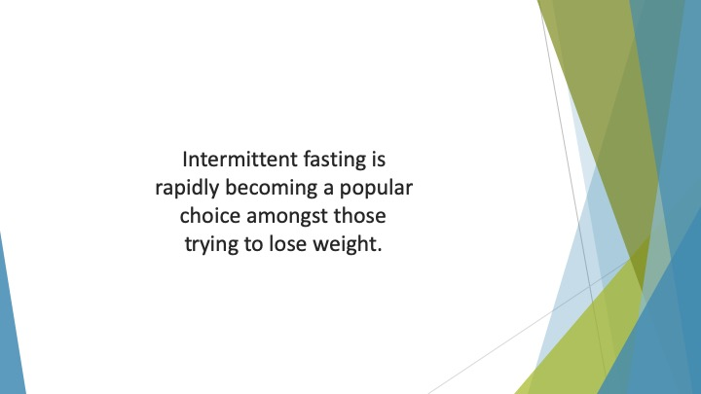
S2 : Intermittent fasting is rapidly becoming a popular choice amongst those trying to lose weight.

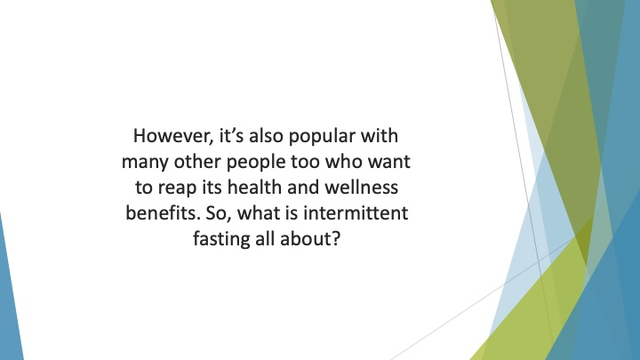
S3 : However, it’s also popular with many other people too who want to reap its health and wellness benefits. So, what is intermittent fasting all about?

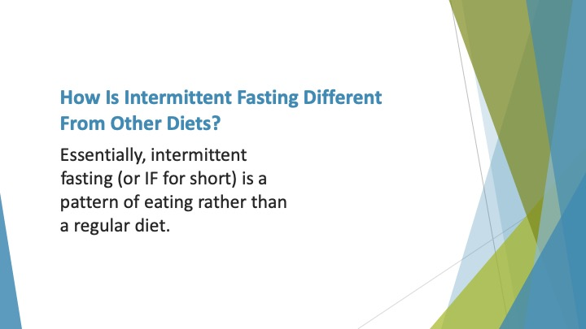
S4 : How is Intermittent Fasting Different from Other Diets?

Essentially, intermittent fasting (or IF for short) is a pattern of eating rather than a regular diet.

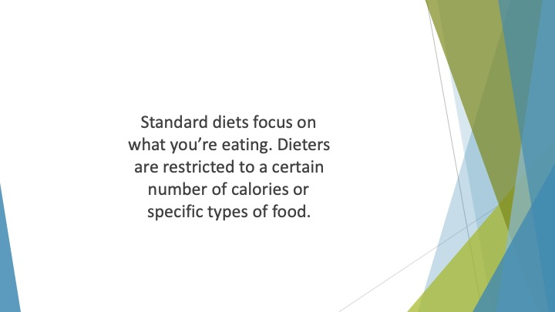
S5 : Standard diets focus on what you’re eating. Dieters are restricted to a certain number of calories or specific types of food. This leads to dieters thinking constantly about what they are and aren’t allowed to eat.

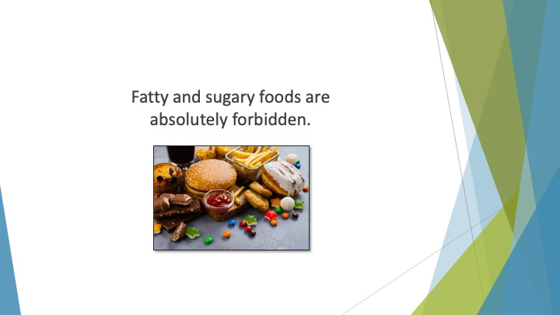
S6 : Fatty and sugary foods are absolutely forbidden. There is a strong focus on vegetables, fruit and low-fat, low-sugar meals.

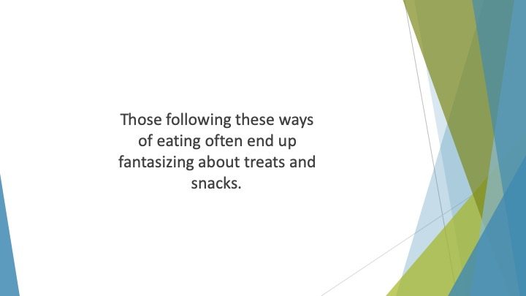
S7 : Those following these ways of eating often end up fantasizing about treats and snacks.

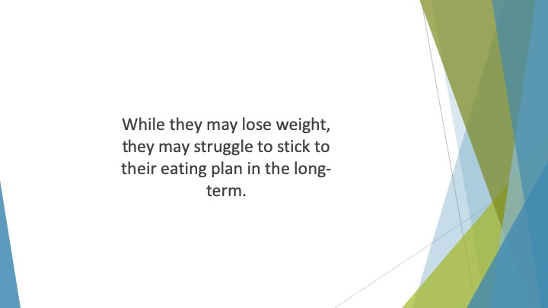
S8 : While they may lose weight, they may struggle to stick to their eating plan in the long-term.

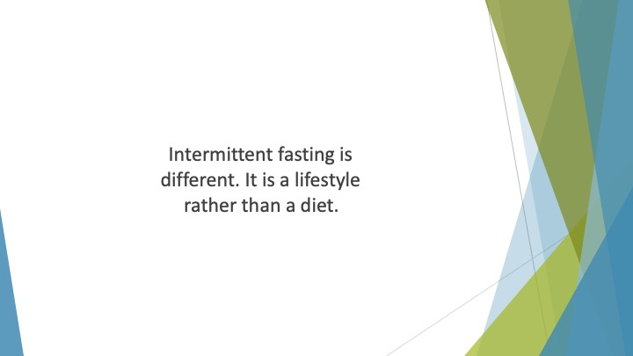
S9 : Intermittent fasting is different. It is a lifestyle rather than a diet. It involves eating patterns during which you cycle between windows of fasting and eating.

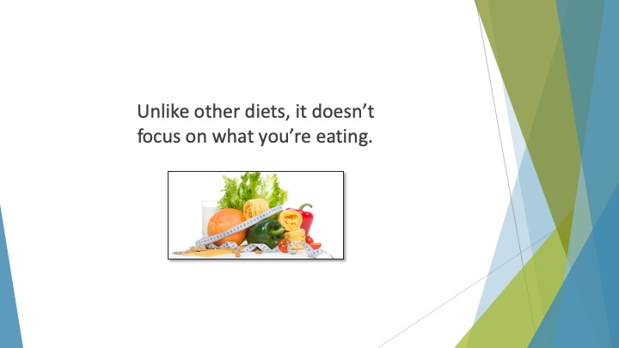
S10 : Unlike other diets, it doesn’t focus on what you’re eating.

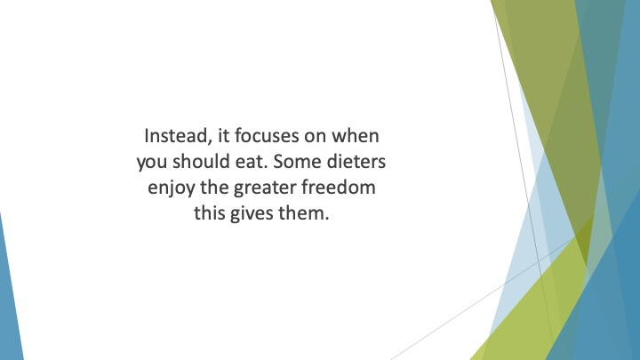
S11 : Instead, it focuses on when you should eat. Some dieters enjoy the greater freedom this gives them. They can eat the foods they enjoy without guilt.

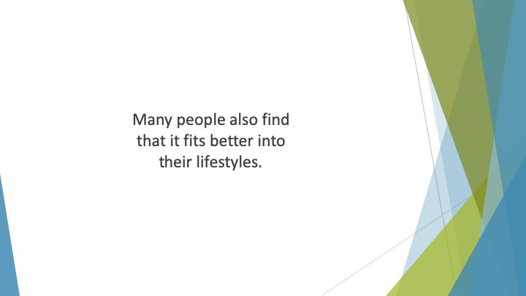
S12 : Many people also find that it fits better into their lifestyles.

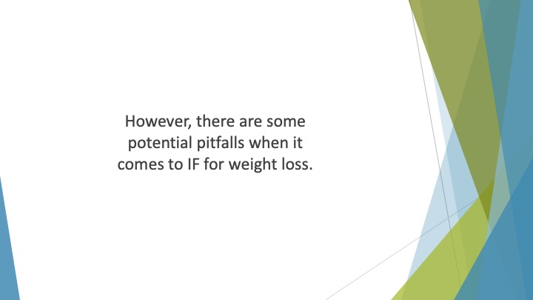
S13 : However, there are some potential pitfalls when it comes to IF for weight loss.

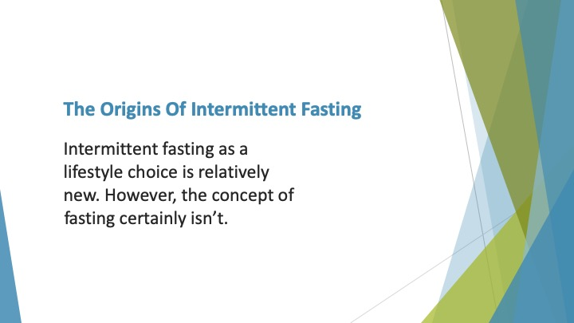
S14 : The Origins of Intermittent Fasting

Intermittent fasting as a lifestyle choice is relatively new. However, the concept of fasting certainly isn’t. There are verses in the Bible and Koran about fasting for religious purposes.

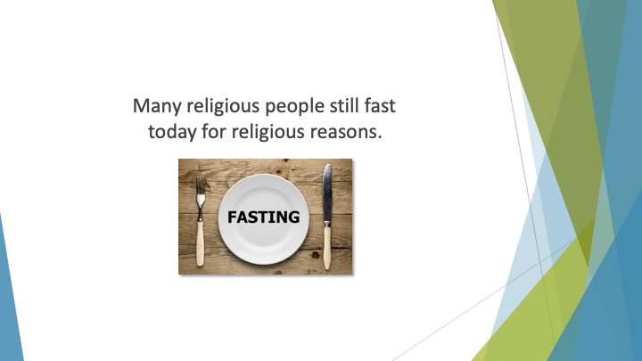
S15 : Many religious people still fast today for religious reasons.

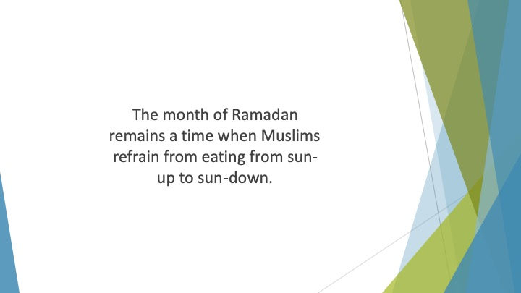
S16 : The month of Ramadan remains a time when Muslims refrain from eating from sun-up to sun-down. Therefore, it’s easy to see where the idea of intermittent fasting originates.

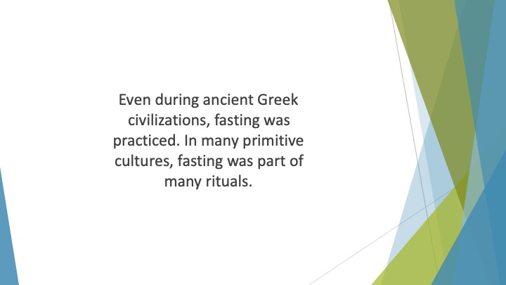
S17 : Even during ancient Greek civilizations, fasting was practiced. In many primitive cultures, fasting was part of many rituals.

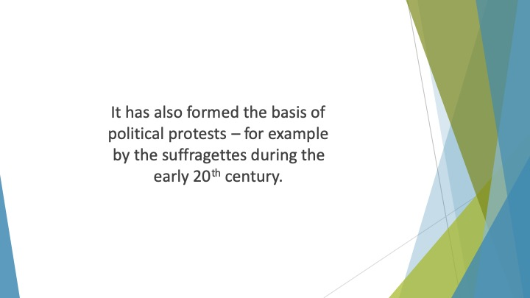
S18 : It has also formed the basis of political protests – for example by the suffragettes during the early 20th century.

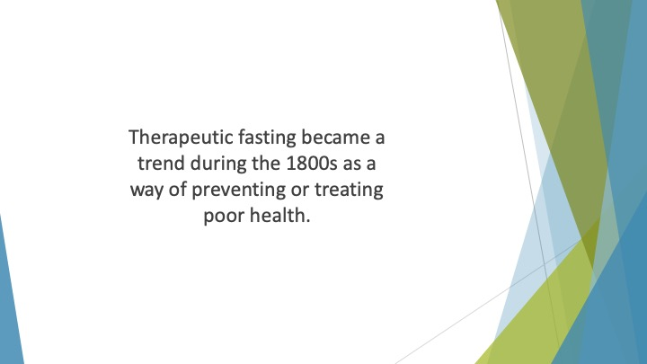
S19 : Therapeutic fasting became a trend during the 1800s as a way of preventing or treating poor health. Carried out under a doctor’s supervision, this type of fasting was adopted to treat many conditions from hypertension to headaches.

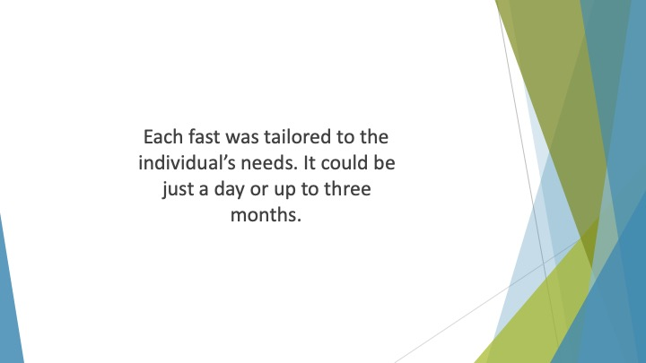
S20 : Each fast was tailored to the individual’s needs. It could be just a day or up to three months.

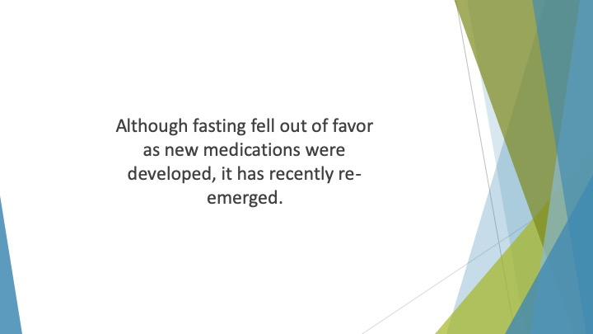
S21 : Although fasting fell out of favor as new medications were developed, it has recently re-emerged.

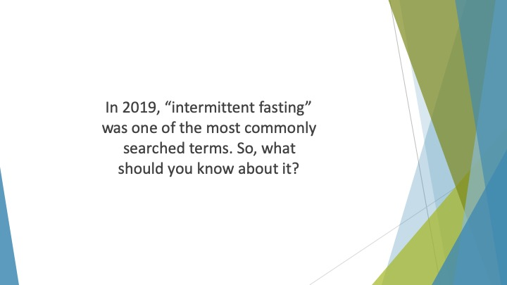
S22 : In 2019, “intermittent fasting” was one of the most commonly searched terms. So, what should you know about it?

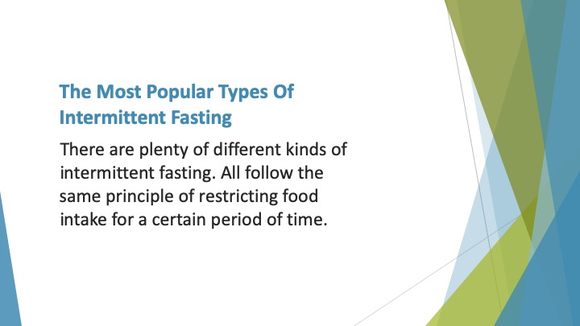
S23 : The Most Popular Types of Intermittent Fasting

There are plenty of different kinds of intermittent fasting. Each one has its own following. All follow the same principle of restricting food intake for a certain period of time.

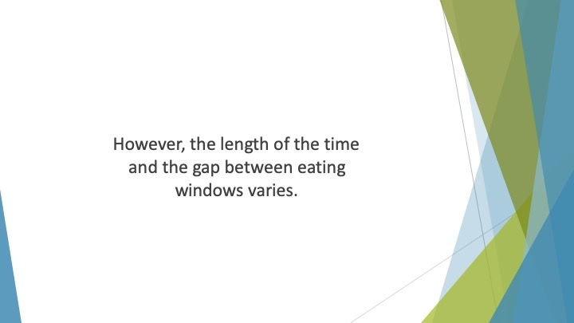
S24 : However, the length of the time and the gap between eating windows varies.

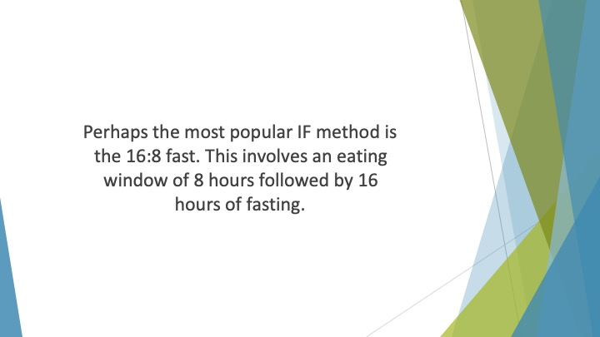
S25 : Perhaps the most popular IF method is the 16:8 fast. This involves an eating window of 8 hours followed by 16 hours of fasting. Many people find this the most convenient option for them.

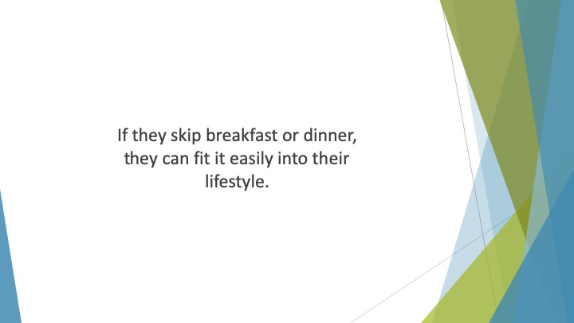
S26 : If they skip breakfast or dinner, they can fit it easily into their lifestyle.

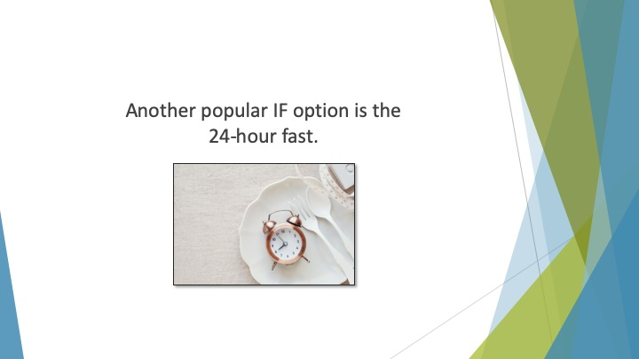
S27 : Another popular IF option is the 24-hour fast. This is sometimes known as the Eat-Stop-Eat method.

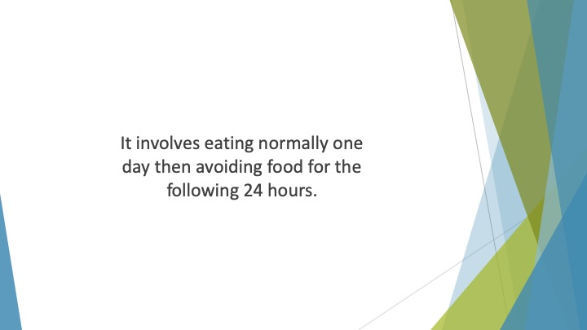
S28 : It involves eating normally one day then avoiding food for the following 24 hours.

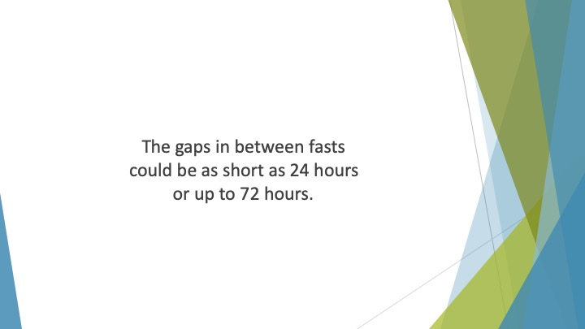
S29 : The gaps in between fasts could be as short as 24 hours or up to 72 hours.

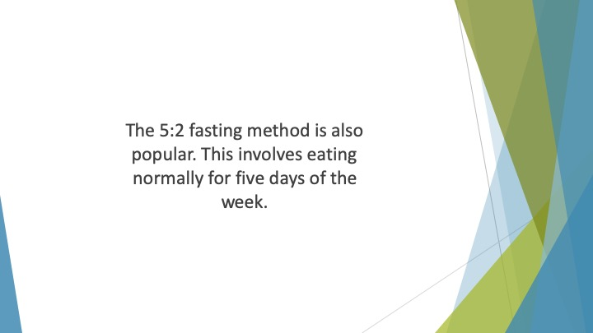
S30 : The 5:2 fasting method is also popular. This involves eating normally for five days of the week.

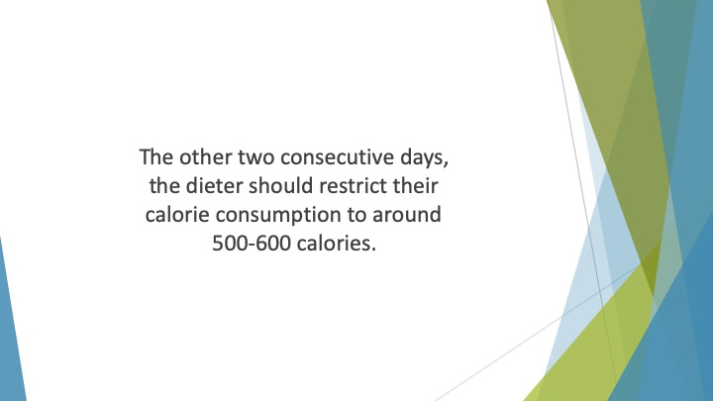
S31 : The other two consecutive days, the dieter should restrict their calorie consumption to around 500-600 calories.

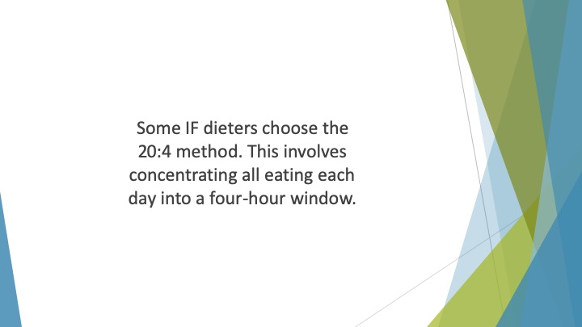
S32 : Some IF dieters choose the 20:4 method. This involves concentrating all eating each day into a four-hour window.

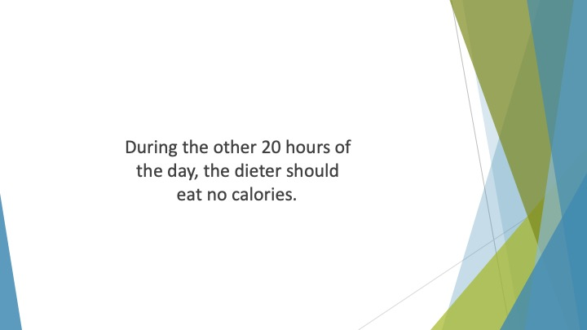
S33 : During the other 20 hours of the day, the dieter should eat no calories.

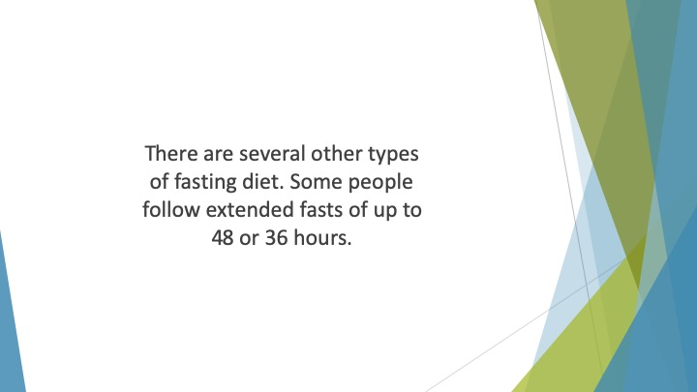
S34 : There are several other types of fasting diet. Some people follow extended fasts of up to 48 or 36 hours. Others fast for even more extended periods.


S35 : If you’re considering trying IF, you’ll need to choose the right method for you.

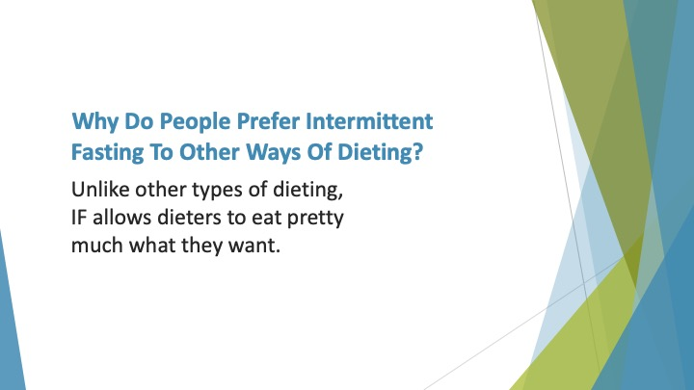
S36 : Why do People Prefer Intermittent Fasting to Other Ways of Dieting?

Unlike other types of dieting, IF allows dieters to eat pretty much what they want. They can eat the sugary or fatty foods they crave.

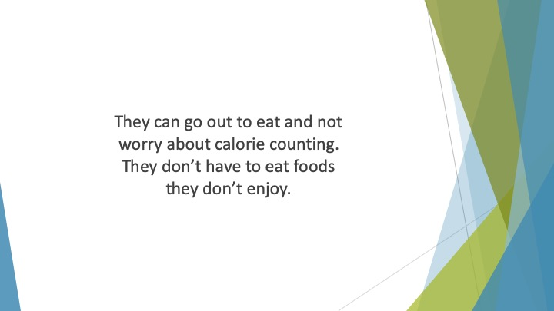
S37 : They can go out to eat and not worry about calorie counting. They don’t have to eat foods they don’t enjoy. They don’t have to feel as if they’re depriving themselves of the things they love.


S38 : It’s easy to see why it’s such a popular choice.

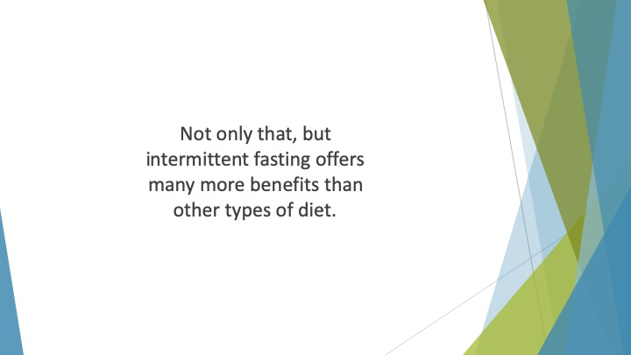
S39 : Not only that, but intermittent fasting offers many more benefits than other types of diet.

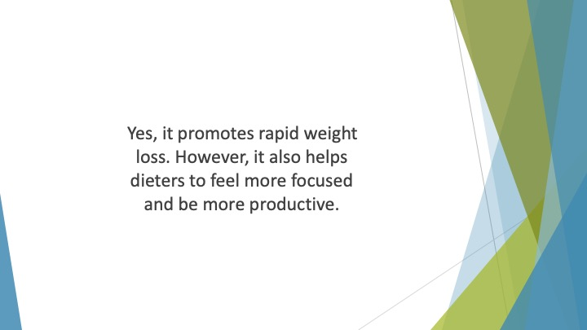
S40 : Yes, it promotes rapid weight loss. However, it also helps dieters to feel more focused and be more productive.


S41 : It helps them to feel healthier and more energetic.

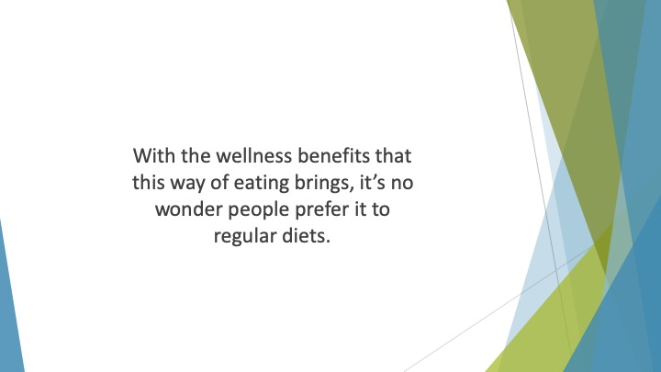
S42 : With the wellness benefits that this way of eating brings, it’s no wonder people prefer it to regular diets.

