Conclusion


S1 : Pause for 2 seconds

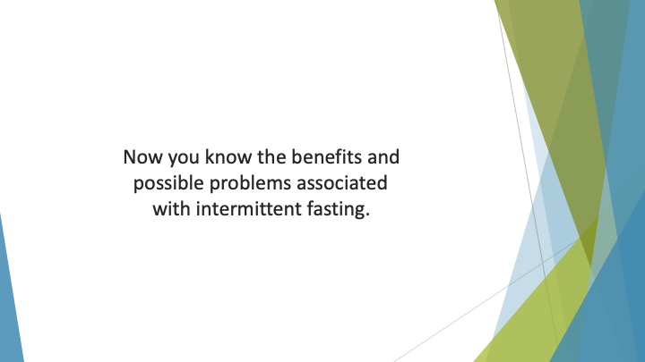
S2 : Now you know the benefits and possible problems associated with intermittent fasting.

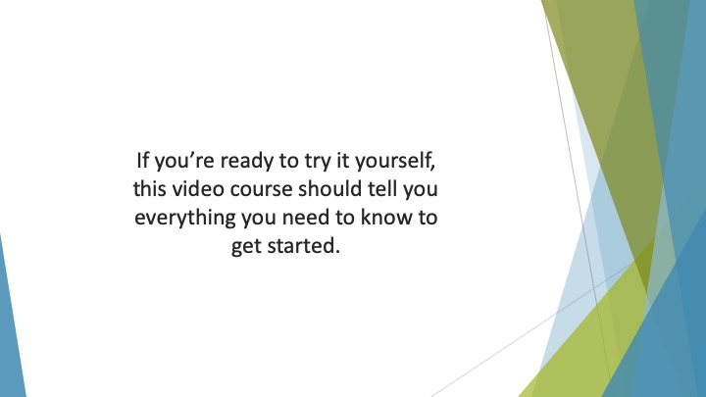
S3 : If you’re ready to try it yourself, this video course should tell you everything you need to know to get started.

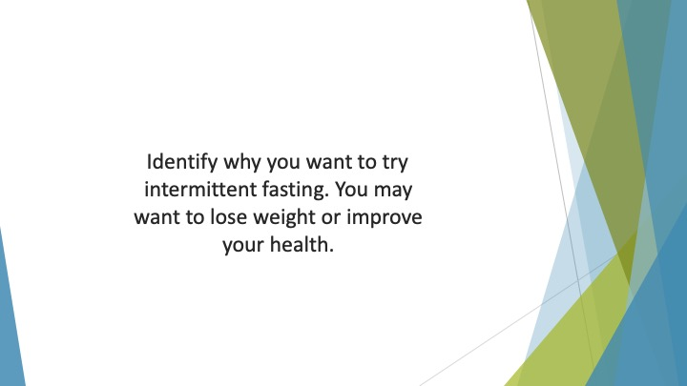
S4 : Identify why you want to try intermittent fasting. You may want to lose weight or improve your health.


S5 : You may just want to see if it makes you feel more focused and energetic.

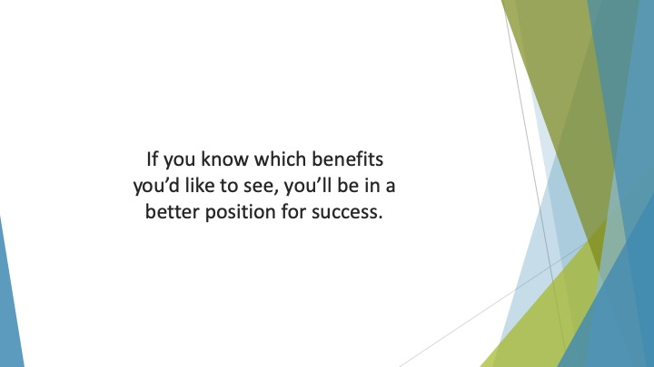
S6 : If you know which benefits you’d like to see, you’ll be in a better position for success.

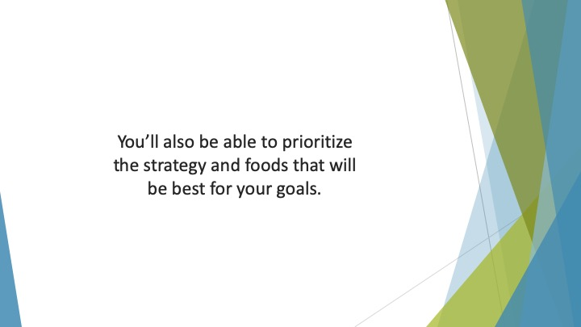
S7 : You’ll also be able to prioritize the strategy and foods that will be best for your goals.


S8 : As you’ve seen in this video course, there are several different IF plans to choose from.


S9 : You’ll need to consider which one is right for you.

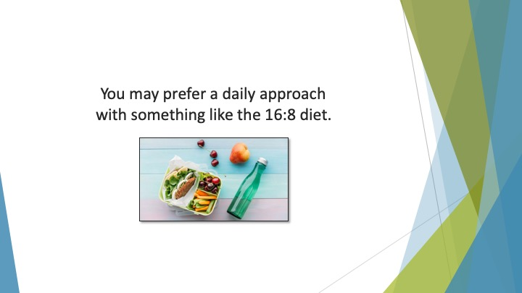
S10 : You may prefer a daily approach with something like the 16:8 diet.

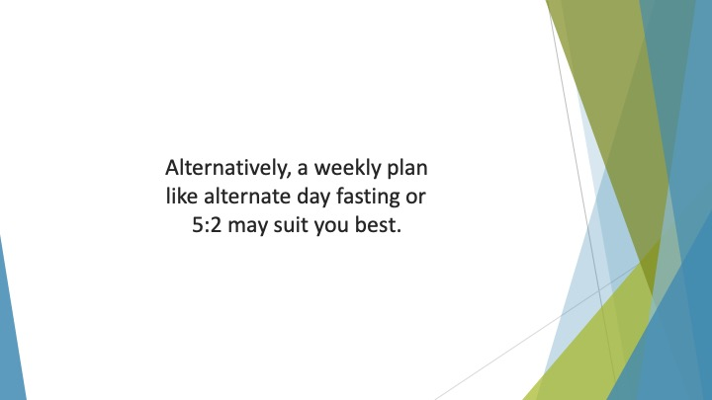
S11 : Alternatively, a weekly plan like alternate day fasting or 5:2 may suit you best.

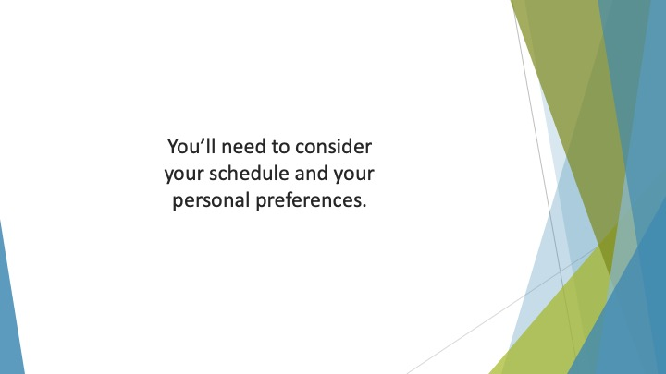
S12 : You’ll need to consider your schedule and your personal preferences.

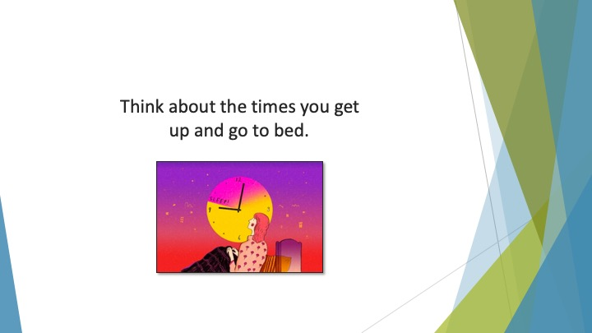
S13 : Think about the times you get up and go to bed.

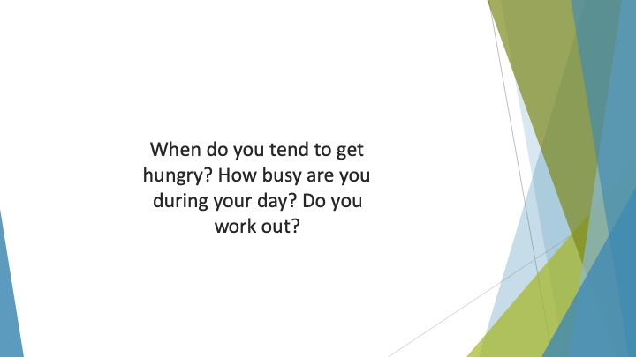
S14 : When do you tend to get hungry? How busy are you during your day? Do you work out?

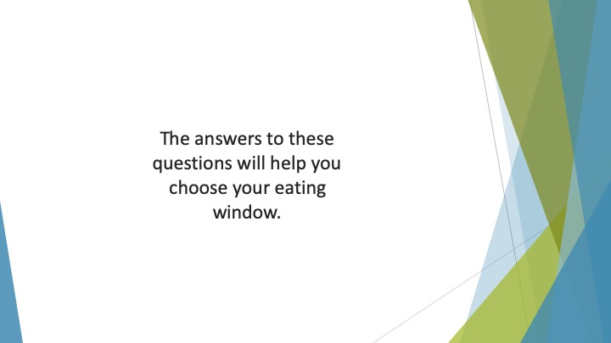
S15 : The answers to these questions will help you choose your eating window.

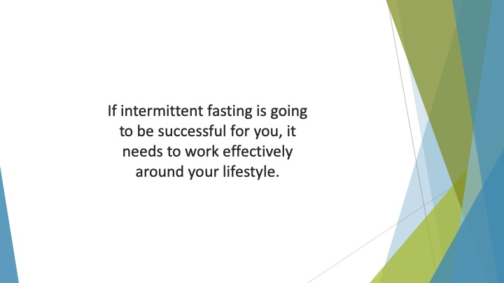
S16 : If intermittent fasting is going to be successful for you, it needs to work effectively around your lifestyle.

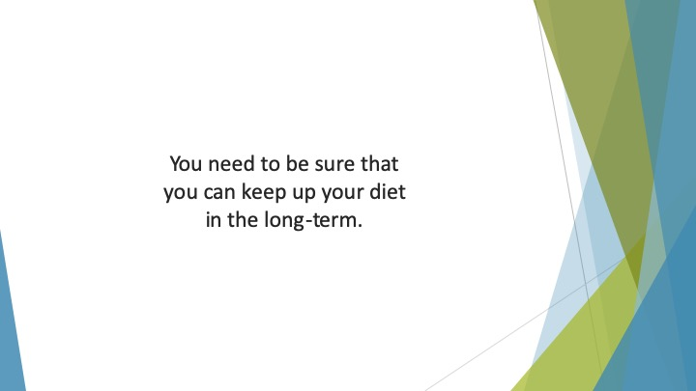
S17 : You need to be sure that you can keep up your diet in the long-term.

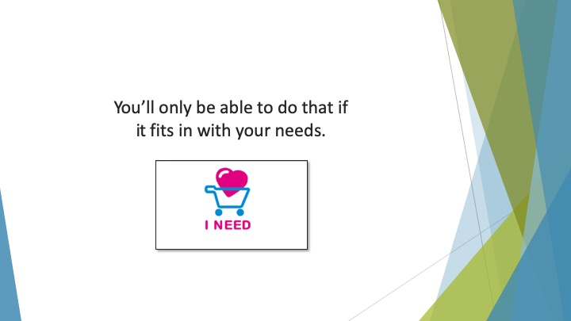
S18 : You’ll only be able to do that if it fits in with your needs.

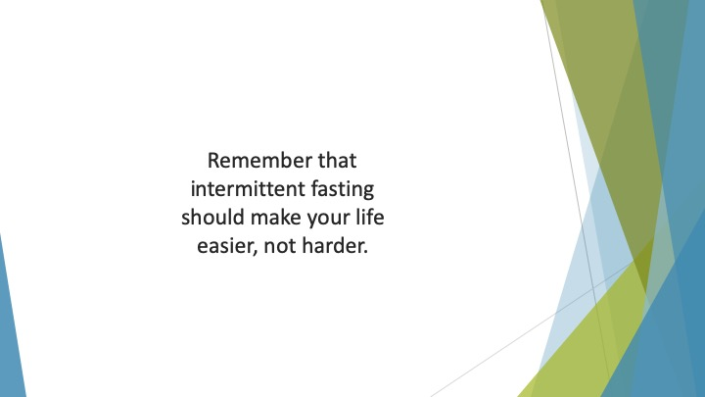
S19 : Remember that intermittent fasting should make your life easier, not harder.

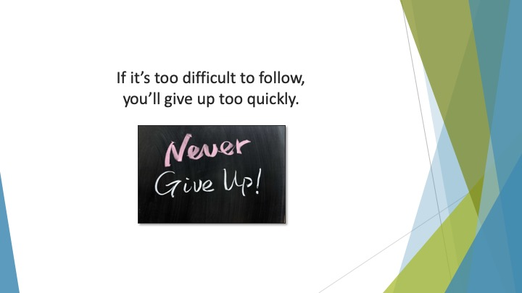
S20 : If it’s too difficult to follow, you’ll give up too quickly.

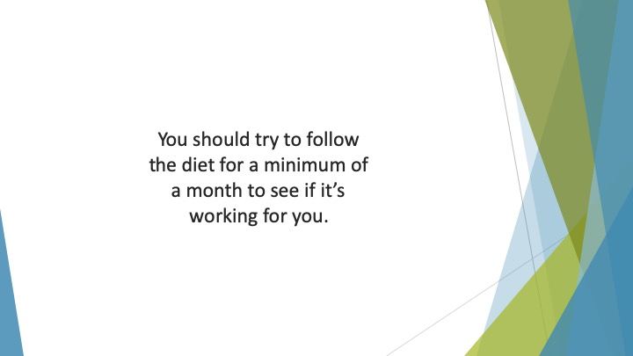
S21 : You should try to follow the diet for a minimum of a month to see if it’s working for you.

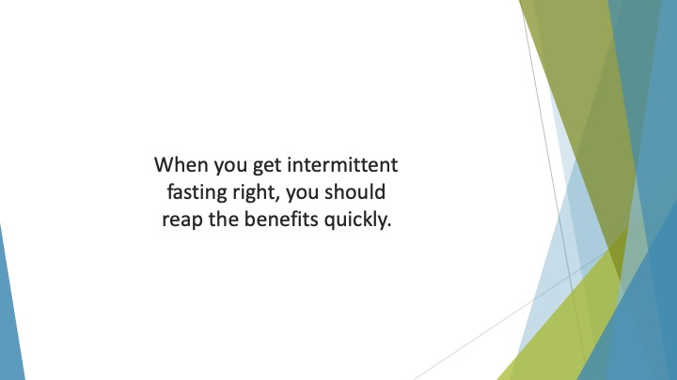
S22 : When you get intermittent fasting right, you should reap the benefits quickly.

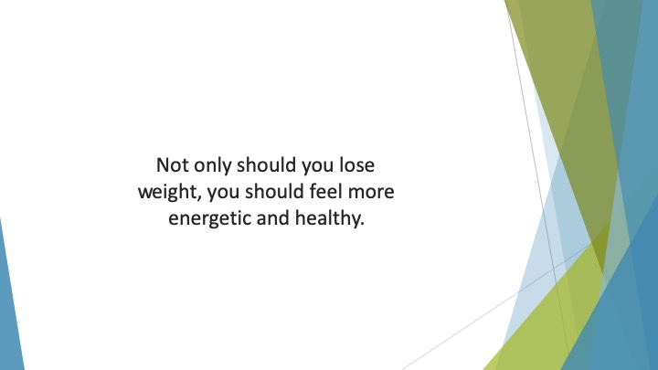
S23 : Not only should you lose weight, you should feel more energetic and healthy.

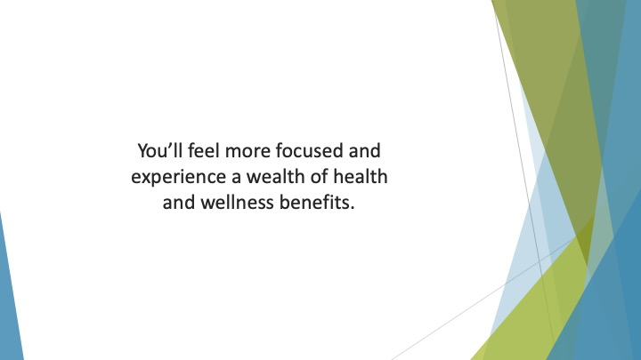
S24 : You’ll feel more focused and experience a wealth of health and wellness benefits.

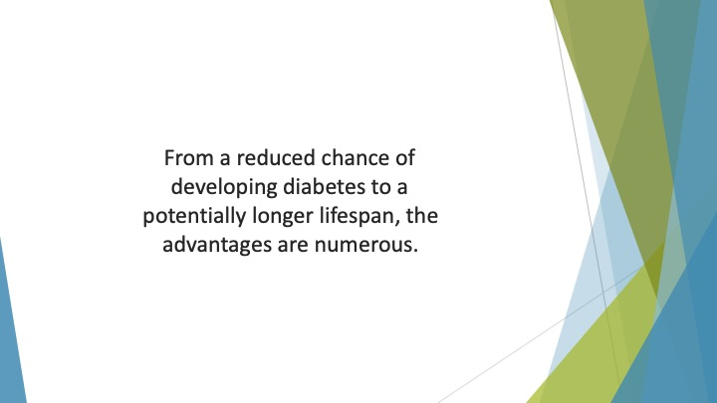
S25 : From a reduced chance of developing diabetes to a potentially longer lifespan, the advantages are numerous.

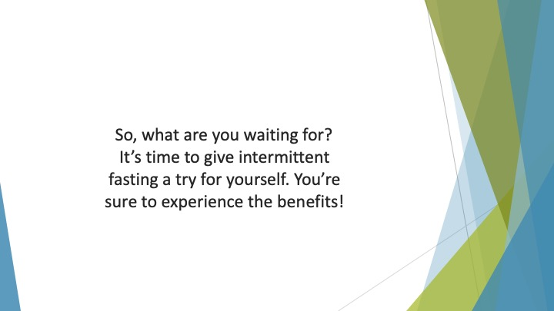
S26 : So, what are you waiting for? It’s time to give intermittent fasting a try for yourself. You’re sure to experience the benefits!

