Chapter 9: How to get Started with Intermittent Fasting

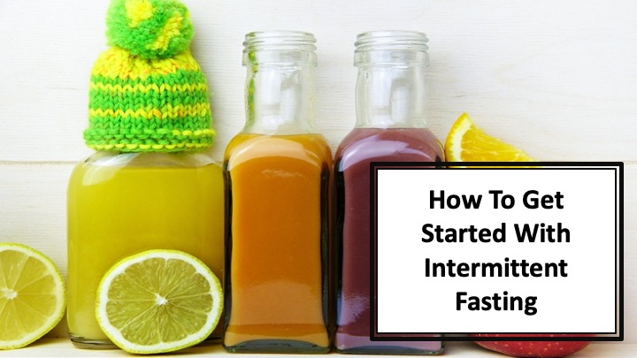
S1 : In this video, we’ll discover about “How to get Started with Intermittent Fasting”

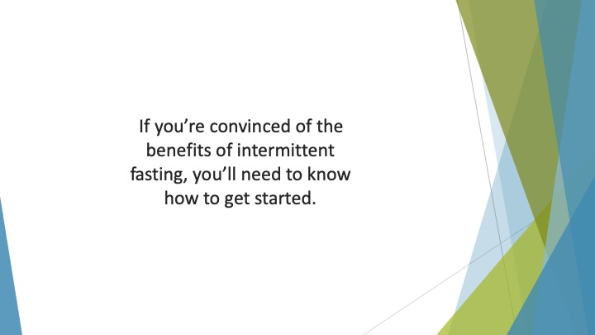
S2 : If you’re convinced of the benefits of intermittent fasting, you’ll need to know how to get started. After all, embarking on any new regime can be complicated.


S3 : So, how can you get yourself off to the best possible start? Here are some top tips.

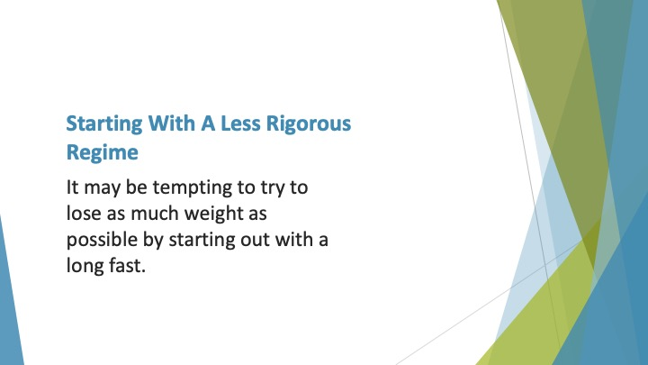
S4 : Starting with a less Rigorous Regime

It may be tempting to try to lose as much weight as possible by starting out with a long fast.


S5 : However, bear in mind this may not be the best approach. As we’ve already mentioned, it can be difficult to fast for extended periods if you’ve never done it before.

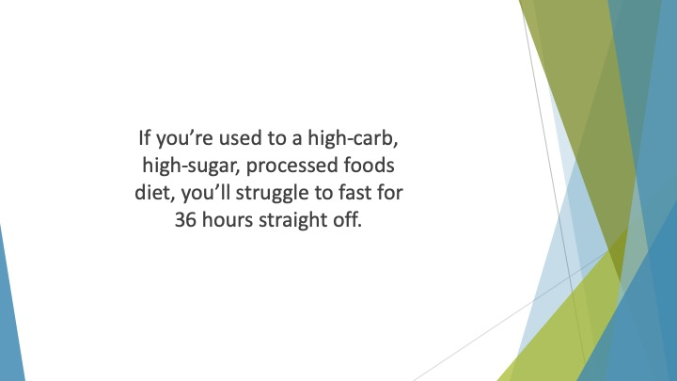
S6 : If you’re used to a high-carb, high-sugar, processed foods diet, you’ll struggle to fast for 36 hours straight off.

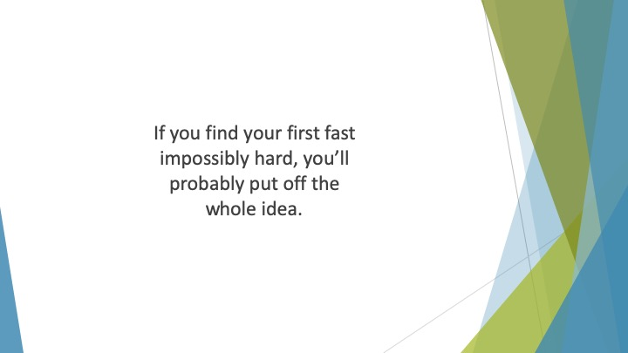
S7 : If you find your first fast impossibly hard, you’ll probably put off the whole idea. Even if you aren’t, the likelihood of sticking to it for any length of time is low.

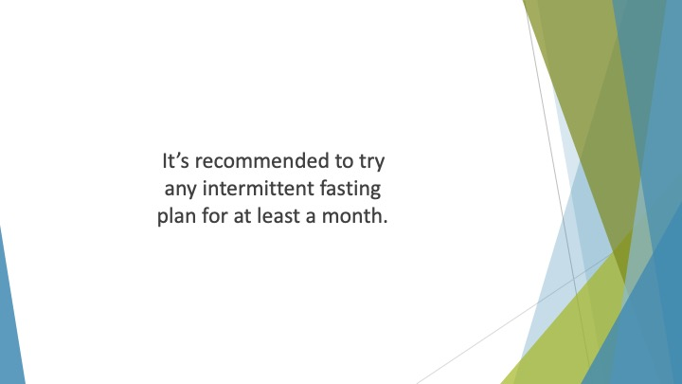
S8 : It’s recommended to try any intermittent fasting plan for at least a month. This will give you enough time to see whether it’s working for you or not.

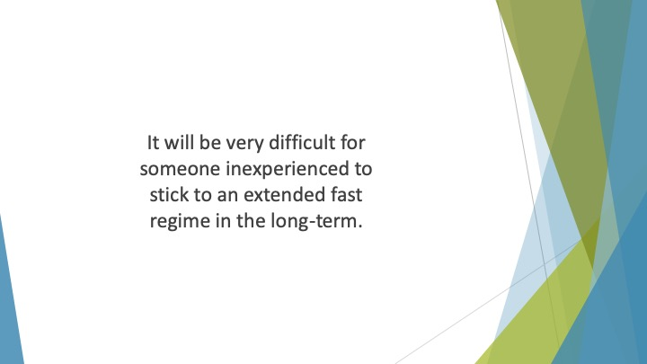
S9 : It will be very difficult for someone inexperienced to stick to an extended fast regime in the long-term.

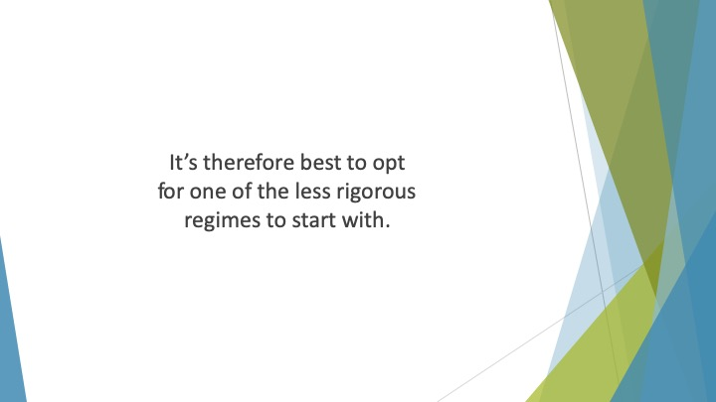
S10 : It’s therefore best to opt for one of the less rigorous regimes to start with. The 5:2 diet allows you to eat some food every day.

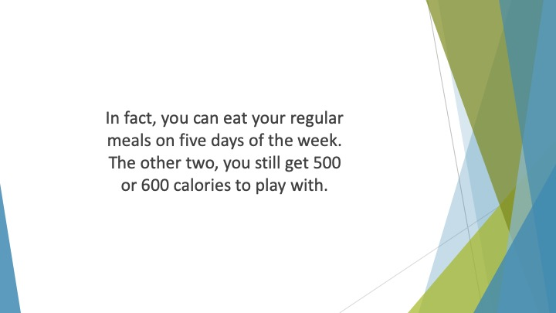
S11 : In fact, you can eat your regular meals on five days of the week. The other two, you still get 500 or 600 calories to play with. This should give you plenty of options as long as you make healthy choices.

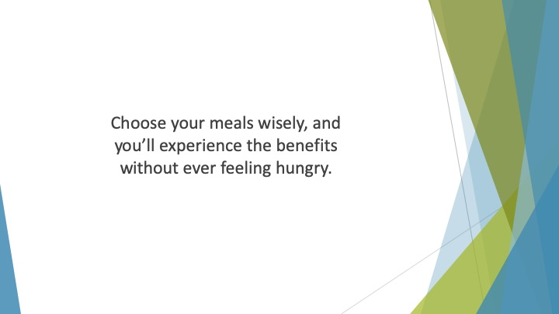
S12 : Choose your meals wisely, and you’ll experience the benefits without ever feeling hungry.

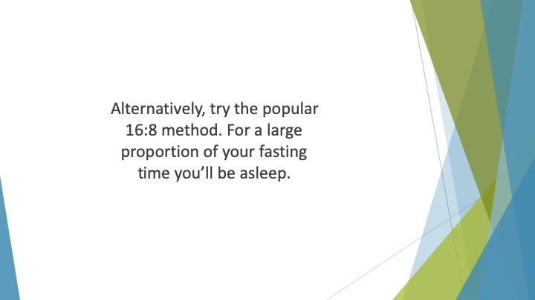
S13 : Alternatively, try the popular 16:8 method. For a large proportion of your fasting time you’ll be asleep. You’ll then be free to eat whatever you like (within reason) during your 8-hour eating window.

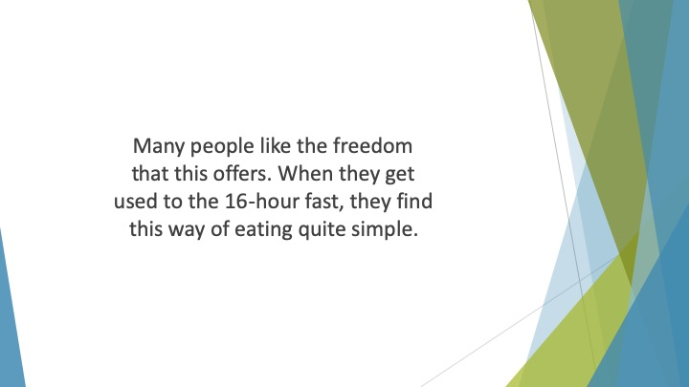
S14 : Many people like the freedom that this offers. When they get used to the 16-hour fast, they find this way of eating quite simple.

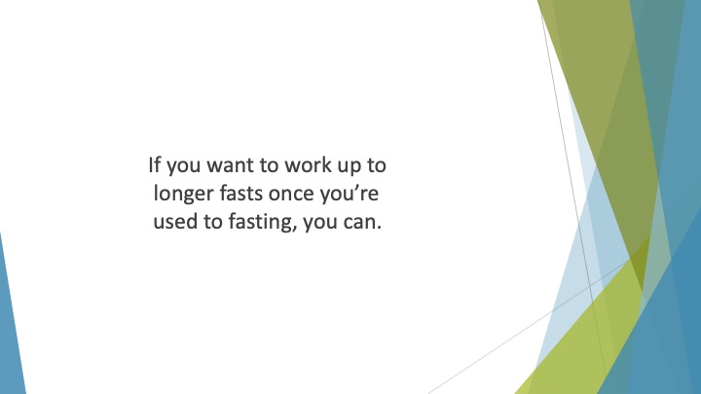
S15 : If you want to work up to longer fasts once you’re used to fasting, you can.

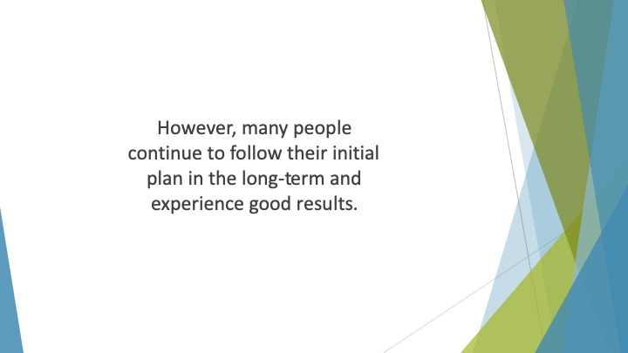
S16 : However, many people continue to follow their initial plan in the long-term and experience good results.

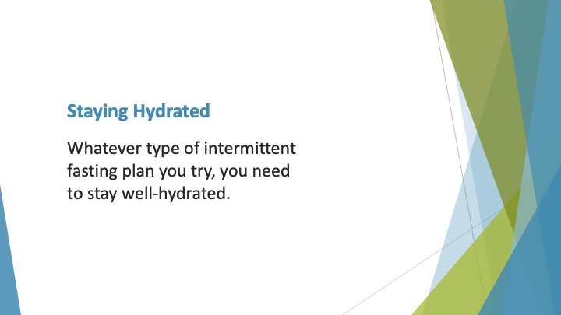
S17 : Staying Hydrated

Whatever type of intermittent fasting plan you try, you need to stay well-hydrated. Fasting is only referring to food and calorie-containing beverages.

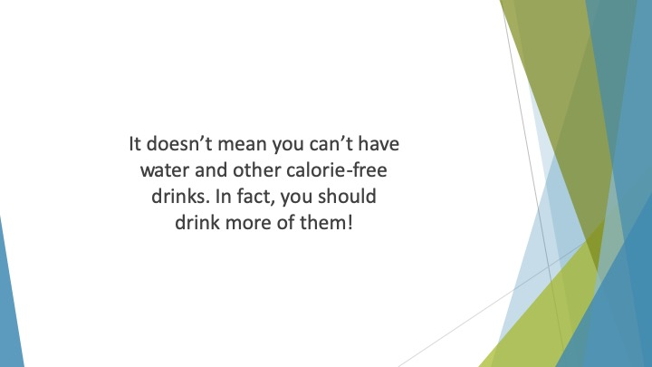
S18 : It doesn’t mean you can’t have water and other calorie-free drinks. In fact, you should drink more of them!

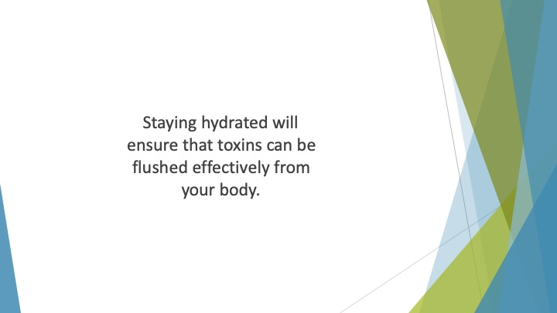
S19 : Staying hydrated will ensure that toxins can be flushed effectively from your body. This will help to promote your weight loss and wellness goals.

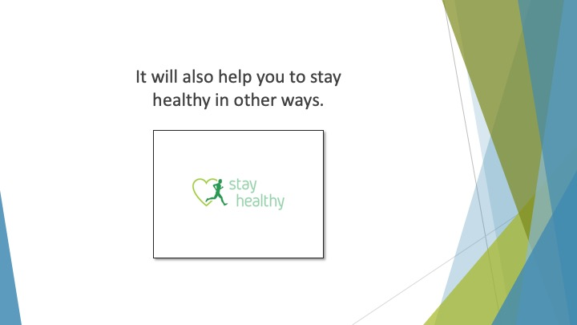
S20 : It will also help you to stay healthy in other ways. Your skin will be healthier. Your bowel habits will be more regular.

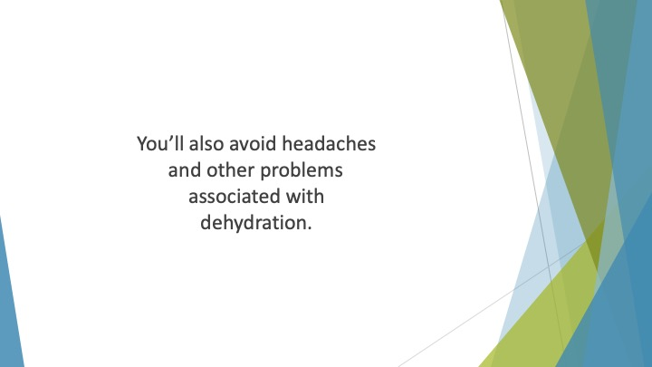
S21 : You’ll also avoid headaches and other problems associated with dehydration.

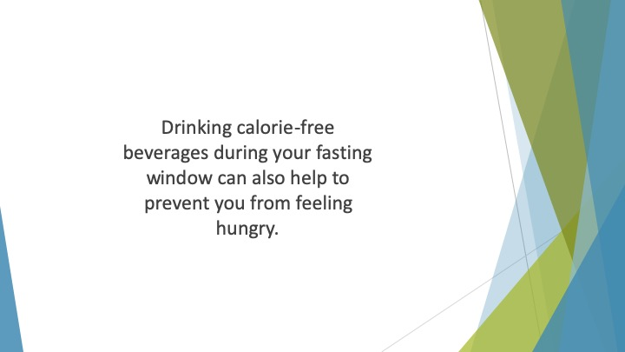
S22 : Drinking calorie-free beverages during your fasting window can also help to prevent you from feeling hungry. Often, we think we’re hungry, but we’re actually thirsty instead.

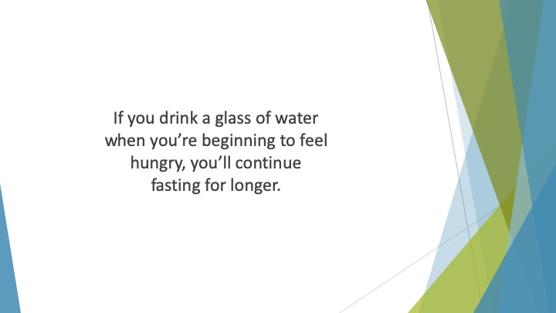
S23 : If you drink a glass of water when you’re beginning to feel hungry, you’ll continue fasting for longer.

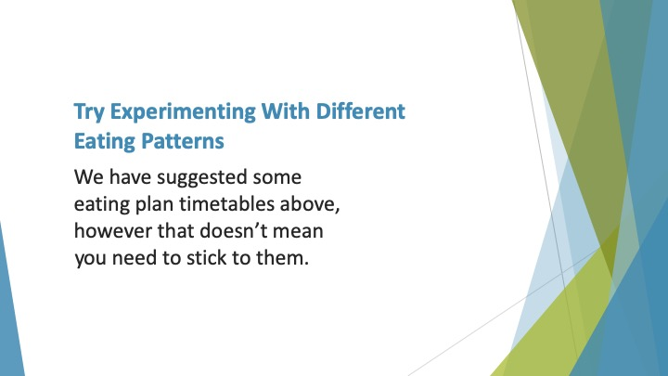
S24 : Try Experimenting with Different Eating Patterns

We have suggested some eating plan timetables above, however that doesn’t mean you need to stick to them. The days and times that we have suggested are just examples.

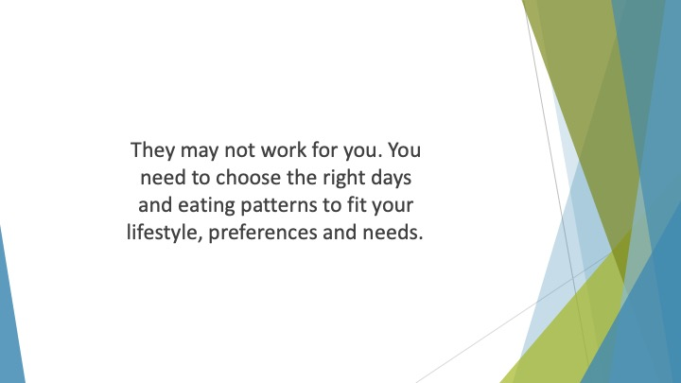
S25 : They may not work for you. You need to choose the right days and eating patterns to fit your lifestyle, preferences and needs.

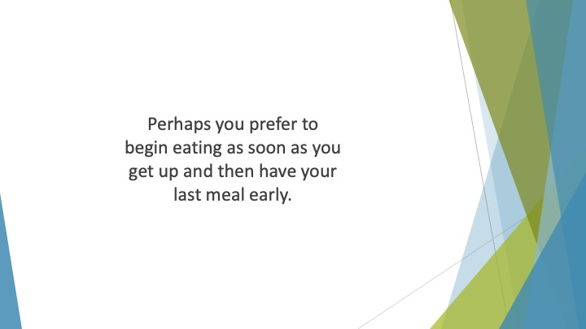
S26 : Perhaps you prefer to begin eating as soon as you get up and then have your last meal early. Or maybe breaking your fast in the early afternoon and having a last meal just before bed is best.

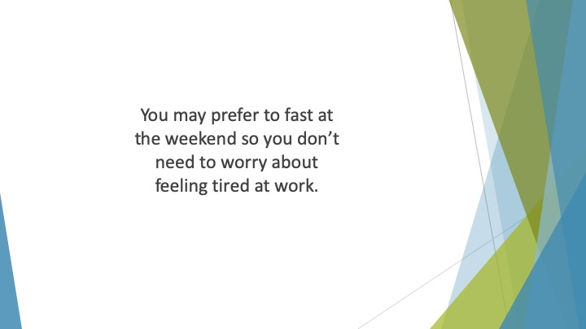
S27 : You may prefer to fast at the weekend so you don’t need to worry about feeling tired at work. Or fasting on a weekday may be right for you so you have distractions.

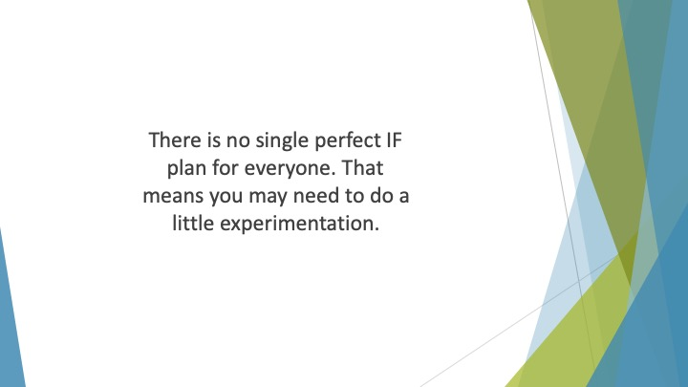
S28 : There is no single perfect IF plan for everyone. That means you may need to do a little experimentation. Weigh up the pros and cons of all the regimes that we’ve suggested.


S29 : Think about which one you’re most drawn to and give it a try. It’s best to try to give it a month to see how well it works for you.

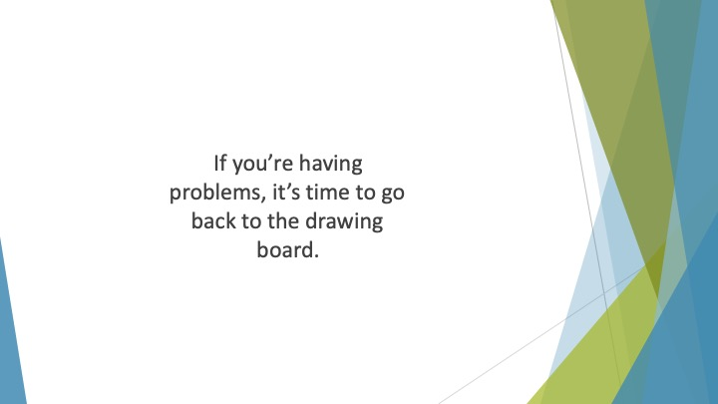
S30 : If you’re having problems, it’s time to go back to the drawing board.

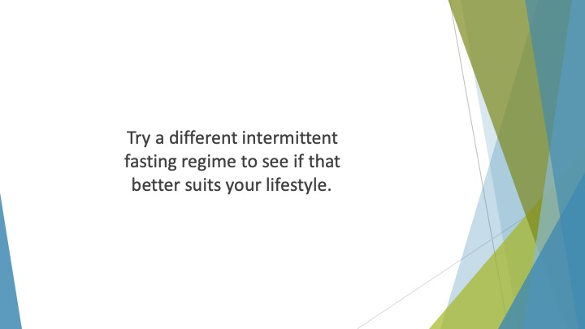
S31 : Try a different intermittent fasting regime to see if that better suits your lifestyle. Or move your eating windows around a little to see if it becomes more manageable.

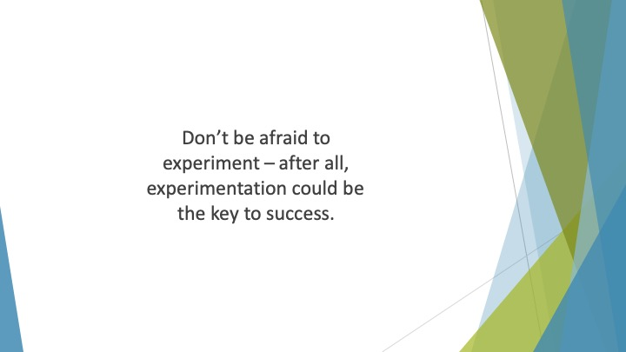
S32 : Don’t be afraid to experiment – after all, experimentation could be the key to success.

