Introduction


S1 : Pause for 2 seconds

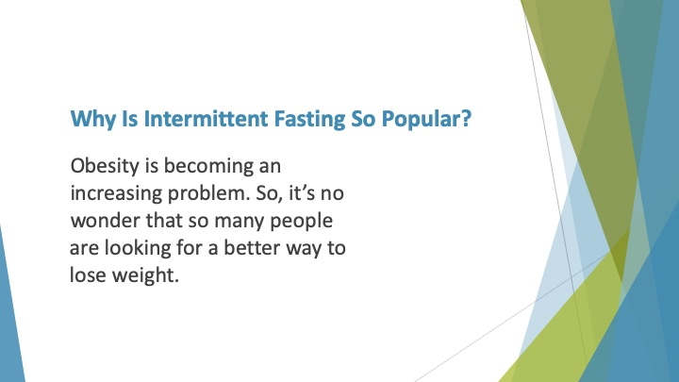
S2 : Why is Intermittent Fasting so Popular?

Obesity is becoming an increasing problem. So, it’s no wonder that so many people are looking for a better way to lose weight.

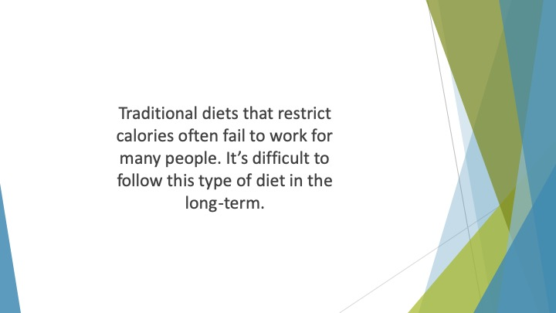
S3 : Traditional diets that restrict calories often fail to work for many people. It’s difficult to follow this type of diet in the long-term.

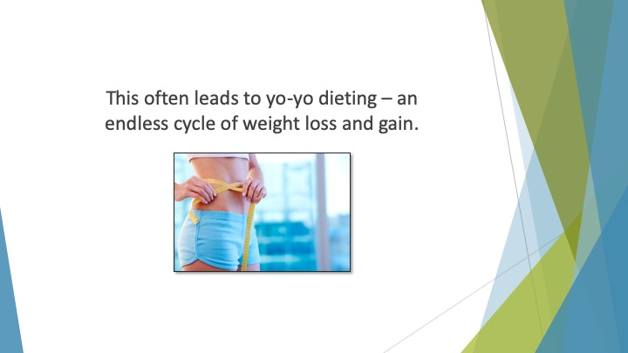
S4 : This often leads to yo-yo dieting – an endless cycle of weight loss and gain.

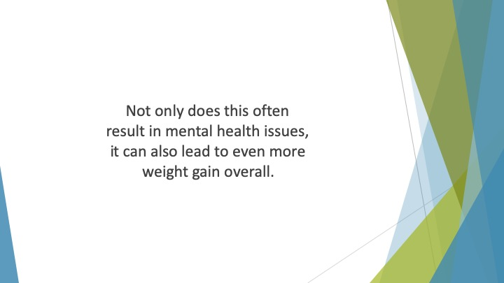
S5 : Not only does this often result in mental health issues, it can also lead to even more weight gain overall.

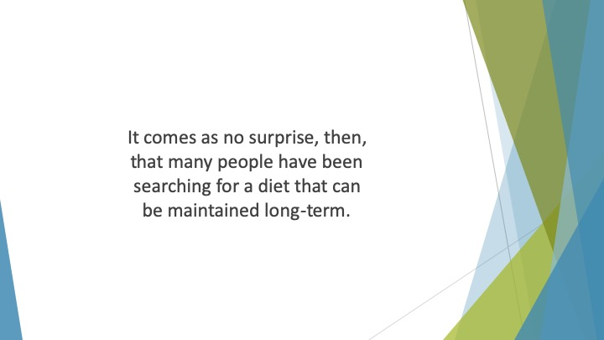
S6 : It comes as no surprise, then, that many people have been searching for a diet that can be maintained long-term.

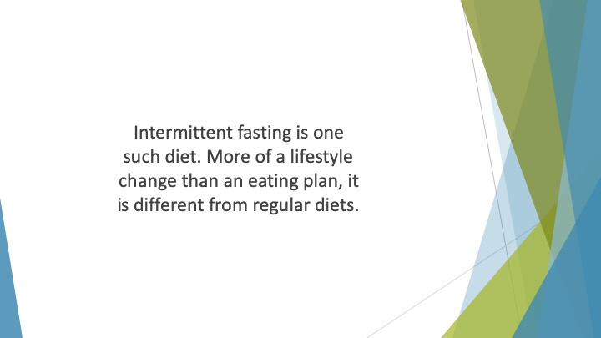
S7 : Intermittent fasting is one such diet. More of a lifestyle change than an eating plan, it is different from regular diets.

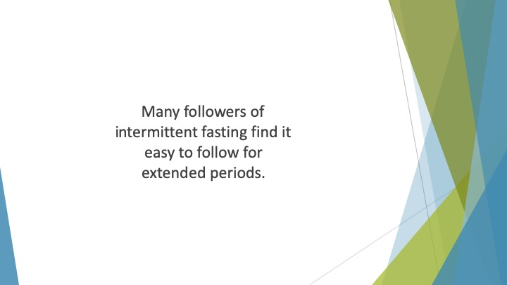
S8 : Many followers of intermittent fasting find it easy to follow for extended periods.

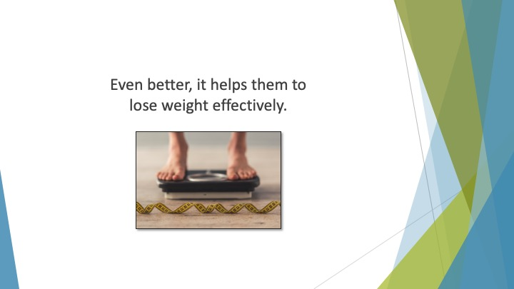
S9 : Even better, it helps them to lose weight effectively.

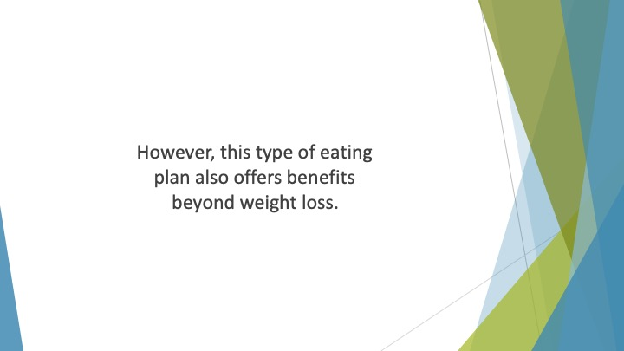
S10 : However, this type of eating plan also offers benefits beyond weight loss.


S11 : Many people believe that it can offer other health and wellness benefits too.


S12 : Some of those benefits are even said to stretch further – some say it makes them more productive and focused.


S13 : As a result, they can become more successful in the workplace.

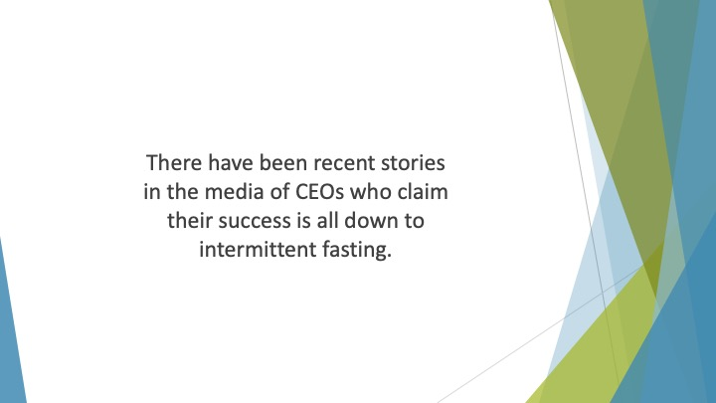
S14 : There have been recent stories in the media of CEOs who claim their success is all down to intermittent fasting.

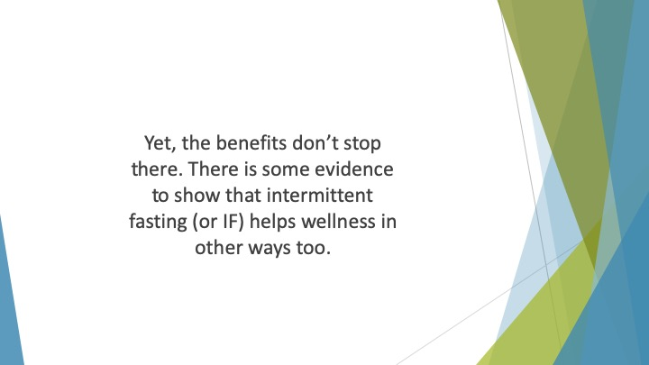
S15 : Yet, the benefits don’t stop there. There is some evidence to show that intermittent fasting (or IF) helps wellness in other ways too.

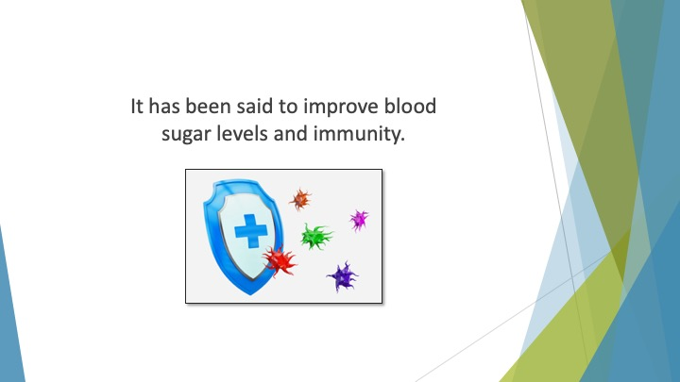
S16 : It has been said to improve blood sugar levels and immunity.

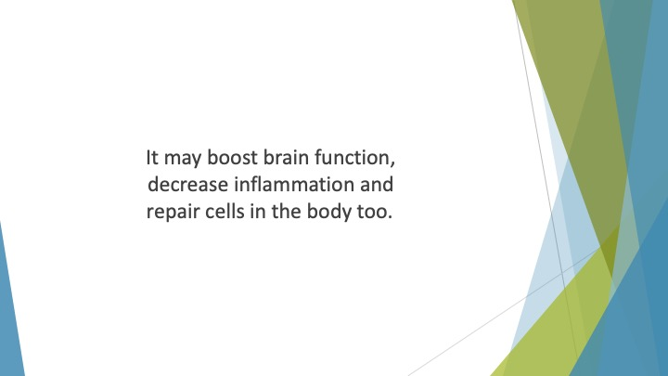
S17 : It may boost brain function, decrease inflammation and repair cells in the body too.

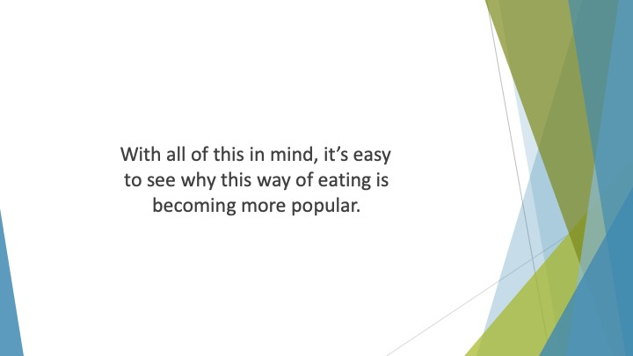
S18 : With all of this in mind, it’s easy to see why this way of eating is becoming more popular.

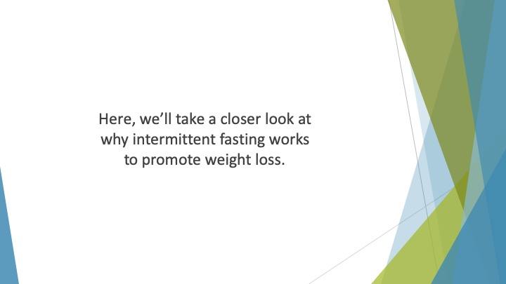
S19 : Here, we’ll take a closer look at why intermittent fasting works to promote weight loss.


S20 : We’ll examine the benefits of this lifestyle change and we’ll show you how to get started with this diet protocol.

