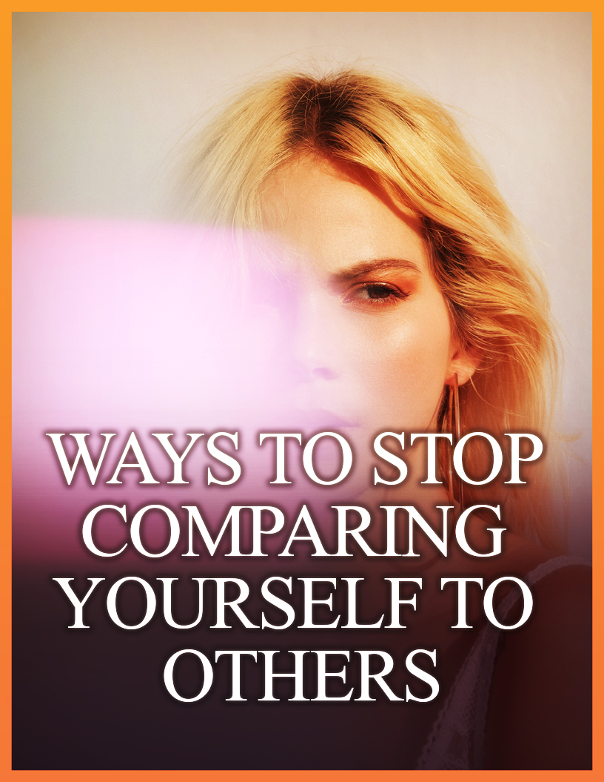

Limited Special Offer
How To Stop Worrying What Other People Think Of You Full Training
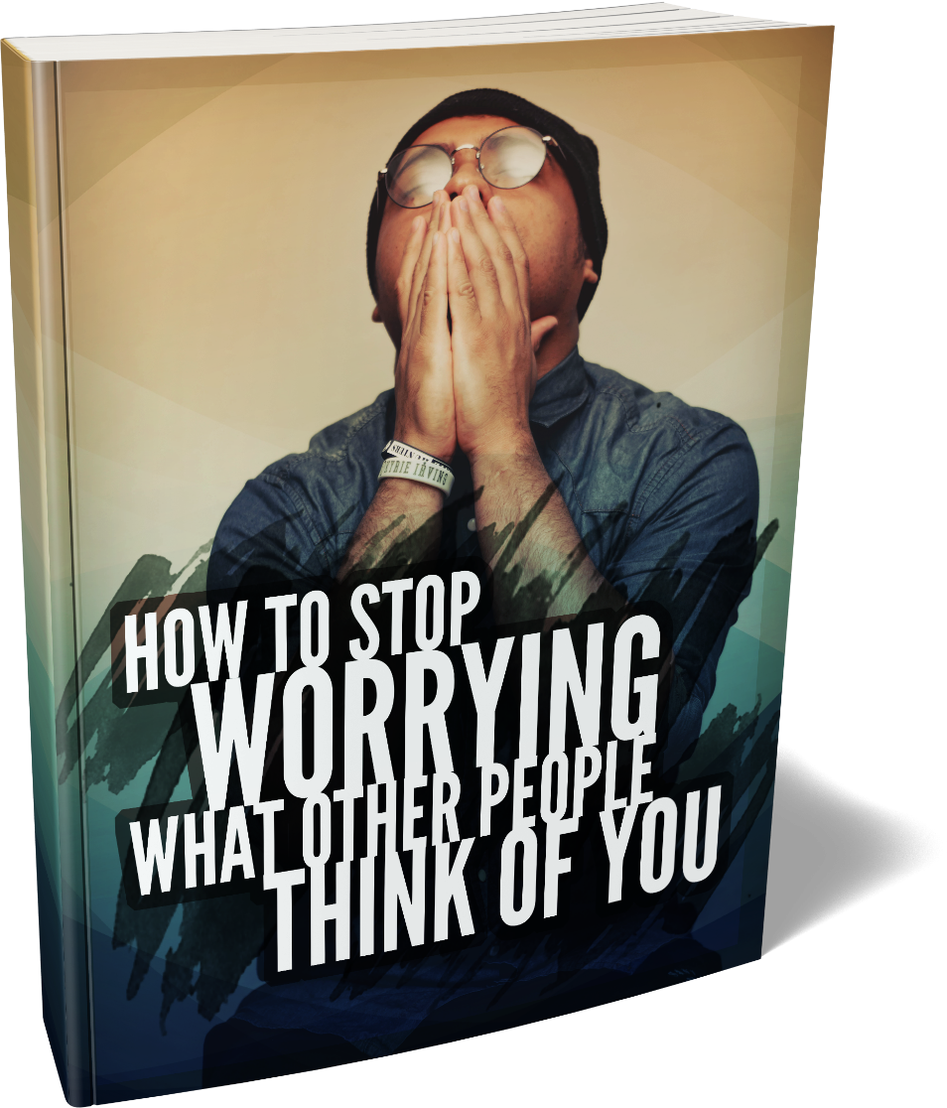

Click Here to Download the Full Training!
(Insert your Front End Offer URL)

It is natural for human beings to compare themselves with others. If this didn’t take place then nobody would be able to see how well they are doing. Most people do not use comparisons in a good way and end up causing themselves all kinds of problems.
Unhealthy comparisons can cause low self esteem, dependency and even depression. If you are constantly comparing yourself with others and becoming bitter and angry then you need to stop doing it.
The techniques in this guide will help you to stop comparing yourself with others in a negative way. You will need to work on these techniques to perfect them so that everything is on autopilot. There is no miracle solution.



How do you really think about yourself? We all have an opinion about ourselves and this is a very important step to take if you want to stop comparing yourself with others in a negative way. You need to be aware of the root cause as to why you keep comparing yourself in an unhealthy way.

This is not the easiest thing to do but you must do it. It is essential for you to break the pattern that you have of negative comparisons with others. You can ask a trusted friend or family member to help you with this task and support you through the process.

Write down how you see yourself at the moment. This will help you to identify the behavior that you need to change. Accept the fact that changing this behavior is going to take time and effort and break everything down into smaller achievable steps.



Having low self esteem is a major reason why people make negative comparisons with others. Self esteem is all about the feelings that you have for yourself. You are going to have some negative feelings and some positive feelings. If the negative feelings far outweigh the positive feelings then you definitely need to work on your self esteem.

If you tend to let others control how you feel then this is a sign of low self esteem. You do not want to be reliant on others to feel happy about your life. It is a good idea to work on improving your self esteem every day regardless of how you feel about yourself at this current moment.



When you feel the need to compare yourself to others write down your thoughts and feelings about this. Why did you want to compare yourself to somebody else in the first place? As soon as you experience these thoughts then write them down. Add as much detail as you can.

If you have already made the comparison then ask yourself how you felt about it. Be sure to record all of the feelings and thoughts that you have about this. Be specific here and write down the exact reasons for feeling down about a comparison. For example a co-worker got a promotion before you did.



This is not always easy to do but certainly worth the effort. Think back to a time when you didn’t feel the need to compare yourself with others. Write this down in your journal and keep thinking about the time when you started to make regular comparisons.

This is powerful because it can help to identify the root causes behind your comparison habit. For example you may have compared yourself to your sister in a negative way because you felt that she got more attention from your parents than you did.

Often people do not realize the damage that negative comparisons do to them. When you write down how a comparison makes you feel then you will develop the necessary motivation to change this destructive habit.



Most people take the things that they already have in their life for granted. So we recommend that you record a gratitude statement in your journal every day. This will certainly help you to focus on yourself more than you do others.

Think about the positive things in your life that you are truly grateful for. You are healthy, you have a loving relationship, you have wonderful children, you have great family and friends, you have a job so that you can pay your bills and so on.

Write down three things that you are grateful for in your journal every day. When you do this reflect on how lucky you are to have them. Use statements like “I am so grateful to have my health” or “I am so grateful to have my family”. This will help you to realize that there are a lot more things in your life that are more important than having a new car for example.



One of the real downsides of comparing yourself in a negative way to others is that you identify reasons why you are not as good as they are. This is nonsense of course but in the moment these feelings are very strong.

This can result in you beating yourself up severely and telling yourself that you are not good enough, useless or worse. Instead of doing this praise yourself for who you are and how far you have come. This will put you in a positive frame of mind and inspire you to do more with your life.



Never forget that you are in control of your life. It can be really difficult to stop comparing yourself to others in a bad way but the only person who can change your life for the better is you. So take responsibility to do that and stop letting others control you.

Stop worrying about what other people have in their lives. You are the most important person in your life and if you are not happy with things as they are then decide that you are going to change. The world does not owe you anything and neither does anyone else.



This is an essential step to prevent you from comparing yourself to others in an unhealthy way but it is also the toughest. You have built up this need to compare yourself over several years and these kinds of patterns are the hardest to break. But break them you must.

It will help you when you understand the process involved with making changes to your thoughts and behaviors. The process comprises of a number of stages that increase awareness of the problem and then implementing the necessary change for improved behavior.

The first of these stages is called pre-contemplation. At this stage you are not ready to make any changes and this is usually due to the fact that you do not have enough information about the problem and why you should change.

Next is the contemplation stage where you are thinking about making a change in your thoughts and behavior. You start to think about the positive aspects of making such a change while also realizing that this can be quite painful to do.

After contemplation comes preparation. When you are at this stage you have decided that you want to change and you are in the process of planning how you will do it. After this comes the action stage, where you start to make the necessary effort to implement the change.

The final two stages are maintenance and termination. Maintenance is all about checking that the actions you took to implement the change are still working. You may need to make some tweaks to your thoughts and behavior here. Once the change is on auto pilot it has reached the termination stage.



If you are in the habit of idolizing others then you need to stop this. It is an unrealistic thing to do and fantasizing about others will get you nowhere. There is always more to another person than meets the eye. By idolizing someone you will only concentrate on the things that appeal to you and you do not see the whole person.



When you make unhealthy comparisons with others this leads to you experiencing negative thoughts about yourself. These negative thoughts can be very powerful and can drive your self esteem right down and even make you depressed.

When you experience negative thoughts after comparing yourself to someone else then take action immediately by using a positive thought to neutralize it. So for example if the negative thought is “I will never be as cool as her” use a positive thought such as “I am wonderful and can attract all the things that I want in my life”.

An alternative strategy is to think about something that you are good at that the other person isn’t. Let’s say that you know a person that is a very good writer. When you think about this you experience negative thoughts about your own writing capabilities.

So if you are thinking “she is a better writer than I will ever be” you can think about something you are good at “I am an expert in graphic design and really creative”. If you want to be a better writer then think “I know that I can improve my writing ability by learning from others”.

Neutralizing negative thoughts with positive ones definitely works but you need to be consistent with this. Don’t expect overnight miracles. If you experience any negative thoughts about yourself for any reason then remember to use a positive thought every time to change your state.



You want to live your life on your terms and not someone else’s. If you have not set any goals for yourself then you need to do this. Always bear in mind that the goals that you set are for your benefit and not for anyone else’s.

We recommend that you use the SMART FOR ME goal setting process. Here is how it works:

Specific – you must set specific goals. What exactly do you want to achieve?

Measurable – it is essential that you can measure your goals so that you will know how well you are progressing.

Attainable – this is all about totally believing that you can achieve the goal.

Realistic – is the goal you have set realistic? Do you have the resources, money and skills to achieve it?
Timed – there must be a deadline for each of your goals.

Focus – it is essential that you set focused goals. Don’t commit to too many goals.

Optimism – you need to write your goals in a positive way so that they are optimistic.

Ready – you must be ready to start working on a goal right now. If you need to wait around for someone to assist you then your goal is not ready.

Meaningful – all of your goals need to tie in with your life’s purpose.

Exciting – all goals that you set must be exciting. They must provide you with an emotional buzz to motivate you at the highest levels.

It is no use just setting a goal or goals and then not seeing how well you are moving towards it. We recommend that you use a journal to record your progress every day. This will assist you to focus on the important things that you need to do to move a step closer to achieving your goal.

Don’t be influenced by others here. If you have set a goal for weight loss and you know that your friend lost 20 pounds in two months it does not mean that you have to do the same. We are all different and so are our bodies. Some people will lose weight faster than others.


You always need to go your own way when planning and working towards achieving your goals. If it takes you a few weeks longer to lose the weight than someone else this is not important at all. If you want to acquire a new skill then set a realistic time frame for this and take into account your pace of learning and the time that you can realistically dedicate.

Please take not here of the very important part of this which is “you want to improve”. Don’t try to improve your life because others tell you that you need to do this. You are far more likely to succeed if you really want to make improvements that come from within.

When you make improvements to your life you will boost your self esteem and increase your confidence. These are both very powerful in your quest to stop making unhealthy comparisons.
Forget about perfectionism when you are working to improve different areas of your life. There is no such thing as perfect. If you strive for perfectionism then you are very likely to achieve nothing. Good enough is fine.


It is natural for human beings to want to compete against each other. But the downside of doing this is that there will always be other people that are better than you at what you are striving to achieve and this can really bring you down.


Instead of competing with others we recommend that you compete with yourself. When you do this you will be competing in a healthy way and it will really challenge you. So it is important that you set challenging goals for yourself and regular track your progress. If you are not where you want to be then you can put in the extra effort needed.

Using other people’s standards to judge yourself is a road that you don’t want to go down. This will fuel your need to compare yourself with others and will likely result in negative thoughts and feelings.


Set your own standards and judge yourself by these. This is all about taking responsibility for your own life and being in control. Always remember that you do not have any control over what other people do. Become comfortable with your own standards so that you refrain from looking at other peoples.

Envy is a really bad thing that can drive you in all of the wrong directions. If you are envious that your neighbor has just purchased a brand new car then you may be tempted to get yourself into a lot of unnecessary debt by buying a new car yourself. It really isn’t worth it.

Be appreciative of others instead. Other people can help you through their different experiences and knowledge levels. Decide that you will use this to your advantage rather than being envious of this. Rather than feeling inferior to them tell yourself that you will learn from them to improve your life. If she can do it so can I!


Having a good coach can really help you to improve your life in so many ways. But different coaches use different approaches and sometimes you will not be happy with how an external coach tries to motivate you to succeed.

So why not be your own coach? After all you know yourself better than anybody else ever will. You will know how to push the right buttons to get yourself to take action. When you are your own coach you will know that you will always treat yourself right. You will appreciate your own efforts and raise your self esteem in the process.


Are you someone that is permanently “plumbed in” to social media? If you receive a notification on your phone do you tend to drop everything and respond to it? A lot of people are addicted to social media and the representations that it makes. There are many people with strong opinions about how people should live their lives.

We are not asking you to get rid of social media altogether. It can be a great way to stay in touch with family and friends and we appreciate that. What we do recommend is that you limit the time that you spend on it.

If you follow people that have a big influence on you then consider stopping this. They don’t know you and what your hopes and dreams are. They maybe living the life that they want but you never know the full story. Being swayed by social media in this way is not healthy for you so we are asking you to be careful who you follow and listen to.


No matter where you turn these days there seems to be an endless amount of images of “perfect people”. You can find these in magazines, TV shows, social media, in movies and just about everywhere else.

It is not a good idea for you to compare yourself with these images. If you don’t measure up then this can lead to you experiencing negative thoughts about yourself. So we are asking you to avoid them and ignore them if you see them by accident.


Again you never get the full story. The pictures of the skinny models on the catwalk may seem appealing but there is a likelihood that most of them are continually hungry because they don’t eat enough. Some photographs are cleverly manipulated using programs such as Photoshop as well.

You are always going to come across people or images of people that seem to have a better life than you do. Maybe they have the perfect relationship that you crave or the perfect body. But nothing in this world is perfect and never likely to be.

In perfect relationships there is often pain. Couples have disagreements all of the time and they might look like the perfect pair from the outside but you don’t know the full story and probably never will.
If someone has a nicer car or house than you then use this as motivation to make positive changes in your life rather than get bitter and twisted over it. Take stock of where you are now and decide where you want to be.

When you think unrealistically about life it seems impossible to get where you want to be. This usually leads to you going into a negative state and feeling that you are worthless. Don’t accept that a person’s life is a bed of roses because this is very unlikely to be true.


You now have 20 great ways to stop comparing yourself with others in a negative way. These techniques work and you need to use them regularly and accept that they will take time to work. So start taking action right away and free yourself from having others control the way that you feel about yourself.


