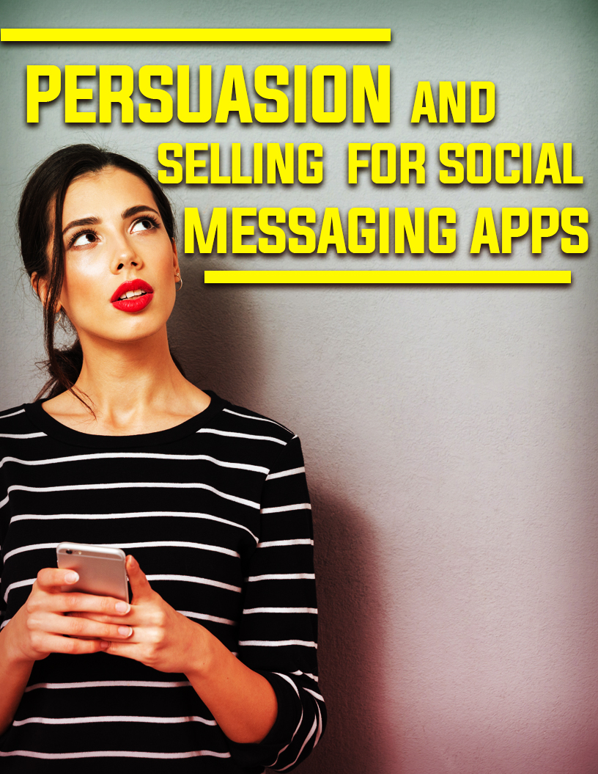

Limited Special Offer
Social Messaging Apps For Marketers Full Training
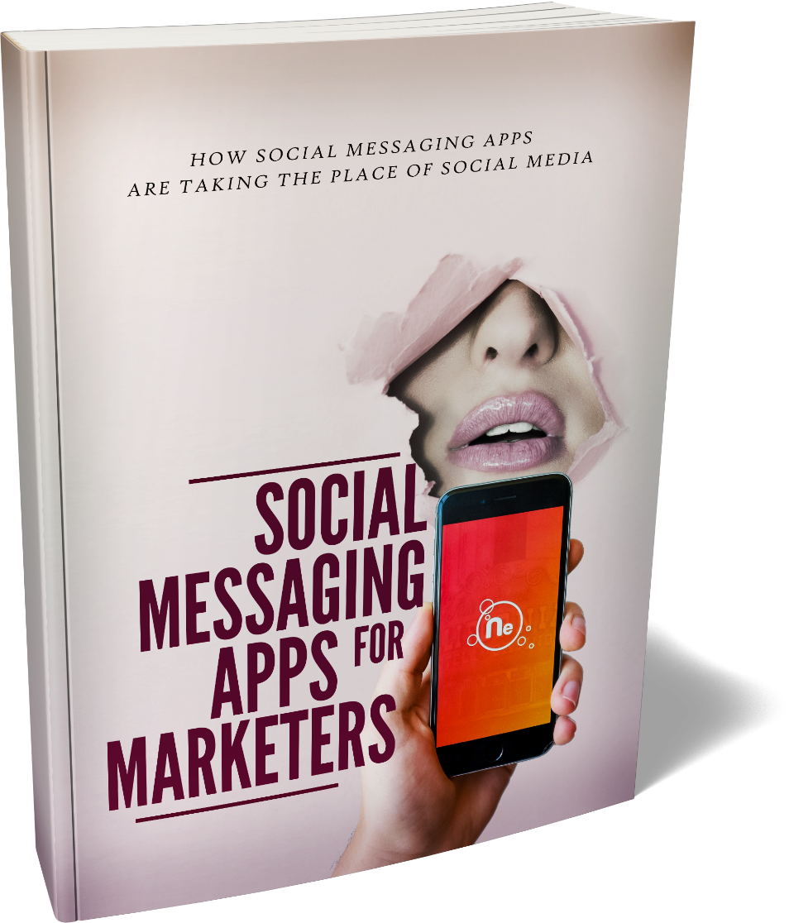

Click Here to Download the Full Training!
(Insert your Front End Offer URL)

Internet marketing has done a LOT of great things for businesses. This is especially true for individual entrepreneurs and marketers. People who once wouldn’t have stood a chance of going head-to-head with big businesses now finally have the same means for reaching gigantic audiences and tracking metrics. This has levelled the playing field and essentially enabled thousands of happy marketers to retire early to their own private islands (well, maybe a few).
Either way though, tools like email marketing, Facebook ads, Google ads, SEO, content marketing and more are a godsend for the small business.
The only problem? These tools in some way make things a little bit too easy. That’s especially true when you think of those ready-made business-in-a-box type offers. You know the ones: the ones where you buy a digital product to sell, along with your email sequence, your sales page, and more.
The issue with this is that while those systems might work well, the buyer doesn’t really understand how to use them. And as such, they don’t get the full benefit.
What’s worse, is that because we’re so reliant on all these “easy wins,” many of us have lost some of the most fundamental and powerful business skills.
In particular?
Talking to people.
That’s right: actually speaking to someone in a live and interactive manner so that you can listen to what they have to say and actually respond. And this makes ALL the difference.
Why? Think of it this way: when you try and sell something through a sales page (a single page that explains to visitors how great a product is), all you will end up doing is talking at them. You can use every psychological technique in the book to try and make your product sound great, but at the end of the day, this is a one-way conversation.
The same thing is true with email marketing, with advertising, and with just about every other tool in the internet marketer’s tool belt.
And that just doesn’t work all the time.
You might be lucky. You might write the perfect sales pitch that happens to perfectly tap into the way that the visitor is feeling right now. You might answer all their questions, and assuage all of their fears.
But then again, you might misread the situation. You might not realize that this particular customer isn’t that concerned about earning money. Or that they don’t like reading. Or that maybe they don’t like being spoken to that way.
Or maybe they have a question: should they get package A or package B?
Can you guarantee that X?
Because no one is around to answer their questions, they will leave. And you’ll never get the chance to sell to them again in most cases.
Compare this with an ACTUAL conversation. In an actual conversation, you still do your sales spiel. You still dish up all the facts and figures and explain why they should definitely choose your product. But then you open up the floor. NOW you have the opportunity to their questions. Or at least you just try and judge from their responses how they might be feeling.
If they’re into it? Great! You can double down on that strategy and really drive home the sale.
If they’re apprehensive? You back off. You try a different tact. Right there you’ve already kept someone who would otherwise have left.
If they have a specific question? You ask them what that is and then answer it for them.
And suddenly, you can turn a pitch that isn’t going so well around.
This is the power that any great door-to-door salesman has at their disposal. And it’s something that is lost when you use any kind of “ready made” sales pitch.
What’s more, is that it’s something that SO MANY of us have forgotten how to do – simply because we haven’t had the opportunity or the need.
But what if we regain that skill and bring it right back?



Social messaging apps include the likes of WhatsApp, Facebook Messenger, Skype, and even things like Instagram DM.
These are not social networks, but rather tools that allow you to instantly contact and message a single person. You can then speak in real-time in a private setting.
A lot of businesses are still ignoring social messaging. Did you know that only 31% of users are using social messaging apps?
This is in spite of the following, extremely impressive stats taken from one popular chatbot site:
Facebook Messenger messages have an open rate of 50-80%
Facebook Messenger messages have a click-through rate of 20%, especially when using chat blasting
Facebook Messenger messages have a conversion rate of 3-5x higher than Facebook desktop ads
Facebook Messenger marketing costs 30-50x less than Facebook ad campaigns
The reason they overlook it is partly because they don’t know how to talk to people any more as we’ve already discussed, and partly because they don’t understand the value. Businesses want to send one message and reach thousands of people, they don’t want to spend time sending multiple messages to a single person.
And granted, if you sell pens then this might NOT be the right strategy for you. But if you sell expensive services, then you may well find that the time you put in is more than worth it.
Because selling in this way can help provide a number of MASSIVE advantages.
For one, it lets you respond to questions and adapt your sales technique in that dynamic way, just as we have already discussed. At the same time, it will also allow you to build trust and engagement with your buyers.
When you speak to someone directly through social messaging apps, this gives them a huge amount of reassurance that they can trust you. For one, they will actually get to know you. And assuming you’re a good guy or gal, that’s going to be a massive advantage. At the same time though, this gives you the reassurance of knowing that this is a company that you can contact. It’s not some faceless organization that is going to take your money and disappear off the face of the Earth! The customer knows that if they have a problem, they can speak directly to you.
Then there are all the obvious other benefits of social messaging – like the fact that it lets you immediately contact someone so that a notification will show up in their phone’s tray. They can’t miss it and they will open it.



But perhaps you’re still reluctant. Perhaps at this point, you’re worrying how your intended recipient might respond. Surely they’re just going to get angry if you message them on Facebook? After all, Facebook is meant for friends and family?
And what would you say anyway? How would you convince them to hear you out and ultimately buy the thing you’re recommending?
Well that’s precisely the point. THOSE are the old skills that you need to re-develop. This is what will help you stand out head and shoulders above other online marketers and to drive some MASSIVE high ticket sales.
And it’s coming back to digital marketing in a big way thanks to social messaging apps. This is called “conversational commerce,” the process of selling via conversation through online apps. But it requires skills as a salesperson.
Being a good salesman or woman is one of the best business skills there is. Of course having creative vision, leadership, dedication and all those other things is highly important too if you want to be able to create a fully operational business and to run it in such a way that it survives, makes a profit and maybe even changes the shape of your industry; but the point is that if you have the ability to sell anything no matter what it is, then you’re always going to be able to make money.
Going to corporate events provides you with the perfect opportunity to practice these skills and to try mingling and seeing if you can get other people interested in a concept or something else that you care about/might benefit you. This is something that I highly recommend. If you want to become better at selling – there’s nothing like trying to actual mingle and interact with people face to face. So practice out in the real world, and then you can bring those skills you develop to your social messaging strategies.



I’ll get you started though with some powerful ideas.
NLP stands for “Neuro-Linguistic Programming” and it’s a series of different principles that all look at understanding how other people think and then making the most of that to get them to consider the topics we want them to.
NLP is very often taught to salesmen and women to help them shift more units and it can be very effective to this end. This is precisely the kind of business skill that is increasingly being lost in the world of digital marketing.
But the good news is that this is something you can utilize through social messaging apps and use to drive sales.
For instance then, a very basic example of NLP is looking at the different ways people deal with information. Some people work with a very visual brain, while others have a more acoustic one. You can get cues as to which the person you’re talking to uses by listening to their language – if they say things like “I see what you mean” rather than “I hear you loud and clear” then you know they’re more visual and less auditory; and you alter your pitch accordingly.
Another technique comes from a part of NLP called “the Milton model” where your aim is to try and include subtle assumptions in your speech that will register only on an unconscious level. For instance if you say to someone “all the people who want their own one of these are going to be jealous” holds the assumption that there are a lot of people who want whatever it is you’re selling. Looking around the function venues when you say this can help sell that idea further.
They key then is to listen – or in our case read – and to try and further read between the lines. Understand what the other person is really saying, and be extremely careful with how you respond. This way you can build rapport.
Appealing to Statistics and Authority
Something people tend to respond very well to in sale’s pitches is authority and statistics. If you tell someone that four in five people rated your product highly, then you’ll convince an audience more effectively than if you just say that “most people” enjoy your product. Likewise, if you can associate yourself with an authority figure of any time then this can help too to make your product or service seem more authentic and/or impressive.
This works really well as an opening gambit, and it’s something you can use to encourage people to consider your product. By implying that your product is popular, that it is verified, and that it has a wealth of evidence backing it up, you will make it seem more impressive.
From that point, your job is to prevent the other party from doubting this and to convince them it’s true.
Reducing Risk
Reducing risk means thinking about all the reasons they might be afraid to buy and then removing them. This can mean things like “what if the product doesn’t work for me.” You reduce risk here by offering a full money back guarantee. There is no reason NOT to do this, seeing as you will sell so many more items that the few you return aren’t going to hurt your profits.
The great thing about social messaging versus a sales page is that you can actually respond to their concerns with solutions. Likewise, you can offer people to get in touch IF they have a concern. That way, they might read a sales page, worry that you don’t deliver their address (or whatever) and then speak with you to find out that isn’t the case.
Appealing to the “Value Proposition”
One of the most important concepts when selling ANYTHING is to remember the value proposition. This is “the way in which your product makes life better.” The old saying is that you “don’t sell hats, you sell warm heads.”
Likewise, your ebook about fitness is not really an ebook about fitness at all – it is a set of six packs, a hot partner, and tons of confidence. THAT is what you are selling. And that’s what you have to really talk about when trying to get someone to buy.
This also means addressing their personal pain points. What are they not happy with right now and why are they thinking of buying your product? Ask them!
“I notice you’ve been looking at X product. What is it about that product that you like?”
Now you can understand what makes them tick, and thereby make your product sound perfect for them! It’s an easy strategy that is very powerful and only possible through social messaging.
(How do you see that someone is looking at your product and then message them? One example might be using tracking software and retargeting. Another is by seeing if they comment on a post with your product in, or if they answer a poll saying they’re interested.)
Engaging Your Audience – A Foot in the Door
When someone realises you’re trying to sell them something, then chances are they’ll quickly try and get away from you and move on. A great ting to practice at functions then is getting your pitch in under the radar, which you can accomplish by using some opening statements and questions that don’t sound like a sales pitch you can get someone to drop their guard and then “reel them in” to hit them with your real sales pitch.
So how do we translate this concept to the world of social messaging apps?
Actually, it’s one of the most important aspects of all. So let’s take a look.


All these sales techniques can work absolute wonders when paired with the reach and impact of social messaging apps. The problem is that a lot of people won’t LIKE being messaged this way. When you message someone on WhatsApp or Facebook Messenger, they might just be annoyed that companies are contacting them through here.
So what do you do to ensure they respond well and not angrily?
One option is to make sure that you have that foot in the door and a good reason to message them.
For example, you can do this by using Messenger to continue a conversation that has gone on on Facebook. Post something and if they respond, you can then respond to their response and so on. If this goes on for more than 3 messages, you can then legitimately respond to them in their Messenger inbox and just say you “thought that it would be easier to continue the conversation here.” There are even apps that will automatically message ANYONE who talks to you by leaving a comment (they’re listed in the full ebook).
Another option is to use Messenger to send a confirmation email if someone signs up to your mailing list for example, and to let your visitors respond to that email if they “have any questions.”
There are other tools out there that make this easy too. For example, you can embed a Facebook messenger option in your website, or you can include a checkbox plugin that will allow users to sign up for Messenger contact at the same time as signing up for a mailing list. This is also how you’ll gain permission if you want to message people on WhatsApp.
Instagram has lots powerful tools as well. One example is an option that allows you to run polls and then see who responds. Ask something like “who is interested in X product” then message the people who say yes! These are qualified leads that implicitly gave you permission to contact them – it’s the perfect situation.
What to Say
So now you know how to contact people through messaging apps and what to say to sell, the other question is how do you begin the conversation?
Firstly: don’t try and sell right away. Use one of the “reasons” we’ve discussed to message and then try to bring the conversation around to sales. The only exception is if someone has already expressed an interest, or if you have a really good offer to share.
Next, make sure the message is short. People HATE getting long messages from businesses this way. It should take them two seconds to read and be even quicker to respond to.
A quick tip? To encourage a response, get them to say “no” instead of saying “yes.” For example, don’t ask:
“Do you have a minute?”
Instead say:
“Are you busy right now?”
This subtle difference makes them feel less “trapped” and they’ll be much more likely to answer you.
Use their name and be personal. Use what you know about them, and check their profile to find out more. BUT don’t be creepy. And be respectful: no one wants to get a message at 5am in the morning, so make sure to check local time zones.
It’s a learning curve for sure, but once you re-learn how to sell via conversation, you’ll find that your marketing game in general improves many times over. And using social messaging apps? This is one of THE most powerful tools there is for any marketer. You just need to know what you’re doing.
That will come with time, but the good news is that in the meantime all this can actually be quite fun! And it might just help with your dating, negotiating, and personal life as well.

